NNIPCamp Denver

Session 4: Thursday 10/23/2014, 4:00pm-5:00pm
Location: Theater

Session Title: Data as a tool for engagement
Organizer: Jordan Wirfs-Brock
Primary Notetaker: Jordan Wirfs-Brock
Participants:
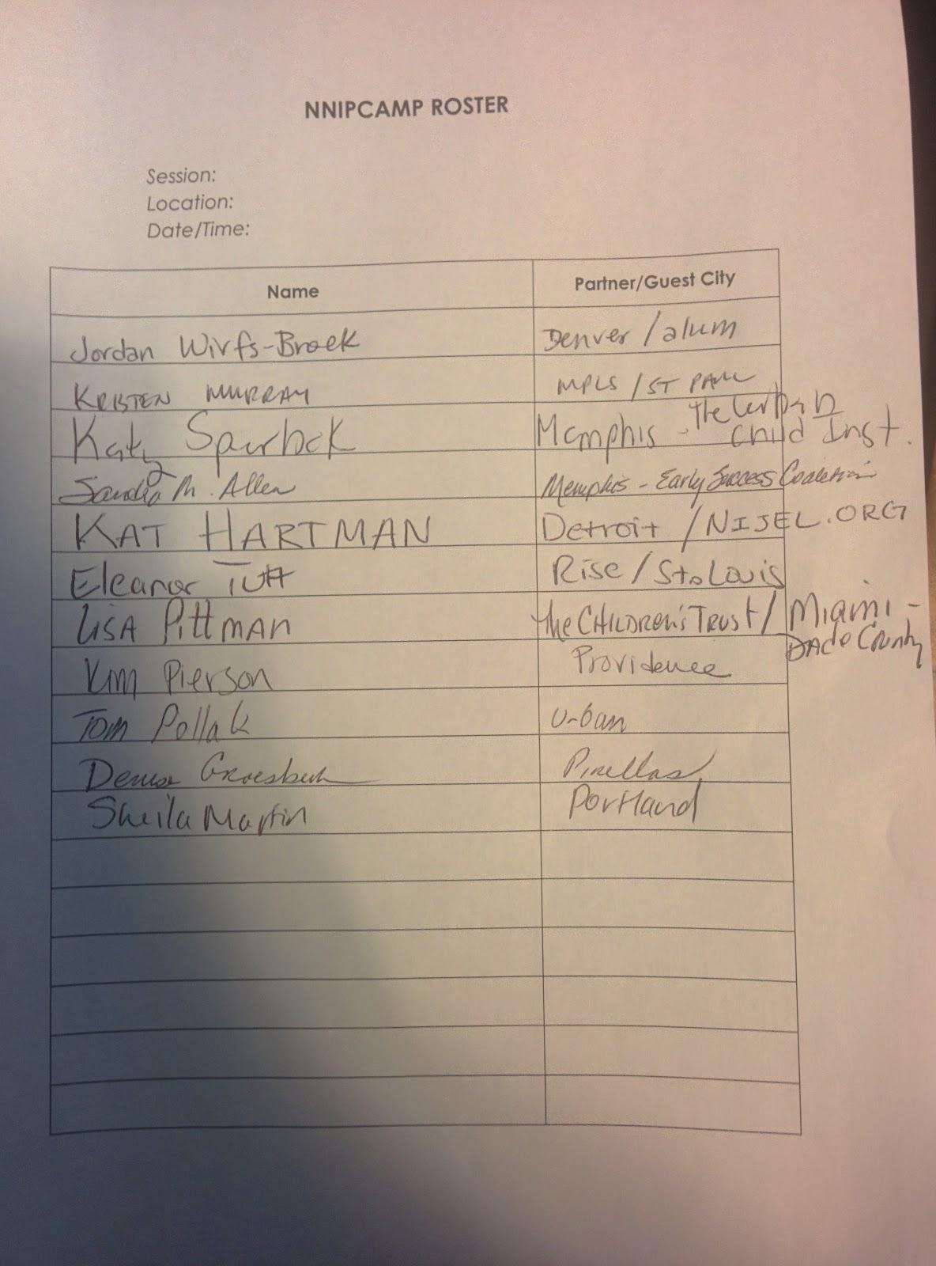

Notes:
· What does engagement mean?
o Engagement measurements
· Who are you trying to engage and who are you missing?
o Geographic area (residents)
o Everyone who interacts is a child
o Parents
o Grandparents
o Aunts/uncles
o Low income residents
o Non-profit groups
o Childcare providers
o Faith based groups
o Social service agencies
o Engage the engagers, block captains, business community
· Presenting information leads to discussion, but how do you encourage commitment?
o Sharing information
o Discussing with people
o Taking Action
· Want to create an organic process that is customized and community driven
· You can’t always steer the ship and that’s ok
· Who is responsible for change? And who leads?
· Data is a tool for engagement but it doesn’t finish the job
· Who takes ownership of an issue – it’s more powerful for people to present their own data
o Shared an example of kids presenting at neighborhood data day, had more impact
· Things to remember: food and childcare to get people to come to meetings
o Also translators
o Ask, what is actually the goal here?
· Encouraging volunteering helps break down those barriers
· Problem: what if there is no existing convener?
o Dudley ST. Boston?
o Find a microcosm:
o Hire a community organizer?
o Identify assets like grocery stores or other informal communication
o Ask: who do you go to for information?
o What are you willing to do?
o Figure out the state of the data
o Offer small grants for businesses, easy to enter challenges like micro-grants

