NNIPCamp Denver

Session 3: Thursday 10/23/2014, 2:45pm-3:45pm
Location: Theater

Session Title: Leaflet Implementation
Organizer: Sheila Martin
Primary Notetaker: Katya Abazajian
Participants:
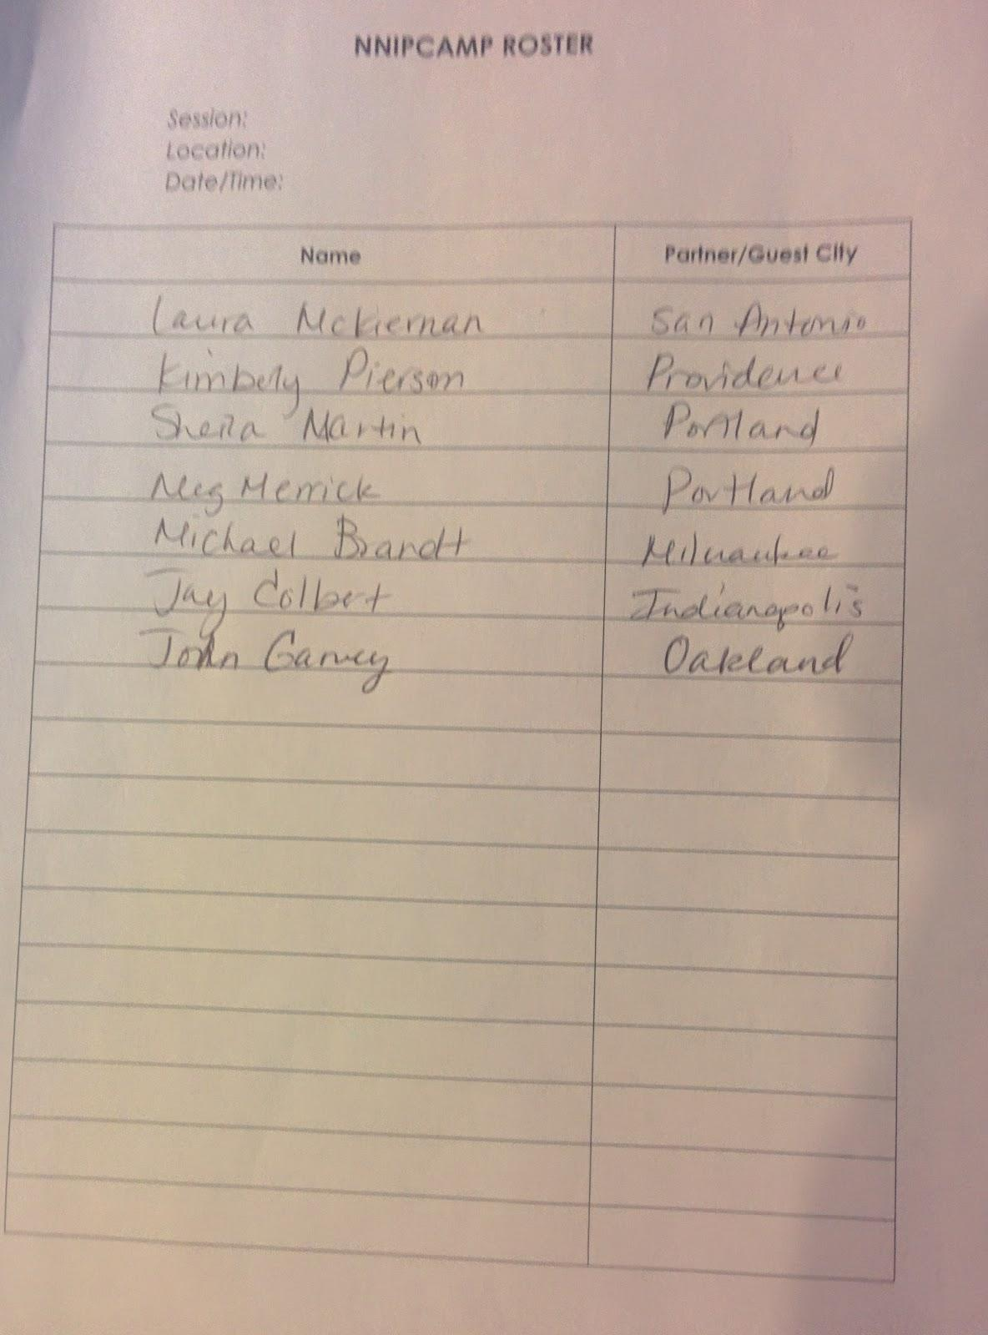

Notes:
- Proposed question: Was using Weave, having trouble figuring out leaflet
- Weave vs. leaflet
  - Will keep using for now but need something with iPad capability
  - Using high charts for tables
- Providence - using leaflet on neighborhood profiles
  - can overlay polygons, points
  - uses robust library
  - User friendly legen
  - Can make an Arcmap that user can understand
    - Use layers from Arcmap to leaflet
    - take shape file with lat/long
  - Is there a prepackaged front end?
    - Programmers at providence use Json
    - If you dont have programming capacity in house, might be difficult
- Tableau might be helpful because makes maps
- At providence, programmer code for leaflet is on github
- Portland’s has a good relationship with Metro and is working with Coalition for Livable future to develop mobile capability
- Ultimate goal is to be able to directly upload Portland’s data
- Programming problems:
  - Sometimes geospatial things are turned into tiles and you lose attribute data
    - Need to upload shape files, need non=tile based layers
    - Leads to needing points to pull data
- Options other than Leaflet?
  - Tableau
  - Bootleaf from Github
  - MapBox, not standalone
- What is the user experience goal?
  - EquityAtlas in Portland is a good example of what end should look like
  - Want to be a data viewer more than a data analytical tool?
    - Downloadable data because experienced users just want to download and do it themselves
  - To give more options to basic users maybe provide specific instruction as a serious of “range sets”?
    - Might be possible to preset limitations to allow/make sure people see an appropriate representation of data
- What attribute of leaflet do you find most helpful?
  - It’s a blank slate so there is a lot of flexibility
- Without a programmer is Tableau better?
  - Leaflet is more comprehensive so could be more helpful
- Bootleaf is more canned (user interface)
  - Need a server then plug it into your data and pulls from leaflet
- Leaflet is good for programmers
  - CartoDB is a more hosted solution
  - Style everything, popup windows and then just embed tags into website
  - Better online user interface
  - Moving away from Weave?
    - Good for small geographies?
    - Maybe not best style
    - Might be good for large databases
    - Maintaining databases for \weave is very labor intensive
- TileMill <- MapBox desktop version
- ArcGIS Online is a good expensive solution
- Amigo Cloud out of SD, QGIS open source tool
- Flash is not usable anymore - weave
  - Started doing static images
  - Would crash in live presentations
- Data.openoakland.org
- Record track from Oakland
- Subject areas:
  - Converting to Json
  - Embedding maps
  - Data portals
- Providence built theirs from scratch from Django
- Portland send your question to the listserve
  - For small discrete things, cartoDB is great, but might bog down when using too much data
- Can NNIP host a discussion of best practices tech tips?
  - Check out tech tips part of website
- Propublica data journalism does a really good job of cataloging what/how they do data vis
  - Write metadata for how they construct things
- Share link to Mr. Data

