Local Policy Research and Advocacy Support
Systems Scan to the Annie E. Casey Foundation and National Neighborhood Indicators Partnership (NNIP)
By the Community Research Council
February 15, 2008

Community Research Council
739 McCallie Ave
Chattanooga Tennessee 37403

Contact Information
Eileen Robertson-Rehberg
errehberg@researchcouncil.net
1.423.425.5612

Part 1
School Readiness and Early Grade Success

Systems Scan: Summary of Agency Collaboration

Guided by the objectives of the School Readiness and Early Grade Success project, the Community Research Council (CRC) engaged state and local partners in discussions about early childhood education, childcare and children in the City of Chattanooga and Hamilton County. An Advisory Board of early childhood program administrators was convened monthly and introduced to the Core Indicators of School Readiness listed in the project’s resource guide and toolkit. Project objectives provided a guided forum for preliminary discussion during four meetings of the Board. For feedback and future direction, CRC distributed a draft section of the School Readiness and Success Brief to Board members to begin a collaborative process of articulating a problem statement. A copy of the report is included as Part 2 of this document

The Advisory Board highlighted the following local issues and concerns with regard to School Readiness and Early Grade Success:
- There is not accepted understanding of what school readiness means. The public school PreK program uses the First STEP assessment for children entering PreK and Kindergarten. But the Director of the PreK program questions the assessment’s validity. Children do not come into a school system with information about their early years. Tennessee has Early Learning Standards for child development but if child care centers use the standards to assess children, they do not document information for the schools. Some schools in the public school system do ask for childcare history, but there is no uniform method of collecting the information and it is not centrally collected.
- There is a lack of knowledge about the extent and nature of children’s social and emotional problems that contribute to negative behaviors. Children who have behavioral issues increasingly burden childcare and pre school systems. It was noted that in some cases young children have been ejected from a number of childcare and other pre school settings before Kindergarten due to disruptive behaviors.
- A connection between community investment in children ages 0 to 3 years old and the return on the investment could close service gaps. In some cases community investment might benefit middle class families who are in need of services but left out of the “at-risk” categories.
- Tennessee has a 3-Star program to increase childcare quality. The National Association for the Education of Young Children has an accreditation considered better than the state system because it is more extensive. But few childcare and pre-school providers are members of the NAEYC. Cost of compliance with membership standards is a factor for childcare centers. NAEYC requires a number of staff to have certification as a Childcare Professional Associate (CDA) and that imparts additional cost on the employer to pay for employee training and maintaining the certification. Does accreditation make a difference? Is this difference measurable? What outcomes should be measured?

Part 2

DRAFT (Items highlighted in green are to be completed)
School Readiness and Early Grade Success in Hamilton County, Tennessee
Community Research Council
February 15, 2008

Introduction and Overview

Hamilton County, Tennessee has a variety of services and programs – both educational and non-educational -- for children ages 0 to 5 that are designed to prepare children for kindergarten. There are also programs designed to support early grade success once a child has entered the public school system. Yet, there has been no comprehensive examination of the scope, effectiveness and quality of these programs.

This document attempts to provide the beginnings of an environmental scan of current conditions in the county. At the most basic level, we seek to outline both need and capacity. We attempt to pay particular attention to both barriers and opportunities in the current environment. Where possible, we provide actual data that describes the current condition: in other cases, we have sought to identify potential sources of data that will be explored as we move forward with the development of a brief on this issue.

Children Under 5 in Hamilton County

- Data from both the 2000 Census and 2006 American Community Survey indicate that there approximately 18,500 to 19,500 children under five in the County.
- In 2000, 50.7% of children under 5 lived in Chattanooga (Hamilton County’s largest city with a population equal to approximately half the county total): 2006 ACS suggests that the City’s portion of the under 5 population has declined to 48.4% of the countywide total.

Table 1
Children under 5 – 2000 Census and 2006 ACS
Population under 5 | 2000 | 2006
Chattanooga | 9241 | 9315
Hamilton County | 18228 | 19250

- Countywide birth data are consistent with Census and ACS data. On average, over a six year period from 2000 to 2005, there were 3,974 births per year in Hamilton County: thus, a five year birth cohort would total 19,870 children.
Table 2
Births in Hamilton County – 2000 to 2005
Hamilton County: Total live births*
Y2000 | Y2001 | Y2002 | Y2003 | Y2004 | Y2005
4034 | 4045 | 3882 | 3945 | 3979 | 3959
Data for years 2000 to 2004 were accessed from the Centers For Disease Control online database titled Natality Information: Live Births. The 2005 natality data was accessed from the Tennessee Department of Health online database titled Birth Outcome and Risk Assessment. NOTE: 2006 data will be available for the final draft of the Scan.
- Finally, data on kindergarten enrollment for both public and private schools is also consistent with Census, ACS and birth data. For the two years where both public and private school data at the county level are available, the average kindergarten cohort was 3,869 children.

Table 3
Kindergarten Enrollment – Hamilton County (2001-2005)
 | 2000-2001 | 2001-2002 | 2002-2003 | 2003-2004 | 2004-2005
Public school | 3,102 | 3,163 | 3,223 | 3,180 | 3,375
Private school | NA | 841 | NA | 554 | NA
Total |  | 4,004 |  | 3,734
Source: National Center for Education Statistics

Geography of the Under 5 Population

- Analysis of 2000 Census data by neighborhood for under 5 population
Table 4
Population of children under 5 years old by neighborhood
ID | Neighborhood Name | Total population | Population under 5 years old
ID | Neighborhood Name | Total population | Number | %of total
36 | Amnicola/East Chattanooga | 8096 | 712 | 8.8%
26 | Ridgedale/Oak Grove/Clifton Hills | 8619 | 655 | 7.6%
14 | Dallas Bay/Lakesite | 10339 | 765 | 7.4%
29 | South Chattanooga | 12409 | 887 | 7.1%
27 | Downtown | 7014 | 494 | 7.0%
31 | Brainerd | 7631 | 514 | 6.7%
34 | Ooltewah/Summit | 10455 | 698 | 6.7%
10 | Harrison Bay | 5724 | 379 | 6.6%
30 | Red Bank | 10172 | 660 | 6.5%
35 | Middle Valley | 8799 | 570 | 6.5%
24 | Glenwood/Eastdale | 6851 | 441 | 6.4%
13 | East Brainerd | 7987 | 508 | 6.4%
6 | Lupton City/Norcross | 5984 | 380 | 6.4%
18 | Soddy Daisy | 8048 | 506 | 6.3%
33 | Lookout Valley/Lookout Mtn | 7209 | 452 | 6.3%
11 | Birchwood | 6783 | 423 | 6.2%
15 | Hixson | 12312 | 760 | 6.2%
2 | Hickory Valley/Hamilton Place | 10263 | 633 | 6.2%
8 | Bonny Oaks/Highway 58 | 6060 | 365 | 6.0%
9 | Tyner/Greenwood | 8695 | 495 | 5.7%
28 | Dupont/Murray Hills | 8320 | 463 | 5.6%
21 | Walden/Mowbray/Flat Top Mtn | 7976 | 439 | 5.5%
25 | Collegedale | 10843 | 591 | 5.5%
4 | Woodmore/Dalewood | 11374 | 619 | 5.4%
23 | Signal Mtn (Town Area) | 6437 | 348 | 5.4%
32 | Bushtown/Highland Park | 7805 | 414 | 5.3%
19 | Bakewell | 6186 | 325 | 5.3%
1 | East Ridge | 20768 | 1078 | 5.2%
20 | Falling Water/Browntown | 7247 | 375 | 5.2%
17 | Harrison | 7797 | 390 | 5.0%
22 | Mtn Creek/Moccasin Bend | 7617 | 363 | 4.8%
16 | Northgate/Big Ridge | 5502 | 260 | 4.7%
7 | Westview/Mountain Shadows | 8111 | 366 | 4.5%
12 | Apison | 9347 | 418 | 4.5%
5 | Riverview/Stuart Heights | 6348 | 250 | 3.9%
3 | North Chattanooga/Hill City/UTC | 6768 | 232 | 3.4%
Source: Census 2000 SF 3

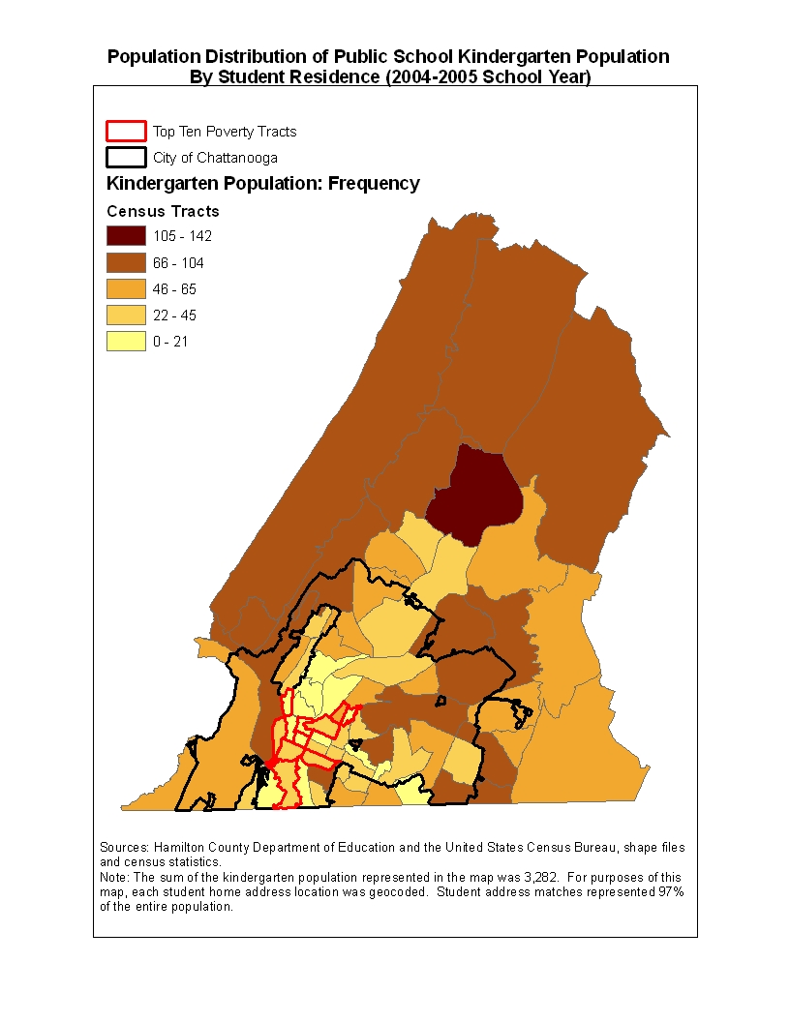

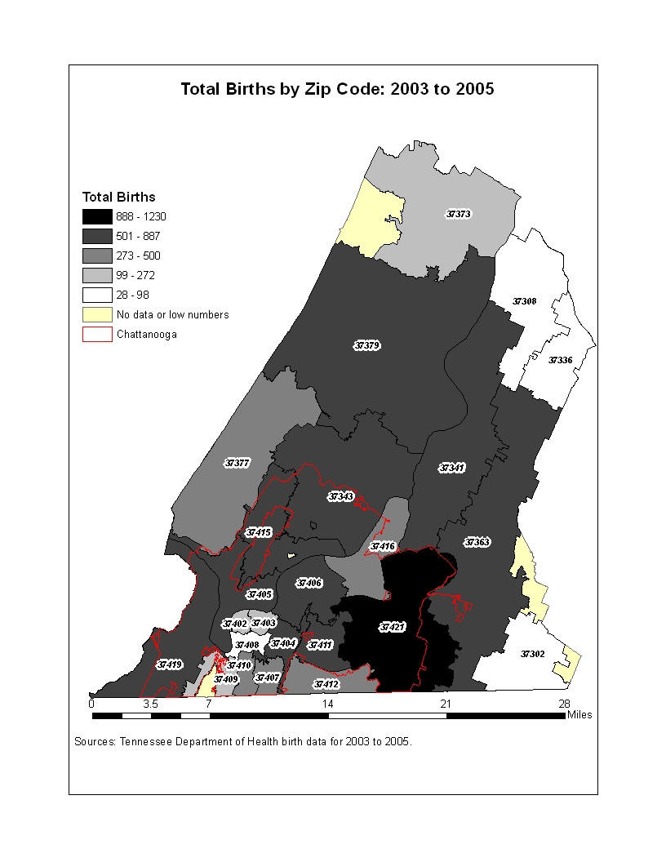

Table 5
Hamilton County residential births and birth rates by zip code
 | ZIP | 2003 | 2004 | 2005 | Total births 2003-2005 | 3-year average | Female population (Ages 15 to 44)* | Birth rate**
Chattanooga (Tiftonia) | 37419 | 484 | 51 | 57 | 592 | 197.3 | 980 | 201.4
Chattanooga (Alton Park) | 37410 | 245 | 69 | 61 | 375 | 125 | 1048 | 119.3
Sale Creek | 37373 | 132 | 22 | 20 | 174 | 58 | 567 | 102.3
Harrison | 37341 | 427 | 144 | 146 | 717 | 239 | 2557 | 93.5
Lupton City | 37351 | 6 | 5 | 6 | 17 | 5.7 | 61 | 92.9
Chattanooga (Downtown) | 37402 | 75 | 69 | 67 | 211 | 70.3 | 792 | 88.8
Chattanooga (East Lake) | 37407 | 30 | 195 | 187 | 412 | 137.3 | 1555 | 88.3
Chattanooga (South Broad) | 37408 | 50 | 29 | 19 | 98 | 32.7 | 371 | 88.1
Chattanooga (St. Elmo) | 37409 | 50 | 59 | 46 | 155 | 51.7 | 616 | 83.9
Graysville | 37338 | 129 | 0 | 0 | 129 | 43 | 545 | 78.9
Chattanooga (Highland Park) | 37404 | 153 | 223 | 248 | 624 | 208 | 2921 | 71.2
Chattanooga (Brainerd) | 37411 | 276 | 226 | 259 | 761 | 253.7 | 3947 | 64.3
Signal Mountain | 37377 | 255 | 131 | 111 | 497 | 165.7 | 2618 | 63.3
Chattanooga (East Chattanooga) | 37406 | 163 | 244 | 227 | 634 | 211.3 | 3410 | 62
Chattanooga (North Chattanooga) | 37405 | 248 | 168 | 163 | 579 | 193 | 3128 | 61.7
Chattanooga (Erlanger UTC) | 37403 | 227 | 20 | 25 | 272 | 90.7 | 1506 | 60.2
Chattanooga (East Brainerd) | 37421 | 333 | 468 | 502 | 1303 | 434.3 | 8557 | 50.8
Lookout Mountain | 37350 | 9 | 19 | 18 | 46 | 15.3 | 324 | 47.3
Chattanooga (Red Bank) | 37415 | 149 | 270 | 271 | 690 | 230 | 5018 | 45.8
Apison | 37302 | 17 | 24 | 30 | 71 | 23.7 | 539 | 43.9
Ooltewah | 37363 | 24 | 308 | 324 | 656 | 218.7 | 5504 | 39.7
Soddy Daisy | 37379 | 6 | 295 | 277 | 578 | 192.7 | 4954 | 38.9
Chattanooga (East Ridge) | 37412 | 4 | 235 | 261 | 500 | 166.7 | 4371 | 38.1
Chattanooga (Highway 58) | 37416 | 1 | 194 | 149 | 344 | 114.7 | 3066 | 37.4
Hixson | 37343 | 22 | 424 | 441 | 887 | 295.7 | 7920 | 37.3
Birchwood | 37308 | 17 | 19 | 17 | 53 | 17.7 | 564 | 31.3
Georgetown | 37336 | 1 | 15 | 12 | 28 | 9.3 | 824 | 11.3
McDonald | 37353 | 4 | 9 | 5 | 18 | 6 | 814 | 7.4
*Source: Census 2000
**Birth rates were calculated from the 3-year average and total females ages 15 to 44 years old.

Demographics of Children Under 5 in Hamilton County

- Overall, both the 2000 Census and 2006 ACS indicate that approximately two-thirds of all children under 5 in Hamilton County are white and approximately one-quarter are African American: in both 2000 and 2006, a majority of children under 5 in Chattanooga were African American

- 2006 ACS data suggests a growth in the number and share of Latino children under 5

Table 6
Race/Ethnicity for children under the age of 5 years old
 | Census 2000 |  |  |  | ACS 2006
 | %White | %AA | %Latino | %All other | %White | %AA | %Latino | %All other
Chattanooga | 46.1% | 47.1% | 1.4% | 5.0% | 41.8% | 44.0% | NA* | 14.2%
Hamilton County | 67.1% | 26.0% | 2.3% | 6.9% | 66.0% | 23.0% | 6.2% | 4.8%
*Latinos living in the City of Chattanooga represent a relatively small proportion of the entire City population. Therefore the sample included in the 2006 American Community Survey was too small for estimates of this population subgroup.

- African American children under 5 are very concentrated within the City of Chattanooga: in 2000, 91.8% of all African American children in the County lived in Chattanooga and African Americans accounted for just 4.3% of all children under 5 living in Hamilton County, but outside of Chattanooga

- The geographic concentration of African American children under 5 revealed by the 2000 Census is consistent with data on students enrolled in public schools. Overall, based on data for the 2005 school year, 35.2% of all students were African American. Out of 36 neighborhoods in Hamilton County, there were eight where African American students accounted for 75% or more of all students from the neighborhood enrolled in Hamilton County public schools. Those eight neighborhoods accounted for 25% of the total student enrollment, but 61.4% of all African American students.
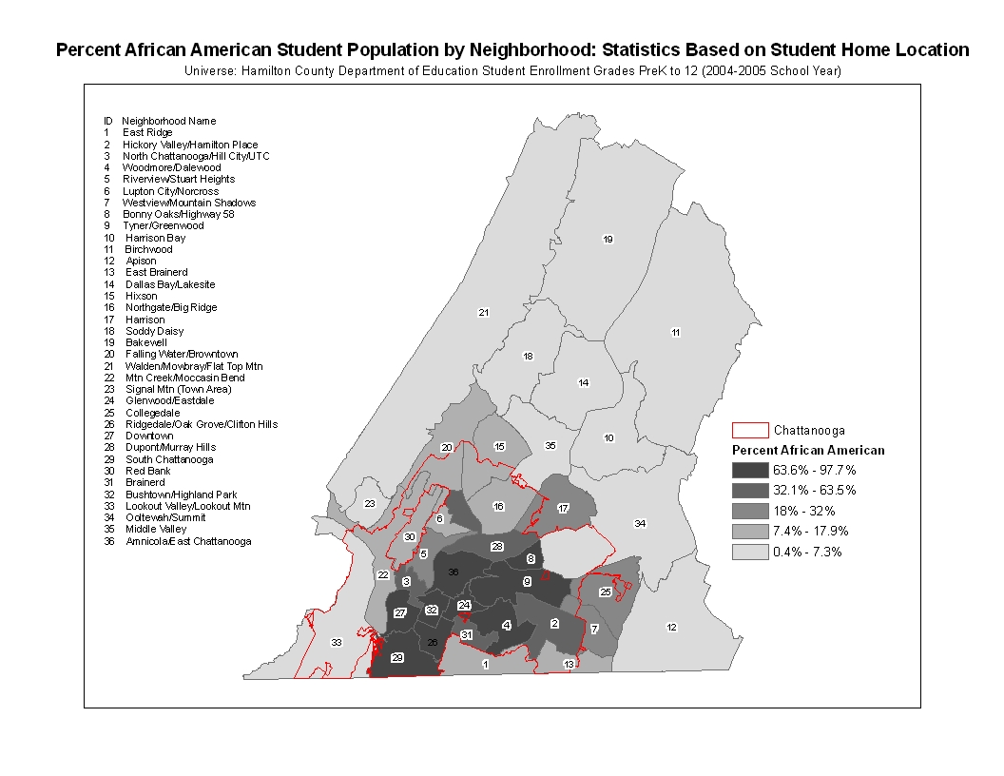
- Birth data for the 2000 – 2004 period is also consistent with 2000 Census and 2006 ACS data. In particular, it reflects the growing population of under 5 year old Latinos

- Birth data for 2000 to 2005 suggest a decline in annual African American births and a steady increase in births to Latino parents

Table 7
Hamilton County birth statistics by Race/Ethnicity
Year* | White | African American | Latino | Asian/Pacific Islander | All other | Total
Y2000 | 2720 | 1079 | 151 | 72 | 12 | 4034
Y2001 | 2667 | 1028 | 242 | 100 | 8 | 4045
Y2002 | 2571 | 1021 | 217 | 72 | 1 | 3882
Y2003 | 2644 | 954 | 263 | 76 | 8 | 3945
Y2004 | 2609 | 994 | 279 | 84 | 13 | 3979
Total | 13211 | 5076 | 1152 | 404 | 42 | 19885
Year* | White | African American |  |  | All other (Including Asian/Pacific Islander) | Total
Y2005 | 2874 | 999 |  |  | 86 | 3959
*Data for years 2000 to 2004 were accessed from the Centers For Disease Control online database titled Natality Information: Live Births.
**The 2005 natality data was accessed from the Tennessee Department of Health online database titled Birth Outcome and Risk Assessment. NOTE: In the final report, birth data will be provided by race and ethnicity at the neighborhood level and will include 2006.

- The growing under 5 year old Latino population appears to be the result of increases in births to parents who are originally from Central or South American countries other than Mexico, as well as those from Mexico.

Table 8
Latino births: Totals by mother's country of origin
 | Y2000 | Y2001 | Y2002 | Y2003 | Y2004 | 5-year total
Mexican | 69 | 104 | 95 | 105 | 129 | 502
Central or South American | 69 | 115 | 97 | 137 | 135 | 553
All other Latino | 13 | 23 | 25 | 21 | 15 | 97
Source: Centers for Disease Control

- Data from both the 2000 Census and 2006 ACS indicate that males comprise a majority of the Hamilton County population of children under 5 – 51.1% in 2000 and 50.2% in 2006

Table 9
Children under 5 by sex
 | 2000 |  |  | 2006
 | Hamilton County | Chattanooga | Other Hamilton County | Hamilton County | Chattanooga | Other Hamilton County
Male under 5 years old | 9309 | 4729 | 4580 | 9670 | 4456 | 5214
Female under 5 years old | 8919 | 4411 | 4508 | 9580 | 4859 | 4721
Total | 18228 | 9140 | 9088 | 19250 | 9315 | 9935
Source: Census 2000 SF3 and ACS 2006

Barriers to Success: Childhood Poverty

- 2000 Census and 2006 ACS data suggests that approximately one-in-five children under 5 in Hamilton County are in households with incomes below the poverty level: in Chattanooga, the childhood poverty rate increases to closer to one-in-three

- In 2000, 78.1% of young children living in poverty in Hamilton County lived in Chattanooga. In 2006, 80.4% of young children living in poverty in Hamilton County were living in Chattanooga

Table 10
Children under 5 below poverty level
 |  | 2000 |  |  | 2006
 | Hamilton County | Chattanooga | Other Hamilton County | Hamilton County | Chattanooga | Other Hamilton County
Total children under 5 in poverty | 3459 | 2703 | 756 | 3937 | 3164 | 773
% Children under 5 below poverty | 18.9% | 29.5% | 8.3% | 20.5% | 34.0% | 7.7%
Source: Census 2000 SF3 and ACS 2006

NOTE: The final draft will include Census Tract level mapping of childhood poverty based on 2000 Census data.

- Both data for Families First – the State’s TANF program – and reduced and free lunch eligibility data for Hamilton County public schools confirm high levels of concentrated poverty within Chattanooga. Countywide, there were 113.4 Families First recipients per 1000 families: in some parts of the county, the Families First participation rate is more than eight times the countywide rate.

Table 11
Families First Enrollment by Zip Code
Post Office Location | Zip code | Families First | Rates per 1000 families (Census 2000)
Chattanooga (Downtown) | 37402 | 549 | 924.2
Chattanooga (Alton Park) | 37410 | 654 | 558.5
Chattanooga (East Chattanooga) | 37406 | 2035 | 494.9
Chattanooga (East Lake) | 37407 | 886 | 432.4
Chattanooga (Highland Park) | 37404 | 1077 | 343.8
Chattanooga (South Broad) | 37408 | 120 | 282.4
Chattanooga (Erlanger UTC) | 37403 | 104 | 258.1
Chattanooga (Brainerd) | 37411 | 888 | 189.7
Chattanooga (St. Elmo) | 37409 | 108 | 158.6
Lupton City | 37351 | 11 | 142.9
Chattanooga (North Chattanooga) | 37405 | 329 | 106.4
Chattanooga (Highway 58) | 37416 | 391 | 92.2
Chattanooga (East Ridge) | 37412 | 385 | 67.6
Chattanooga (East Brainerd) | 37421 | 711 | 63.9
Chattanooga(Red Bank) | 37415 | 350 | 55.4
Chattanooga (Tiftonia) | 37419 | 91 | 55.4
Hixson | 37343 | 518 | 47.0
Sale Creek | 37373 | 35 | 45.2
Soddy Daisy | 37379 | 282 | 39.9
Harrison | 37341 | 137 | 38.4
Ooltewah | 37363 | 224 | 32.5
Apison | 37302 | 19 | 25.4
Birchwood | 37308 | 18 | 24.8
Georgetown | 37336 | 19 | 18.8
Signal Mountain | 37377 | 25 | 5.9
Lookout Mountain | 37350 | 1 | 1.7
Graysville | 37338 | 0 | 0
McDonald | 37353 | 0 | 0
Total |  | 9967 | 113.4
Source: State of Tennessee Department of Health and Human Services
Snapshot data: Status as of January 2006. NOTE: Data will be updated to January 2008.

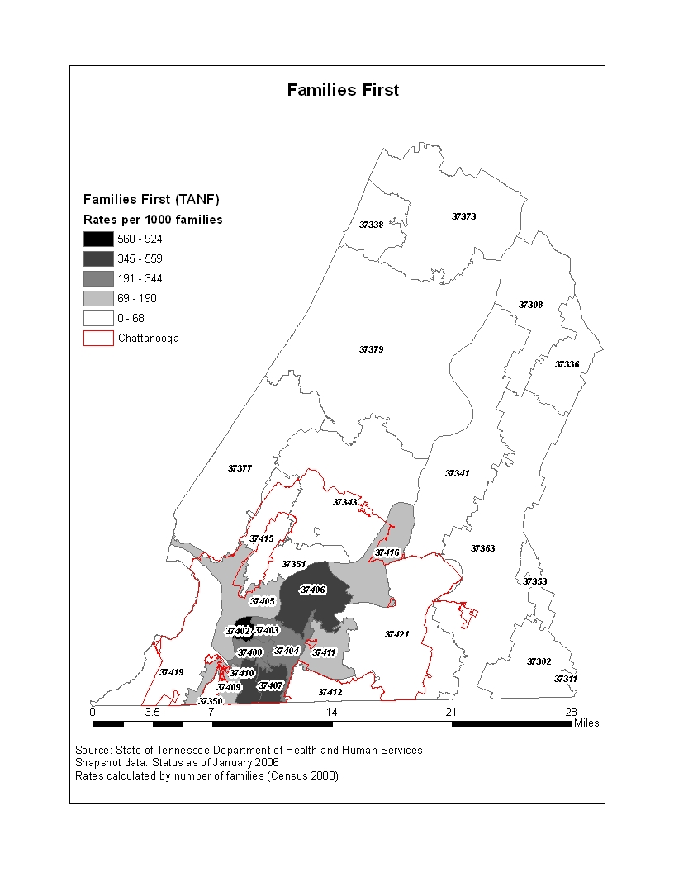

- The ten neighborhoods where Hamilton County public school students had the highest rates of eligibility for free and reduced lunch account for 30.2% of total public school enrollment and 49.9% of all eligible students. NOTE: The final report will include neighborhood level data on USDA reduced lunch programs for child care and other preschool programs.

Table 12
Reduced and Free Lunch Eligibility
 |  | Students eligible for free or reduced lunch (2004-2005)
Neighborhood Name | Total Students | Frequency | Percent | Rank
Ridgedale/Oak Grove/Clifton Hills | 1479 | 1335 | 90.3% | 1
Downtown/MLK/Southside | 757 | 683 | 90.2% | 2
Amnicola/East Chattanooga | 1475 | 1302 | 88.3% | 3
Bushtown/Highland Park | 1122 | 989 | 88.1% | 4
St Elmo/Alton Park/East Lake | 1673 | 1465 | 87.6% | 5
Glenwood/Eastdale | 1092 | 933 | 85.4% | 6
Tyner/Greenwood | 1134 | 804 | 70.9% | 7
Woodmore/Dalewood | 1663 | 1172 | 70.5% | 8
North Chattanooga/Hill City | 408 | 272 | 66.7% | 9
Brainerd | 885 | 580 | 65.5% | 10
Lake Hills/Bonny Oaks | 997 | 644 | 64.6% | 11
Northgate/Murray Hills | 977 | 570 | 58.3% | 12
Red Bank | 1122 | 613 | 54.6% | 13
Mtn Creek/Moccasin Bend | 664 | 357 | 53.8% | 14
East Ridge | 2325 | 1224 | 52.6% | 15
East Brainerd/Airport | 1149 | 546 | 47.5% | 16
Soddy Daisy | 1190 | 515 | 43.3% | 17
Stuart Heights | 608 | 262 | 43.1% | 18
Falling Water/Mtn Creek | 756 | 316 | 41.8% | 19
Collegedale | 1323 | 513 | 38.8% | 20
Riverview/Stuart Heights | 337 | 130 | 38.6% | 21
Harrison 2 | 1052 | 382 | 36.3% | 22
Birchwood | 975 | 342 | 35.1% | 23
Bakewell | 982 | 337 | 34.3% | 24
Apison | 722 | 234 | 32.4% | 25
Lookout Valley/Lookout Mtn | 823 | 252 | 30.6% | 26
Hixson | 1441 | 437 | 30.3% | 27
Dallas Bay | 1563 | 403 | 25.8% | 28
Harrison 1 | 843 | 213 | 25.3% | 29
Westview | 959 | 231 | 24.1% | 30
Hixson/Dupont | 562 | 133 | 23.7% | 31
East Brainerd | 860 | 187 | 21.7% | 32
Ooltewah/Summit | 1720 | 311 | 18.1% | 33
Middle Valley | 1133 | 198 | 17.5% | 34
Walden/Mowbray/Flat Top Mtn | 1251 | 203 | 16.2% | 35
Signal Mtn | 734 | 36 | 4.9% | 36
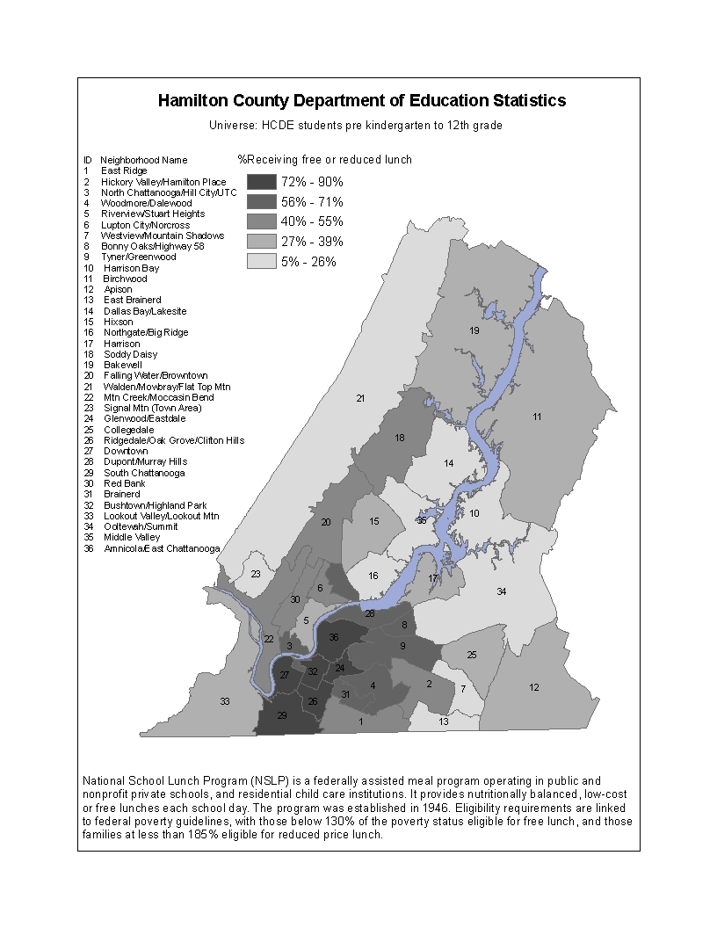

Barriers to Success: Single Parent Households

- Based on 2000 Census data, there were 2,211 households in Hamilton County headed by a single parent with children under the age of 6: 27% of all households in the county with a child under six were headed by a single parent.

- In Chattanooga, there were 1,589 households headed by a single parent with children under the age of 6: this represented 71.9% of all such households in the county and 40% of all households with a child under 6 in the city.

- Analysis of single parent households with children under the age of 6 by Census Tract

- Since 2000, the percentage of total births in the County to single mothers has been rising for both white and African American mothers: more than three out of four births to African American mothers in Hamilton County are to single mothers

Table 13
Birth statistics: Percent of total births to single mothers
Year | %White | %African American
2000 | 26.0% | 74.8%
2001 | 26.8% | 75.2%
2002 | 26.5% | 73.3%
2003 | 26.2% | 76.1%
2004 | 29.2% | 75.6%
2005 | 30.3% | 78.6%
Tennessee Department of Health

- Analysis of single parent births by neighborhood and by race

Barriers to Success: Maternal Educational Attainment

- 2000 Census data indicate that among all women with children in Hamilton County, 16% of whites and 19.6% of African Americans did not complete high school. College attendance among white women with children was more than three and a half times the rate among African Americans

Table 14
Educational attainment of women with children in Hamilton County
 | Did not complete high school | High school | 1 to 3 years college | 4 or more years college
White | 16.0% | 24.7% | 35.1% | 24.3%
African American | 19.6% | 42.0% | 31.6% | 6.9%
Source: 2000 Census Public Use Microdata

- Birth data for 2000 – 2006 indicate a rising percentage among both white and African American mothers who did not finish high school.

Table 15
Hamilton County birth statistics: Percent of births to mothers who did not finish high school
 | Y2000 | Y2001 | Y2002 | Y2003 | Y2004 | Y2005
White | 18.6% | 23.1% | 20.0% | 21.0% | 21.4% | 22.2%
African American | 35.1% | 34.4% | 35.5% | 33.2% | 34.3% | 36.8%
Source: Tennessee Department of Health

- Analysis of birth data by neighborhood and including 2006

Barriers to Success: Low Birth Weight Babies

- Analysis of low birth weight by geography, including neighborhood level and 2006 data

Table 16
Low birth weight*
Year | Hamilton |  | Chattanooga |  | Other Hamilton County
 | Total Births | %Low Weight Births | Total Births | %Low Weight Births | Total Births | %Low Weight Births
2001 | 4042 | 11.4% | 2535 | 12.9% | 1507 | 8.9%
2002 | 3882 | 12.0% | 2400 | 13.8% | 1482 | 9.1%
2003 | 3943 | 11.5% | 2463 | 12.9% | 1480 | 9.2%
Source: Tennessee Department of Health
*Note: Table will be updated with 2004, 2005, and 2006 birth data in next report draft.

- African American mothers – both those who are married and unmarried – have higher rates of low birth weight babies than white mothers in Hamilton County. The rate of low birth weight babies for unmarried African American mothers – who account for more than three-quarters of all African American births – is more than double the rate for whites.

- Race appeared to have more of an impact on likelihood of low weight births than maternal educational attainment

- Analysis of adequacy of prenatal care by neighborhood and including 2006 data

Table 17
Adequate prenatal care*
Year | Hamilton |  | Chattanooga |  | Other Hamilton County
 | Total Births | %Adequate Prenatal care | Total Births | %Adequate Prenatal care | Total Births | %Adequate Prenatal care
2001 | 4042 | 77.3% | 2535 | 74.8% | 1507 | 77.3%
2002 | 3882 | 78.3% | 2400 | 72.5% | 1482 | 87.7%
2003 | 3943 | 78.7% | 2463 | 75.3% | 1480 | 87.0%
Source: Tennessee Department of Health
*Note: Table will be updated with 2004, 2005, and 2006 birth data in next report draft.

Barriers to Success: Children of Teenage Mothers

- Analysis of teen pregnancy data by race, geography and including 2006 data

Barriers to Success: Children with Special Needs

- No data is collected by the Census for children under 5 and disabilities. For children 5 to 15 years old, 2000 Census indicated that 6.7% had one or more disabilities: the rate for boys (8.6%) was significantly higher than for girls (4.6%)

- Applying the overall rate to three, four and five year olds (assuming an annual cohort of 4,000 children), there would be 804 children with special needs

- In the 2004-5 school year, there were 302 three, four and five year olds enrolled in special education (excluding enrollment for intellectually gifted students) for Hamilton County schools

- Need updated data for 2006 HCDE special education enrollment

- Need special education enrollment by race and geography

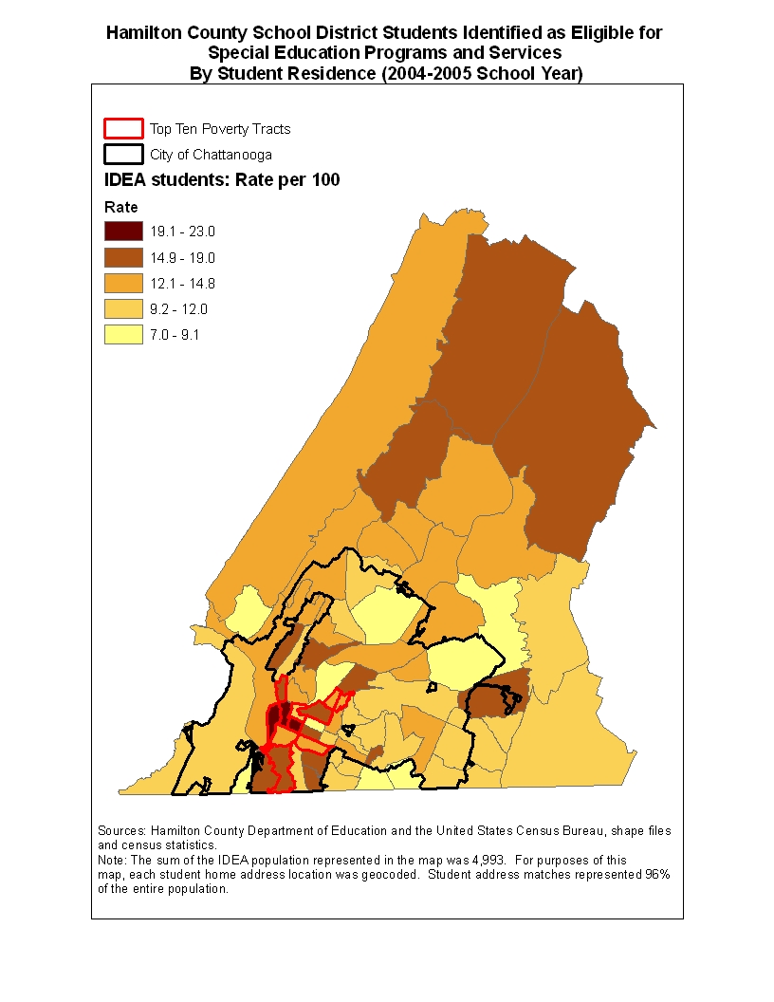

Barriers to Success: Children in the Child Welfare System

- Need up to date data on children in foster care by neighborhood and race

- Need up to date data on allegations of abuse and neglect by neighborhood and race
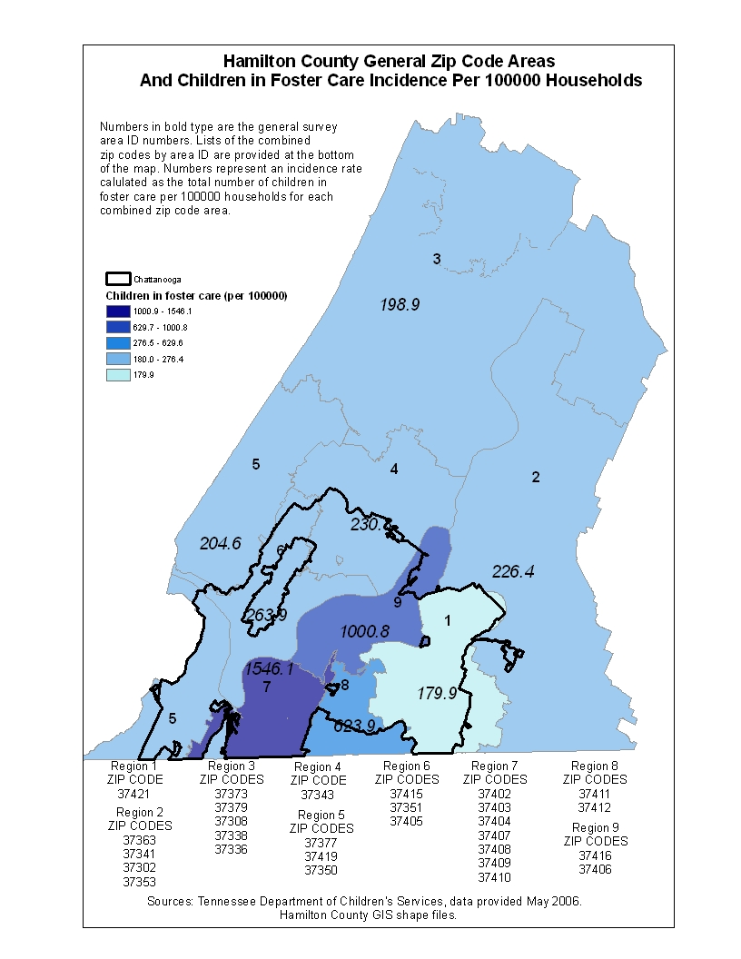

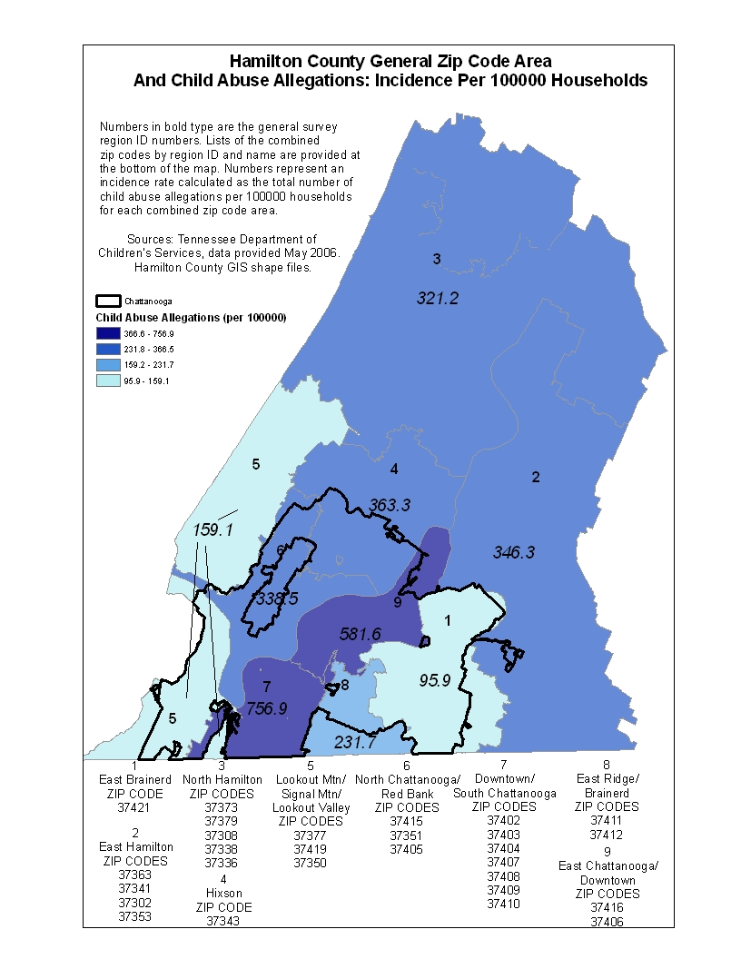

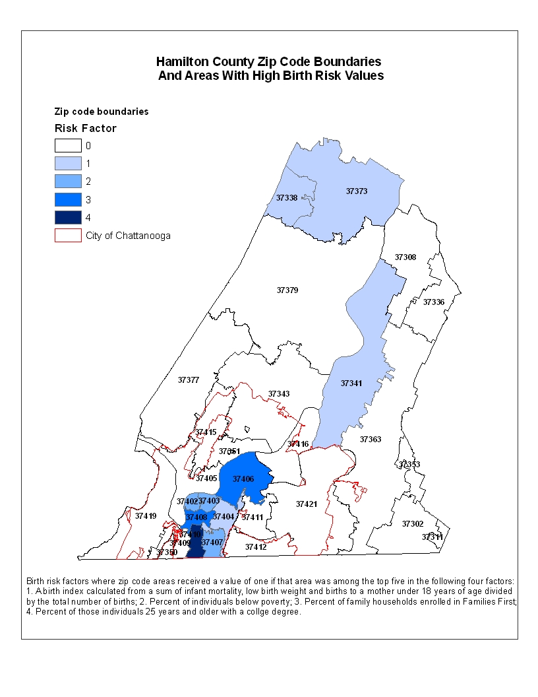

Interventions for Success: Child Care in Hamilton County

- Quality child care programs are – nationally and in Hamilton County – an important intervention to help children, especially those most a risk, to be better prepared for school and early grade success. In Tennessee, child care programs are rated based on a series of criteria by the State: three star quality is the highest rating.

- There are 141 licensed child care centers – each serving more than 12 children – with an enrollment of 7,884 children of five and under in Hamilton County: 69.9% of children are in three star quality centers.

Table 19
Center Child Care
Star Rating | Number of locations | Enrollment under 5 | Capacity (All Ages)
0 | 17 | 505 | 1012
1 | 1 | 28 | 46
2 | 17 | 978 | 1248
3 | 74 | 5512 | 6968
New* | 11 | 825 | 873
Not Participating | 1 | 36 | 36
Not Rated** | 20 | Not Available | 1929
Total | 141 | 7884 | 12112
Child care locations are those that include service to children under 5 years old
*A facility must be in operation for at least one year before a star rating is assigned
**Not rated is a child care location that is exempted from participating due to a religious affiliation

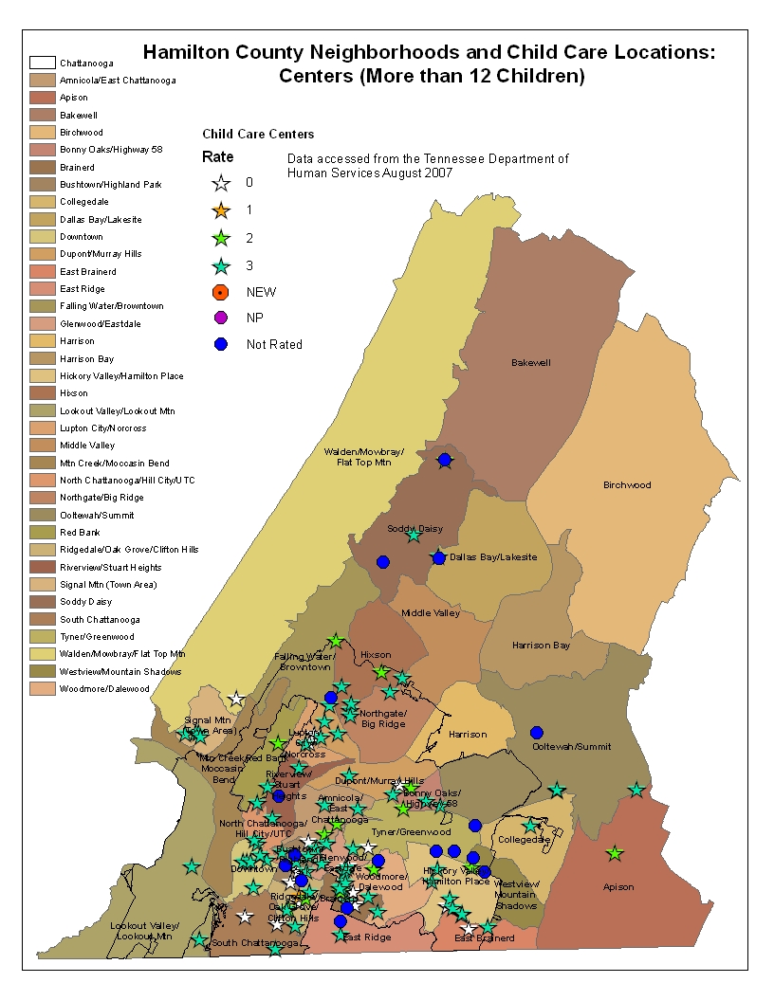
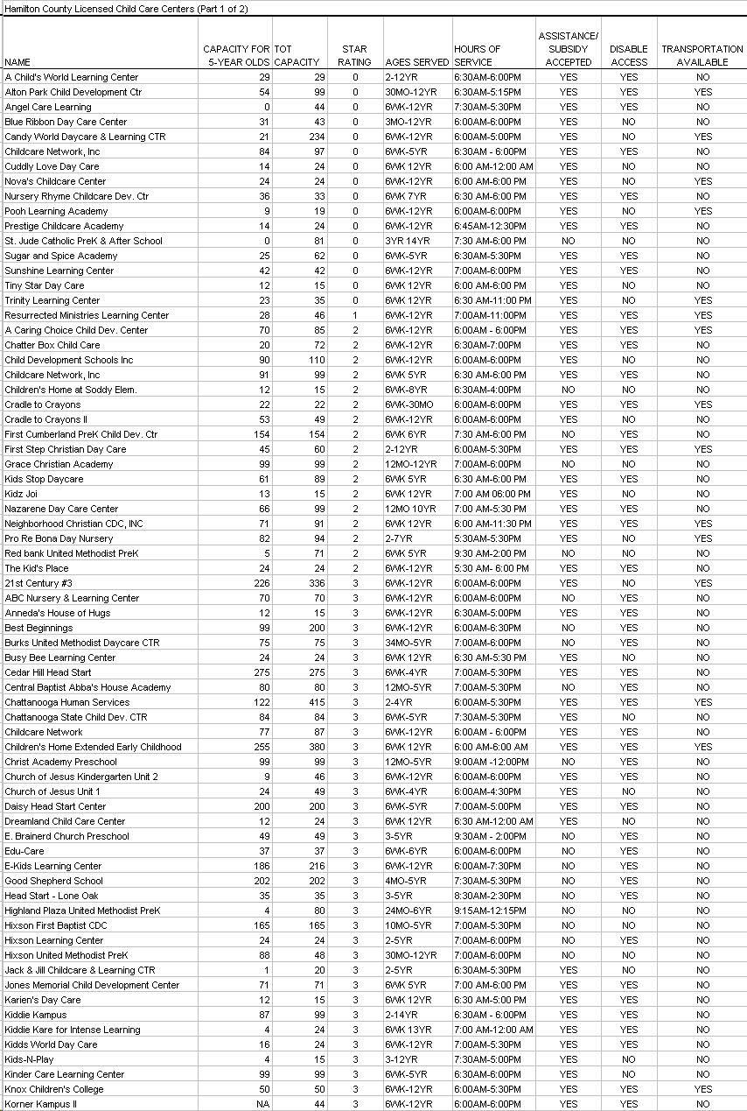
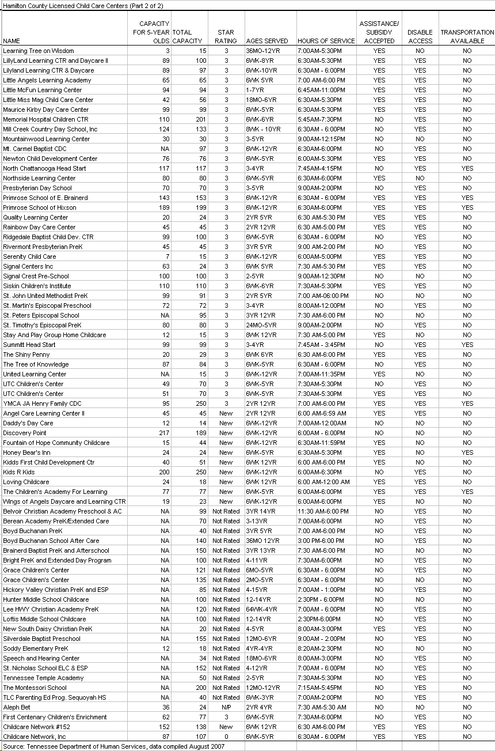

- Some child care is provided through family and group home care programs that are registered with the State. Family programs generally serve between five and seven children and group home programs generally serve between eight and twelve children.

- There are 64 registered and licensed family and group home programs in Hamilton County with enrollment as of August 2007 of 496 children under 5: 43.5% of children under five are in three star facilities.

Table 21
Family and Group Home Child Care
Star Rating | Number of locations | Enrollment under 5 | Capacity (All Ages)
0 | 5 | 38 | 45
1 | 1 | 12 | 12
2 | 11 | 79 | 99
3 | 30 | 216 | 280
New* | 15 | 144 | 145
Not Participating | 1 | 7 | 7
Not Rated** | 1 | Not Available | 12
Total | 64 | 496 | 600
Child care locations are those that include service to children under 5 years old
*A facility must be in operation for at least one year before a star rating is assigned
**Not rated is a child care location that is exempted from participating due to a religious affiliation

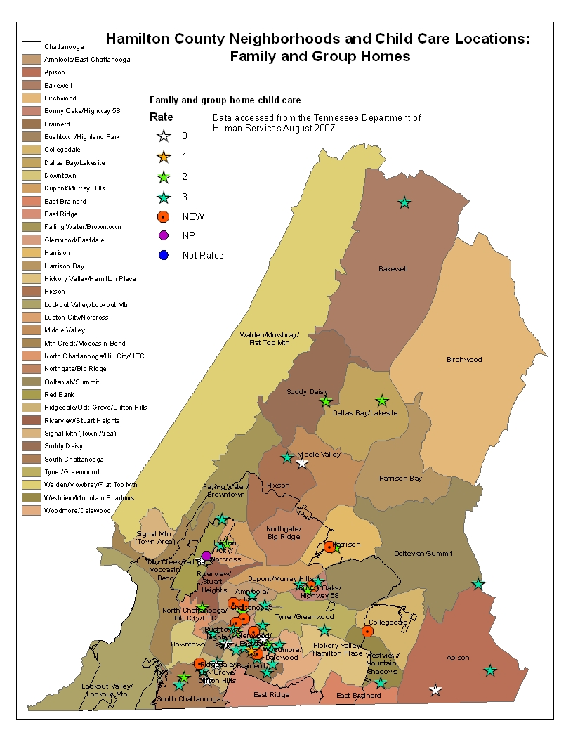

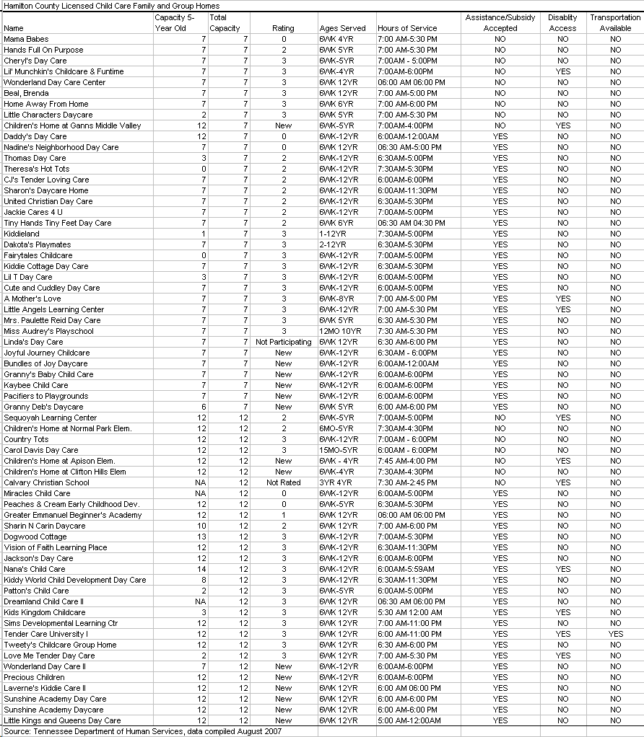

- Not all licensed child care services meet the needs of low income parents of small children. Out of the 205 licensed providers in the county, 134 provide eight hours or more of service and accept subsidies for child care. Overall,

Table 22
Child care services registered with TDHS available to children 5 and under, child care 8 hours or more of service, and accepts child care subsidies
 | Total | Star-rated | %Star-rated | 3-star | %3-star
Under 10 | 26 | 17 | 65.4% | 10 | 38.5%
11 to 25 | 48 | 31 | 66.0% | 26 | 55.3%
26 to 50 | 16 | 8 | 50.0% | 6 | 37.5%
51 to 75 | 8 | 6 | 75.0% | 4 | 50.0%
76 to 100 | 21 | 17 | 81.0% | 11 | 52.4%
101 to 150 | 5 | 3 | 60.0% | 2 | 40.0%
151 to 200 | 3 | 3 | 100.0% | 3 | 100.0%
201 to 300 | 3 | 2 | 66.7% | 2 | 66.7%
300 or more | 4 | 4 | 100.0% | 4 | 100.0%
Total | 134 | 91 | 68.4% | 68 | 51.1%

- Different parts of the county have different degrees of access to licensed child care programs in general and three star quality programs in particular

Table 23
Hamilton County child care facilities, capacity by zip code
Post office | Zip code | Child care facilities: Universe of facilities that include care for children 5 years and under |  |  | Total facility capacity (Under 5 years)
Post office | Zip code | Star rated | 3-star | Total facilities | Total capacity | %Star-rated | %3-star
Apison | 37302 | 2 | 1 | 3 | 48 | 75.0% | 25.0%
Birchwood | 37308 | 0 | 0 | 1 | 20 | 0.0% | 0.0%
Collegedale (PO Box) | 37315 | 1 | 1 | 1 | 99 | 100.0% | 100.0%
Georgetown | 37336
Graysville | 37338
Harrison | 37341
Hixson | 37343 | 16 | 13 | 20 | 1710 | 78.3% | 65.7%
Lookout Mountain | 37350 | 1 | 1 | 1 | 202 | 100.0% | 100.0%
Lupton City | 37351
McDonald | 37353 | 2 | 2 | 2 | 56 | 100.0% | 100.0%
Ooltewah | 37363 | 3 | 3 | 5 | 528 | 60.4% | 60.4%
Sale Creek | 37373 | 1 | 1 | 1 | 7 | 100.0% | 100.0%
Signal Mountain | 37377 | 7 | 7 | 8 | 491 | 91.4% | 91.4%
Soddy Daisy | 37379 | 5 | 2 | 9 | 402 | 75.6% | 67.2%
Chattanooga (Downtown) | 37402 | 3 | 3 | 4 | 696 | 86.4% | 86.4%
Chattanooga (Erlanger UTC) | 37403 | 5 | 5 | 7 | 521 | 81.4% | 81.4%
Chattanooga (Highland Park) | 37404 | 11 | 9 | 24 | 1406 | 45.4% | 35.4%
Chattanooga (North Chattanooga) | 37405 | 4 | 3 | 6 | 427 | 72.4% | 69.6%
Chattanooga (East Chattanooga) | 37406 | 16 | 11 | 27 | 1094 | 67.8% | 53.8%
Chattanooga (East Lake) | 37407 | 5 | 3 | 9 | 813 | 85.7% | 77.0%
Chattanooga (South Broad) | 37408 | 1 | 1 | 2 | 111 | 89.2% | 89.2%
Chattanooga (St. Elmo)
Chattanooga (Alton Park) | 37410 | 2 | 1 | 4 | 153 | 9.2% | 4.6%
Chattanooga (Brainerd) | 37411 | 22 | 17 | 36 | 1732 | 67.4% | 51.3%
Chattanooga (East Ridge) | 37412 | 1 | 1 | 5 | 348 | 20.4% | 20.4%
Chattanooga(Red Bank) | 37415 | 7 | 6 | 13 | 497 | 59.8% | 45.5%
Chattanooga (Highway 58) | 37416 | 9 | 5 | 16 | 539 | 66.0% | 27.6%
Chattanooga (Tiftonia) | 37419 | 2 | 1 | 3 | 134 | 85.1% | 11.2%
Chattanooga (East Brainerd) | 37421 | 10 | 9 | 20 | 1781 | 42.6% | 37.8%
Tennessee Department of Human Services: List of child care providers data compiled August 2007

Interventions for Success: Preschool Programs in Hamilton County

- Hamilton County Department of Education (HCDE) administers the county’s Tennessee’s Voluntary Pre-K Program. Children who meet free or reduced price lunch income guidelines, and are four years old by September 30th have priority for enrollment.

- HCDE also provides Title I Pre-K programs. These programs generally serve Title I designated schools, and can serve any preschooler in the specific school zone, regardless of income. Preference is given to students who: (a) have been deemed at risk based on a screening assessment; (b) are zoned for a Title I school, especially to a school that have not made significant gains on standardized test scores; and (c) are eligible for free and reduced lunch programs.

- There are a total of 900 pre-kindergarten slots in Hamilton County schools and programs run by Hamilton County schools.

- Analysis of waiting list for pre-kindergarten programs

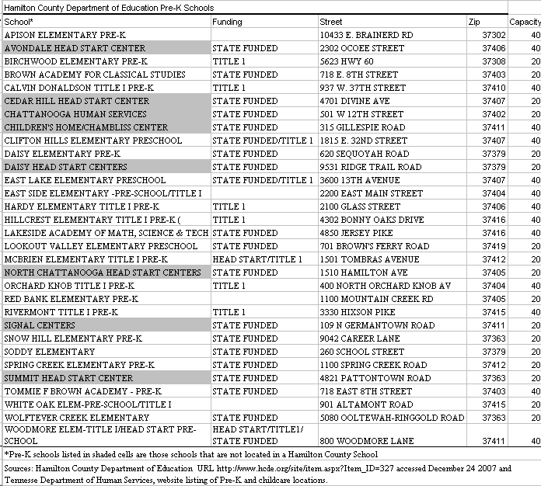

- Head Start is a federal program for preschool children from low-income families: in Hamilton County, it is administered by the Chattanooga Department of Human Services. In some cases, Hamilton County Department of Education Pre-K partners with Head Start: Head Start programs also partner with for-profit child care centers. Children who attend Head Start participate in a variety of age-appropriate educational activities, receive medical and dental care, have healthy meals and snacks, and enjoy playing indoors and outdoors in a safe setting. A minimum of ten percent (10%) of enrollment opportunities are offered to children with disabilities. Children in state custody or are homeless are given enrollment priority.

- Head start and early start programs serve a total of 768 children from households below 50% poverty. The average household wage of a Head Start/Early Start household is $5,068

Complete table below. Also, indicate overlap between Head Start/Early Head Start count and Pre-K student count if any.
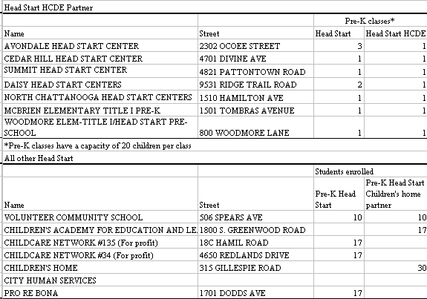

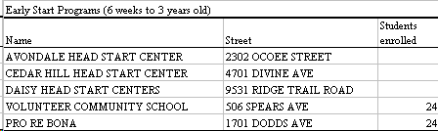
Partial data is also available on pre-kindergarten enrollment for private schools in Hamilton County. Private schools that provide PreK classes are all listed as licensed child care programs. Of the 15 schools, three participate in the star quality rating system. Two of the three have the highest quality rating of 3-stars.

Table 27
Private schools PreK enrollment
 |  | PreK Enrollment
INSTITUTION | Grade Levels | 2003-2004 | 2005-2006 | Licensed child care program status | Religion
BEREAN ACADEMY | PreK-12 | 32 | 40 | Not rated | Other religious
BOYD-BUCHANAN SCHOOL | PreK-12 | 40 | 58 | Not rated | Other religious
BRAINERD BAPTIST SCHOOL | PreK-5 | 58 | 58 | Not rated | Other religious
BRIGHT SCHOOL | PreK-5 | 51 | 51 | Not rated | Non Sectarian
CALVARY CHRISTIAN SCHOOL | PreK-12 | 8 | 8 | Not rated | Other religious
GRACE BAPTIST ACADEMY | PreK-12 | 16 | 16 | Not rated | Other religious
HICKORY VALLEY CHRISTIAN SCHOOL | PreK-8 | 19 | 19 | Not rated | Other religious
INNER CITY CHRISTIAN ACADEMY | PreK-3 | 18 | 18 | 3-star | Other religious
MONTESSORI SCHOOL | PreK-8 | 99 | 99 | Not rated | Non Sectarian
NEW SOUTH DAISY CHRISTIAN ACADEMY | PreK-12 | 6 | 6 | Not rated | Other religious
OOLTEWAH ADVENTIST SCHOOL | PreK-8 | 6 | 5 | Not rated | Other religious
SILVERDALE BAPTIST ACADEMY | PreK-12 | 206 | 206 | Not rated | Other religious
ST JUDE ELEMENTARY SCHOOL | PreK-8 | 36 | 36 | 0-star | Catholic
ST NICHOLAS SCHOOL | PreK-5 | 34 | 34 | Not rated | Other religious
ST PETERS EPISCOPAL SCHOOL | PreK-5 | 50 | 50 | 3-star | Other religious
Total |  | 679 | 704
Source: National Center for Education Statistics

Other Interventions for Success

Parents Are First Teachers: This is a home-based program that uses Born to LearnTM Curriculum designed for early childhood education and age appropriate activities for ages 0 to 5. The Parent Educator uses these resources in the home for activities during a monthly visit. In addition to the activities performed during the home visit, follow-up materials can be made available for parents to refer to as they interact with their child apart from the home visit. The program requires that a parent or guardian engage with the Parent Educator during an approximately one hour period dedicated to learning about their child and the types of support needed to create a learning environment in the home. PAFT provides services to approximately 200 children annually.

Neighborhood Reading Centers : In thirteen communities, Centers provide books, literacy activities, and parent education to families within each community. AmeriCorps members serve in child care and Neighborhood Reading Centers to assist children and families with literacy skills. Volunteers are trained by United Way to work with children in neighborhood reading center libraries during the summer months. Each year approximately 15,000 children of all ages use the reading centers to borrow books that are on summer reading lists provided by the school they attend during the school year.

READ 20: Read 20 is a public/private partnership promoting literacy skills for early childhood, in an effort to create a community of readers, and in support of Hamilton County’s community literacy goals: at least 95% of all Hamilton County children will read at or above grade level by the end of the 3rd grade and thereafter will maintain or improve their grade level equivalence.
Strategies for Read 20 are the following:
1. Increase public awareness on the value of reading with infants and young children for 20 minutes or more each day and its impact on personal success and economic vitality in the community.
2. Convene community, faith-based organizations, businesses, educators, and parents to support efforts in improving early childhood literacy being made across the community
3. Create and maintain an early childhood literacy network that provides strategies and support for parents, teachers, and other community/business members who want to engage children in reading
4. Conduct research and focus groups in the community to better understand local reading behaviors, and to set benchmarks for improvement.
5. Engage community in ongoing benchmarking process.
6. Create an effective grassroots outreach for community change through participation by parents, early childhood educators, and members/leaders of faith-based, community, and business organizations.

Coordination and Support Initiatives:

- Governor’s Books From Birth Foundation
- The United Way’s Project Ready for School program provides curriculum support to child care centers in the community. Ages and Stages. screenings are offered to children at events and child care centers to gauge how children’s language, cognitive and motor skills are developing: in the last 3 years, 1700 screenings have been provided to children in Hamilton County. PRFS also provides training and materials to 15 family child care providers to enhance implementation of curriculum to provide appropriate learning experiences for their children.
- Through the Signal Centers, the local Childcare Resource and Referral Network (CCRRN) in Chattanooga provides technical assistance, consultation, materials and resources to child care providers on developmentally appropriate practices, and health related issues and practices. The local Network is a member agency of the National Association of Child Care Resource and Referral Agency (NACCRA) and serves an 8-county region with resources for children with disabilities, onsite consultation to assist parents and child care providers in problem solving child care, health and inclusion issues. Chattanooga’s CCRRN offers 70 to 80 hours of child care training each quarter with 922 people attended training in the last quarter (October-December 2007). The Network also provides a lending library and resources to assist parents seeking child care.
Early Intervention:
Signal Centers, Inc. serves both typically-developing children and those with disabilities/special needs birth through age 5. Low student-to-teacher ratios are maintained, thus enabling individualized attention. Speech, feeding, occupational, and physical therapy are offered in the classroom, and teachers often incorporate these therapies directly into classroom activities. Signal centers provides child development assessments and recommendation for assistive technologies and free loans of adaptive toys. The Children’s Program has over 150 children serviced by the three sites.
Siskin Institute is a child care center for serves both typically-developing children and those with disabilities/special needs including children with developmental delays, cerebral palsy and autism spectrum conditions. The Institute provides education and outreach programs, pediatric health care, and ongoing research in the field of disabilities. Southeast North GA North AL The focus of the AT Center is to promote the incorporation of technology in the lives of people dealing with any disability. Technology is utilized to empower people with disabilities – giving them both control and choices in all aspects of their lives.
The Speech and Hearing Center provides free speech/language screenings for children 5 and under.
Tennessee Early Intervention System. The Tennessee Early Intervention System (TEIS) is Tennessee’s program for Part C of IDEIA. This program coordinates services for children from birth to three. Extensive Transition Planning is required for children exiting this system. The Tennessee Early Intervention Data System (TEIDS) system is used to track children, birth to three, as they enter and progress through the Part C of IDEA system. A KEY focus of the system is the availability to further track these children as they move through their educational experience. The system linkage to other Department of Education data systems allows for the tracking of compliance timelines as well as educational outcomes for the children who participated in Tennessee’s Early Intervention System.
Preschool Programs
Hamilton County Department of Education Pre K. All programs are designed to serve “at risk” students. Preference is given to students who score in the red and yellow areas of the FirstStep screening instrument and students who are zoned for a Title I school, especially to a school that is identified as “on notice”. “On notice” schools were identified by the Tennessee State Department of Education as schools that have not made significant gains on standardized test scores. (Section 1115(b), ESEA). Other students who meet 2006-2007 federal income guidelines for free and reduced lunch qualify for the PreK program. In addition, children who participate in Head Start preschool programs, homeless children, and children in institutions for neglected or delinquent children are eligible.
Other considerations can be children who are in state custody, ELL, and students who may have other at-risk factors if there are not enough students who meet the first criteria.

Health Initiatives: A number of health programs in the community specifically focus on young children. These include:

- Ronald McDonald House: Mobile Medical/Dental/Vision Care visiting public school sites

- Hamilton County Health Services Children’s Special Services (CSS): Program offered to children who have a chronic illness or medical condition which may affect their ability to function independently.

- Hamilton County Health Services HUGS Program: HUGS is a home-based prevention and intervention program targeting first-time pregnant girls/women. Prenatal/postpartum women are provided services to prevent or reduce complications of pregnancy, subsequent unplanned pregnancies, low birth weight babies, developmental delays in unborn children, maternal and/or infant morbidity and mortality. Staff focuses on parenting skills and safety issues and assists the client in accessing and utilizing appropriate health care and other social educational services through coordination and collaboration with community resources.

- Hamilton County Health Services TENNderCARE: Check ups and health care services for children ages birth to twenty one who have TennCare. Hamilton County’s EPSDT (Early, Periodic Screening, Diagnosis and Treatment) Outreach Program is staffed by a supervisor, health educators, and part-time lay outreach workers. Home visits to children who are delinquent in receiving their EPSDT check-ups are provided by the lay workers.
Measuring the Success of Interventions

- Different child care programs and pre-school programs in Hamilton County use various different instruments to assess development of pre-school children.

- Not every program, however, is required to conduct an assessment. Children in Head Start, HCDE Pre-K, PAFT and child care programs in the Project Ready for School program are a minority of total children in child care in the county. There are no assessment requirements related to licensing or receipt of funding through child care subsidies or reduced or free lunch programs.

- Generally, information about assessments conducted while children are in child care or a pre-school program are not shared with their public school at the time of entry into kindergarten: children going from HCDE pre-kindergarten programs to HCDE kindergarten programs are the exception to this general rule.

- While HCDE conducts a First Step assessment of children entering kindergarten, there is no consensus that the First Step represents a measurement of readiness to learn. Instead, it is merely used as a tool for teachers to determine whether there may be a need to provide additional services to the individual student. First Step scores are not shared with the student’s parent or parents.

- Every child in HCDE kindergarten programs does receive a regular assessment through a report card. This is the only measurement of school performance that is shared with the student’s parent. Currently, there is no centralized collection of data related to these assessments.

- In other words, there is no current means of assessing the percentage of children entering public school who are “ready to learn” either at the point of entry into the public school system or during their first year in school.

- There is also no accepted means of measuring the relative success of different intervention programs at the local, operational level – either for the overall population or for subgroups within the population (e.g. low income children, children of parents with low maternal educational attainment)

APPENDIX A
Information About Data Collected For Chattanooga-Hamilton County Core Indicators of School Readiness

Education services
Source/Agency | Available data | Data access | Notes | Geographic identifier
National Center for Education Statistics | School enrollment  Pre K enrollment  Public Private school race/ethnicity and gender  Private school Religious/Sectarian Pre K enrollment  Professional affiliation Teacher/student ratios | Information on all U.S. public schools. The data is collected annually directly from State Education Agencies (SEAs). |  | School
National Association for the Education of Young Children | Early Childhood programs with NAEYC accredited | Available on a NAEYC web site
Tennessee Department of Human Services | PreK programs  School capacity | Information is made public on the TDHS website |  | School
Tennessee Department of Education | Public school teacher credentials and waivers by grade level (K-1) |  |  | School
Hamilton County Department of Education | School enrollment  Student residence Third grade standardized test scores, Free reduced lunch eligibility IDEA students | School data can be coded by student residence and aggregated to neighborhood level |  | Neighborhood
Hamilton County Department of Education Pre K | First STEPS assessment scores for school readiness  Teacher accreditation  Total capacity | First STEPS results cannot be accessed | Although school readiness test scores are collected, the instrument is not deemed reliable by the Director of HCDE preschools and will not release scores | School
Head Start/Early Start | Children enrolled under the age of 4 |  |  | School

Health services
Source/Agency | Available data | Data access | Notes | Geographic identifier
Centers for Disease control | Month prenatal care is sought |  |  | County
Tennessee Department of Health Birth Data | Low birth weight, pregnancies by age, mother’s educational attainment, marital status and parent risk factors | Information can be accessed online on the TDOH website |  | County
Tennessee Department of Health | Low birth weight, pregnancies, infant mortality, mother’s age | Special request for birth statistics |  | Zip code
Tennessee Department of Health, Special request | Low birth weight, pregnancies, infant mortality, race/ethnicity, country of origin | An IRB application was submitted successfully and was required to access birth data | All of the data is not yet provided. We expect to have this for the final report in May | Address level to be aggregated to a level that preserves confidentiality
Tennessee Department of Human Services | Households on TennCare (Medicaid)  SCHIP | Special Request: Data is a snapshot in time |  | Zip Code
Chattanooga Hamilton County Health Department | Birth Data, Immunizations  Lead | Special request: immunization rates | Other information requests have received a negative response due to HIPAA concerns | Immunization rates at county level

Poverty
Source/Agency | Available data | Data access | Notes | Geographic identifier
Tennessee Department of Health and Human Services | Families First (TANF) | Number of families on TANF |  | Zip Code
Tennessee Department of Health | Women Infants and Children | Total number participating in the WIC program on the TDH website |  | County
Department of Health and Human Services | Food Stamps | Special request: Snapshot in time Number of families on food stamps |  | Zip code

Foster care/Child abuse
Source/Agency | Available data | Data access | Notes | Geographic identifier
Tennessee Department of Children’s Services | Foster Care | Number of Children in Foster Care |  | Zip Code
Tennessee Department of Children’s Services | Allegations of Child Abuse | Number of allegations of child abuse |  | Zip Code

Child care services
Source/Agency | Available data | Data access | Notes | Geographic identifier
Tennessee Department of Human Services | Licensed Child Care Providers | Capacity, Ages served, quality as measured by the 3-star program, accepts subsidies for Families First. The 3-Star program is graded based on multiple factors including director and staff credentials and training | Data is readily available on the TDHS web site for each location. Information is a snapshot in time that is constantly updated. Problems are related to the number of legislation that permits religiously affiliated schools autonomy from any state recommended curriculum or other educational standards | Address
United States Department of Agriculture food reimbursement program | Unlicensed child care providers | Overall estimate can of providers be provided at county level. Unlicensed providers can serve up to 4 children. | USDA provides nutritional support for licensed as well as unlicensed providers | County
Chattanooga Housing Authority | Children in public housing by type of child care |  |  | Public housing complex

APPENDIX B

School Readiness and Early Grade School Success

Advisory Board Meeting Notes

October 30, 2007

Introduction of CRC and our affiliation with NNIP and the NNIP initiative on Early Childhood Development.

Introduction of attendees, gathered information on their organizations including, but not limited to their mission, population serviced, data collection issues, and connections with other ECD organizations.

Discussion was directed around who are not currently but should be present at board meetings, what data sources are currently available, and which data/information they would benefit from that is not currently available.

Members of interest for addition to board meetings included:
- Brenda Benford of HCDE
- Emily Perrine of TN Childcare Licensing
- Jackie Hill or Linda Garrett of Chattanooga State Early Childhood program.
- Ava Warren

Available data sources:
- Housing authority: collects data on number of children, age, and current childcare service provided
- Head Start: collects data and serves approx. 60% of children under the age of 4
- Juvenile Court: could be a source for statistics on children neglected by parents
- USDA food reimbursement program: requires childcare providers to fill out an annual report consisting of the number of children, their age group, and income level
- Family operated childcare can be done without a license for up to 4 kids. Lack of data collected concerning these children.
- Homeless children with unregulated care, lack of data for this population as well.

Useful data to have/data not currently available:
- How to determine learning disabilities, autism, behavioral issues, moderate vision and hearing problems, and fetal alcohol use?
- How we invest as a community in children from infancy to 3 years old. What is the return?
- How to determine if drop-out kids are overage for their grade level?
- How to determine mental health issues? Is mental health based on biological or environmental factors?
- Hispanic children population
- Effect of methamphetamine on infants and children.
- The number of disabilities in children is increasing. How does early Head Start from age 0-5 and 3-5 make an impact on these children? What are the impact of the family structure and the educational levels of the parents on these children?
- Involvement of fathers with their children.
- Impact of childcare programs based on the quality of the program and the learning environment.
- Redefinition of “at risk” children. Concentrate on the middle class family who are excluded from most of the benefits provided by the government.

Established an estimation that Chattanooga has around 20,000 kids under the age of 5.
Also learned that Chattanooga State provides a 2-year associate degree in Early Childhood Development.

November 28, 2007

Discussion centered on demographics of the under 6 population in Hamilton County, potential barriers to early grade success and school readiness, interventions for school readiness, and measures of school readiness.

Points brought up in discussion of number of children in Hamilton County:

- Data on number of children under 6 years old from HCDE – updated often
- Kindergarten numbers (public, private, or home school) should be close to birth data, with the addition of in-migration.

Points brought up in discussion of barriers to early grade success:

- Homeless data from service point or from HCDE or childcare centers
- Children on WIC data
- Special needs children:
  - Data from TN Early Intervention Services (TEIS) on children already identified
  - Childcare centers must report number of special needs children for licensing purposes. But number is very fluid and under-identification is a problem.
  - Head start identifies special needs children but does not do much else. Data and service gap here.
- English language learners need a section here.
- Children in foster care:
  - Relative caregiver program – a growing population of around 250 children, data broken down by ages.
  - Private placed in care – a small population of around 50-100 children ages 0-18.

Points brought up in discussion of interventions to school readiness:

- TN Early Learning Standards – based on developmental levels but early childcare centers don’t talk to school about them
- No accepted definition of “readiness”. However, the instruments to develop such a definition are available.
- General population of childcare programs do not have a regimented assessment schedule.

December 14, 2007

At this meeting, discussion centered on measures of school readiness, such as: how do intervention programs measure readiness, how does HCDE measure preparedness, and what are the right measures of early grade success?

Current assessments of children include:

- Ages and stages (Pre-school, PAFT, United Way)
  - Required assessment of Pre-school programs applying for NACTE accreditation.
- First Step (HCDE)
- Creative curriculum (test used by Head Start)

No assessment is required by state licensing or USDA food program.
HCDE federal grantors require some assessment.

HCDE current assessments used:

- First Step: pre-K through 7th grade, different versions based on age.
- Bracken: beginning and end, to track growth
- OWL curriculum
- IGDI: every month
- Contracts: before Kindergarten
- Ongoing teacher observation and notes

1000-1200 out of 3500 children each year had some assessment through Head Start or United Way childcare. Others are in private care or at home.

Assessment data that is passed from childcare centers to public schools should be concise and objective. Creation of useable documents is key.
Some schools do ask for childcare history, but there is no uniform form used.

First Step is not comprehensive and does not yet employ a social-emotion rating scale. Next year this scale will be added and parents will be asked to do this assessment at home with teachers following up in the classroom.

First Step is a screening, not a true assessment because it only identifies characteristics that may require further in-depth assessment. First Step does a good job at what it is designed to do. Teachers do not get a copy of First Step scores.

Reminder that assessment is a snapshot only because 3-5 year olds change very quickly.

Locally, we do not have a good measure for school readiness.

January 16, 2008

The agenda for this meeting was to discuss the system scan draft produced and distributed prior to the meeting. Specifically wanted to get opinions on missing data. Discussion varied greatly and many different points were raised.

- National Association for the Education of Young Children (NAEYC) – offers national accreditation to childcare centers. Considered better than the state evaluation system because it is more extensive. Also more expensive, but important in grant applications. Cost is a factor for childcare centers and some choose not to be re-accreditated after 5 years. NAEYC also requires a number of staff to have certification as a Childcare Professional Associate (CDA) and that imparts additional cost on the employer to pay for employee training and maintaining the certification.

- They see very few connections between public schools and the childcare community.

- Problem with assuming that accreditation will result in measurable outcomes. Does accreditation make a difference? Is this difference measurable? What outcomes should be measured?

- Evidence-based outcomes are the trend.

- Local community centers have set up neighborhood reading centers. Could expand on this with involvement by the neighborhood clinic and the neighborhood association.

- Summary of licensing requirements given to each parent who enrolls their child in a center. They also receive a list of indicators to look for, but this information varies from center to center.

- Parent educators – for parents with children ages 0 to 3. Develops a trust relationship with the parent.

- Density of services is a problem, such as with Parents as First Teachers

- No reimbursement from the state to Chattanooga for the Governor’s Pre-K program, except for teacher’s salary.

- Basic Education Plan (BEP) – the state formula for how much money the community/county receives for education expenses.

- Problem with a non-universal, eligibility-based, targeted Pre-K is a separation of classrooms.

- Pre-K programs within community childcare are more like public school in that they do not have the stigma that eligibility-based Pre-K programs carry.

- Establish targeted Pre-K based on at-risk neighborhoods rather than at-risk households.

- Need to education community about services that get the child ready to succeed in school. Programs need to communicate who they are serving and who they are not.

- Analysis of where money comes from now to support local Pre-K programs (City of Chattanooga Human Services) in order to make projections for universal Pre-K.

APPENDIX C

School Readiness and Early Grade School Success
Advisory Board

Anne Gamble
Director, Project Ready for School
University of Tennessee at Chattanooga

Judy Sisk
Child Care Resource Referral

Bobbie Grantham
Child Care Resource and Referral

Donna McConnico
Signal Centers, Inc
Early childhood and children with disabilities

Shawn Kurrelmeier-Lee
Chief Reading Officer Read 20
Hamilton County Government

Linda McReynolds
Vice President of Organizational Development
United Way

Linda Daniel
Program Supervisor
TN Department of Human Services

Emily Perrine
Child Care Licensing Supervisor
Tennessee Department of Human Services

Beverly McKeldin
Manager: Child Care Programs
Chattanooga Headstart

Dr. David Cook
Director of School Operations
Siskin Children's Institute

Harold H. Baker
Deputy Director
Orange Grove Center

Phil Acord
President/CEO
Children's Home/Chambliss Shelter

Kathy Daniels
AECF Regional Representative
Tennessee Commission on Children and Youth

Debra Vaughn
Data analyst
Public Education Foundation

Jackie Hill
Associate Professor: Early Childhood Education
Chattanooga State College

Brenda Benford
Director
Hamilton county Department od Education Pre K Programs

Community Research Council

David Eichenthal
President/CEO

Eileen Robertson-Rehberg
Data Analyst

Shelby Kain
Research Assistant

Sunitha Siddaramu
Intern

http://tennessee.gov/education/prek/doc/OEL_FAQs.pdf

