  June 2008 | Local Policy Research and Advocacy Support  School Readiness and Early Grade Success  School Readiness Policy Brief  Cuyahoga County, Ohio

Assessing Factors Influencing School Readiness
Claudia Coulton & Rob Fischer
with Paige Hardy, Nina Lalich & Kristen Mikelbank
As part of a cross-site initiative funded by the Annie E. Casey Foundation, an analysis was undertaken to examine the school readiness and early care in Cuyahoga County, Ohio. Conceptually, the project takes stock of existing data in comparison to data needs and is designed to inform a local plan for closing the gap between the two, with a clear link to influencing the dialogue around and policy linking to school readiness. The analysis confirms the elevated risk levels of children residing in higher poverty areas in Cuyahoga County and shows that targeted services are reaching more high risk children in those areas, while services of a more universal nature are reaching children uniformly across the county.

The concept of school readiness typically refers to children arriving at kindergarten cognitively, socially and emotionally ready to learn. In many communities there are disparities in school readiness related to race, income and geography. What does it take to overcome these disparities? In short, it requires a community to recognize the importance of investing in its youngest children and the information and resources to target these investments where the need exists, using practices and programs that can work.

The purpose of this brief is to identify where the gaps in school readiness are likely to exist and assess the capacity of the systems serving young children and families to reduce these gaps. Specifically, the brief will examine the status of Cuyahoga County’s young children and their families on a number of measures of risk known to negatively correlate with school readiness. To do so, we need to know who is at risk, where are they living, and how great the socioeconomic and racial disparities are. Moreover, the brief will also evaluate the observed capacity of the systems serving young children to reduce the disparities in school readiness. This explores the extent to which these systems are reaching at risk children and their families, whether they are being reached early enough by high quality programs and services, and whether the system provides the kind of continuity that sustains progress.

The analysis is organized along several dimensions. One dimension is socio-economic based on the knowledge that low income children are at particularly high risk for problems with school readiness. In this brief, neighborhood child poverty rates are used as a proxy for the socio-economic status of these families. A second dimension is geography because access to and quality of programs and services may differ by geographic area, and there may be pockets of risk factors that are spatially clustered. The third dimension is the stage of child development involved. There are differences between prenatal, newborn, infant, toddler, preschool and school-age children in regard to risk factors, and in their service needs and the systems that affect them.

The Early Childhood System
In a sense, school readiness is the culmination of development from prenatal to school age, and is influenced by a variety of personal, social, and environmental factors. There are many elements of a service system that are required to support optimal development for all children regardless of socio-economic status or geography. A conception of this system appears in Figure 1.

Early Childhood Development System
Comprehensive health services
that meet children
’
s vision,
hearing, nutrition, behavioral,
and oral health as medical
health needs
Early care and education
opportunities in nurturing
environments where children can
learn what they need to succeed
in school and in life.
Economic and parenting
supports to ensure children
have nurturing and stable
relationships with caring adults.
Early identification, assessment
and appropriate services for
children with special healthy
care needs, disabilities, or
developmental delays.
Early Care
and
Education
Health, Mental
Health and
Nutrition
Family
Support
Special Needs
Early Intervention
Adapted from Building an Early Childhood System, National Governors Association Center for Best Practices,
Early Childhood Systems Working Group, 2007.

Figure 1 Conceptual Model of Early Childhood Development System
As this figure suggests, young children require effective parents, high quality child care and preschool education, health insurance and a medical home, mental and behavioral health services and early identification and assistance with special needs. In Cuyahoga County, the Office of Early Childhood (Invest in Children) and its partner agencies have been actively engaged in meeting the needs of children across these domains. For example, the effort delivers a number of home visiting programs that are key components supporting effective parenting. These include prenatal home visiting for at risk mothers, a universal newborn visit for young mothers and first time mothers, ongoing home visiting for families who could benefit, and early screening and services for special needs children. Outreach programs ensure that almost all eligible children in the County are enrolled in Medicaid and there is a focused pilot program to help families establish a medical home. Child care has been expanded to try to meet the demand and quality improvement programs address the professional qualifications and capacities of child care providers. Caregivers of children with special needs receive consultation and technical assistance. In addition, there is a pilot program underway delivering universal pre- kindergarten to over 1,000 children in selected settings.

To better understand the current system for promoting school readiness and assessing the current data availability in Cuyahoga County, a system scan was completed (Coulton & Fischer, 2008). The scan examined local initiatives and data across nine domains, as well as the interconnections between the domains. These domains are: (1) home visiting/family support/parent counseling, (2) foster care / child protective services, (3) registered child care, (4) Head Start, (5) state and local pre-k, (6) Medicaid, SCHIP, EPSDT, (7) immunizations, lead screenings, (8) IDEA (Individuals with Disabilities Education Improvement Act), and (9) kindergarten instruments to assess school readiness. The systems scan for Cuyahoga County found that there is a concerted movement underway to better integrate and coordinate the various parts of the system and that there is a wealth of data available across the system but at present it is only partially available to inform systems-level decision making. In addition, the formulation of a seamless system from birth to kindergarten is challenged by various structural and institutional factors, such as programmatic targeting, multiple funding streams for services that have categorical limitations on use, traditional issues related to agency turf and institutional history, and federal legislation and mandates related to service provision and data access (i.e., HIPAA, FERPA).

The analysis focuses on three primary questions. First, how do child risk characteristics differ across geographic areas based on the level of child poverty in that area? Second, to what extent are services targeted to the early childhood population reaching the population in need? Third, what does the evidence suggest about the early outcomes in regard to school engagement and performance related to these factors.

Risk factors for school readiness
The examination of specific child risk factors is in part dictated by data availability. Table A displays risk factors that will be examined in this brief. Some of them can be broken out by stage, while others can only be calculated for children under 6 as a group. Some of the risk factors can be examined by census tract level or neighborhood, while others cannot be broken down geographically below the county level. Thus, although the conceptualization suggests that it is desirable to examine both risk factors and system resources by stage, geography and socio-economic status of the neighborhood, this is not possible in all cases. Nevertheless, this brief will identify clusters of risk and parts of the system where gaps may occur. The reference period for the indicators varies by data source due to release delays from data providers and/or processing time requirements.

TABLE A Child Status Indicators by Tract/Neighborhood - Risk
 | High Poverty | Moderate Poverty | Low Poverty | County  Total
Number of census tracts | 115 | 89 | 297 | 501
Birth rate to teen mothers (age 15-19) per 1,000 women  % low birth weight births  % births to women without high school diploma  Rate of child maltreatment (reports) per 1,000 infants  Rate of child maltreatment (substantiated/indicated) per 1,000 infants  % of children with elevated blood lead level (>10mcg)* | 66.7  13.6  39.1  231.4  56.7  11.8 | 60.8  12.6  25.6  143.0  29.3  7.8 | 15.9  8.1  6.5  46.2  10.3  1.8 | 40.2  10.3  17.1  92.0  21.3  8.5
* Indicator was calculated at the neighborhood/municipality level and not at the census tract level.

To use the analysis to distinguish between poverty conditions, the census tracts in Cuyahoga County were arrayed into three strata according to the level of child poverty for children under age 5 in 2000: high poverty was defined at 40% or higher, moderate poverty was defined as 20-39.9%, and low poverty was defined as less than 20%.

On six indicators of risk across several domains, risk levels are positively associated with the level of child poverty. Comparing the high poverty to the low poverty areas, expectedly the level of risk is substantially higher in the high poverty areas: birth rates to teen mothers (4.2 times higher), low birth weight births (1.7 times higher), births to women without a high school diploma (6.0 times higher), child maltreatment rate in reports (5.0 times higher) and substantiated/indicated reports (5.5 times higher), and elevated blood lead levels (6.6 times higher).

Measures of service use
A second set of indicators examined the availability and use of specific services in the community intended to improve child well-being and development during the early years. These indicators reflect services for which data access is currently available. They include child care, Medicaid health insurance, early intervention services, newborn home visiting, ongoing home visiting, and child care vouchers. See Table B.

TABLE B Child Status Indicators by Tract – Service Access/Use
 | High Poverty | Moderate Poverty | Low Poverty | County  Total
Number of census tracts | 115 | 89 | 297 | 501
Child care enrollment as % of registered capacity  Ages 0-17 months  Ages 18-35 months  Ages 3-5 years (excluding kindergarten)  % of newborns enrolled in Medicaid  % of children identified as having a developmental delay  % infants receiving newborn home visit  % of infants receiving ongoing home visiting  % of eligible children (0-6) receiving child care voucher | 61.6  57.1  64.3  75.5  7.5  50.3  49.4  57.2 | 57.0  57.7  65.4  59.2  6.4  52.0  36.3  57.9 | 71.9  70.6  75.8  26.1  5.4  40.9  12.8  45.1 | 67.0  64.8  72.0  40.3  5.6  45.4  22.5  49.9

These indicators show patterns in part reflective of the income eligibility of services such as Medicaid and child care vouchers. For these services there is a positive association between use and child poverty levels. The ongoing visiting program targets families with four or more risk factors in an eligibility screen (including poverty status), and is consistent with the pattern showing 3.8 times higher use in high poverty areas. Programs with a more universal mandate (i.e., newborn home visiting program and early intervention services) show a more even usage across geographic areas, though the rates are approximately 1.3 times higher in high poverty tracts. Lastly, the child care enrollment indicators are generally negatively associated with the level of child poverty, confirming the greater ability of families with more resources to access child care within a regional market for early care.

School outcomes
A third category of measures examines the data related to engagement and performance of children in the early grades. These indicators provide a glimpse of the kinds of outcome data that can be used to better understand school readiness. This component of the analysis is limited to tracts only within the City of Cleveland due to school data only being accessible from the Cleveland Metropolitan School District. See Table C.

TABLE C Child Status Indicators by Tract – School Outcomes
 | High Poverty | Moderate Poverty | Low Poverty | City  Total
Number of census tracts (City of Cleveland only) | 106 | 59 | 59 | 224
% of children with chronic absences – kindergarten  % of children with chronic absences – grades 1-3  % passage on 3rd grade proficiency test –reading  % passage on 3rd grade proficiency test –math | 37.5  29.2  47.9  53.1 | 32.7  26.2  50.6  52.0 | 24.8  21.3  63.5  62.6 | 33.9  26.8  51.3  54.2

Data on chronic absences (defined as absence from 11.1% or more of scheduled school days, excused or not) show that city-wide over one-third of kindergarteners had chronic absences and over one-quarter had chronic absences in grades 1-3. The frequency of chronic absences is positively associated with child poverty. In addition, data on 3rd grade proficiency tests in reading and math were examined and these show a mild positive association with child poverty. The relative flatness of this pattern is likely due, in part, to the data being limited to the City of Cleveland.

Discussion
Taken together, these data confirm the elevated risk levels of children residing in higher poverty areas in Cuyahoga County. The data also document that targeted services are reaching more high risk children in high poverty areas, while services of a more universal nature are reaching proportionately equivalent numbers of children across areas. A further consideration is the geographic dispersion of these indicators. To examine the spatial distribution, two summary scores were computed at the tract level – a risk score and a service score. Figure 2 displays the distribution along the risk dimension.

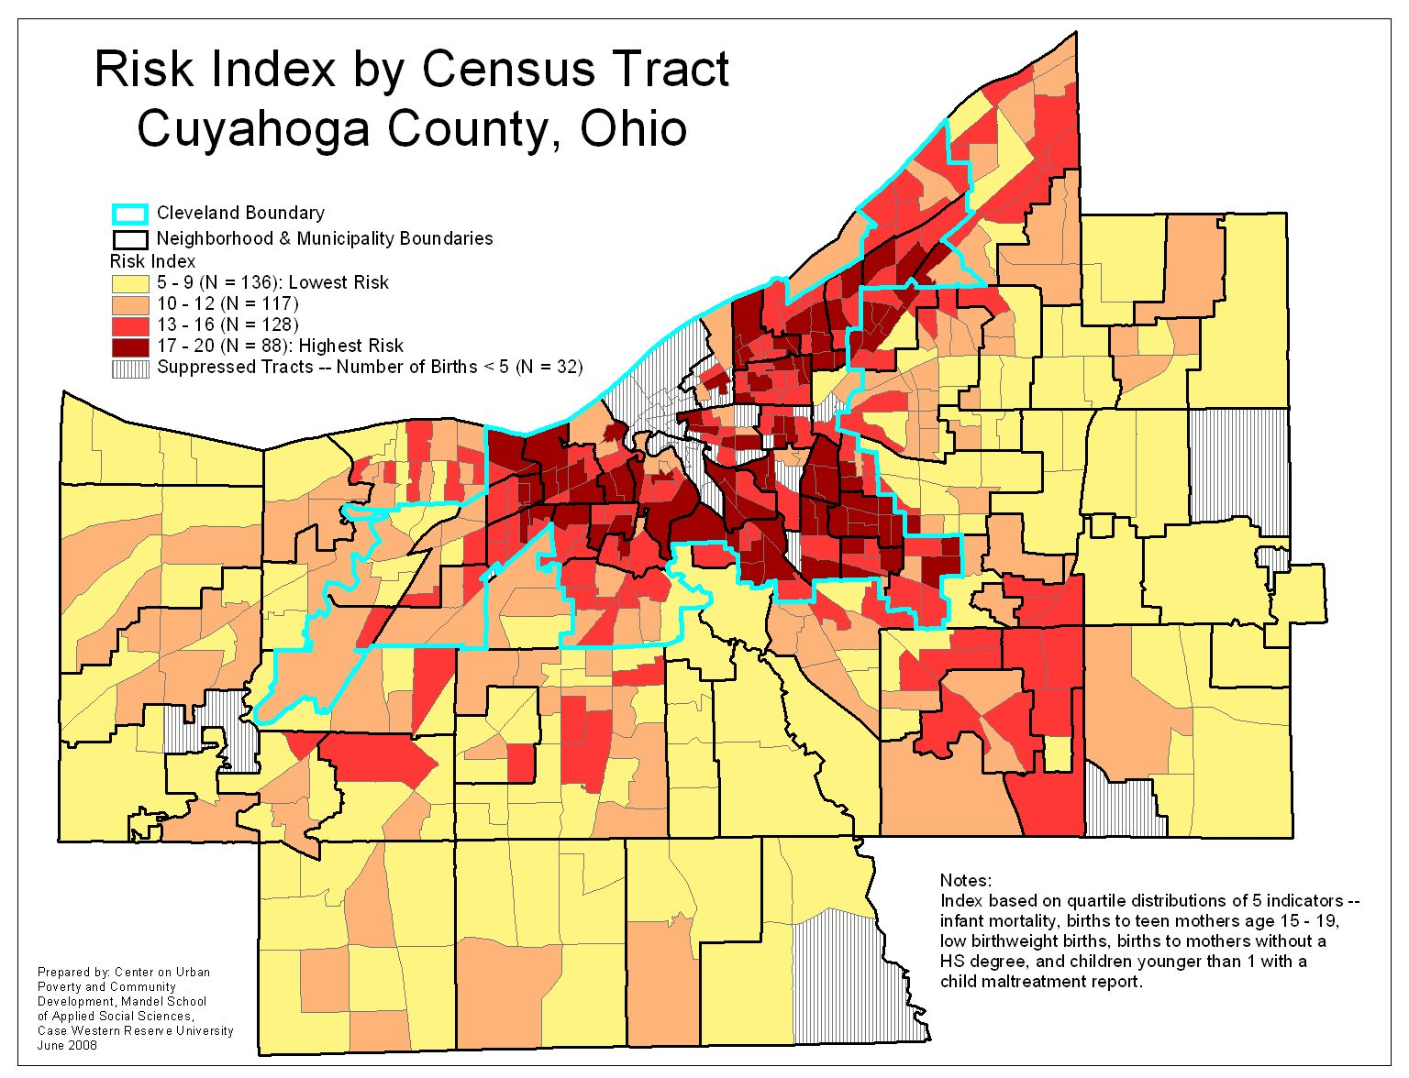
Figure 2 Summary Risk Index Score by Tract

The risk score was computed using five indicators: (1) births to teen mothers, (2) births to mothers without a high school diploma, (3) low birth weight births, (4) infant mortality, and (5) infants with a maltreatment report. Tracts were categorized by quartiles on each indicator and then the quartile values were summed. The magnitude of the value reflects the severity of the risk. The map shows that the occurrence of risk, though clearly clustered in the urban core, also extends into all suburban areas. These pockets of risk suggest that otherwise low risk communities do exhibit risk levels of concern in isolated areas.

Figure 3 displays the distribution of summary scores along the service use dimension. The service use index score was computed using five indicators: (1) newborns enrolled in Medicaid, (2) infants identified with a developmental delay, (3) newborns receiving a newborn home visit, (4) infants receiving ongoing home visiting, and (5) eligible children under age 6 receiving a child care voucher.
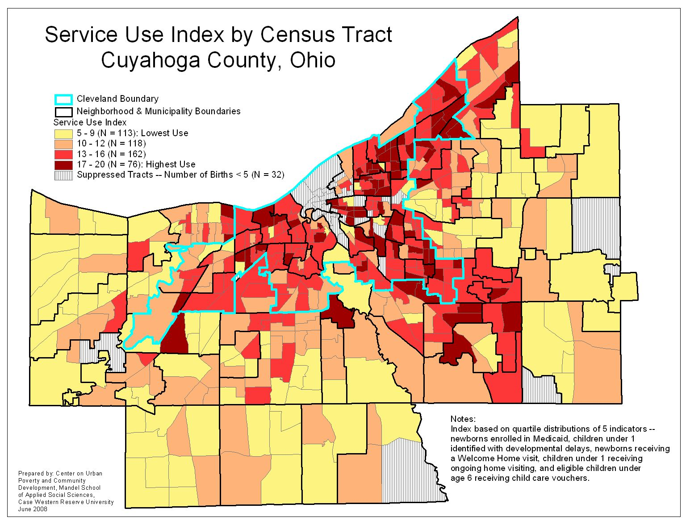
Figure 3 Summary Service Use Index Score by Tract

Similarly, the effectiveness of programmatic outreach and engagement appears to vary dramatically across regions. This unevenness suggests that sweeping statements about which areas of the community may be well served or not are wholly inappropriate. The ability of community services to meet families’ needs differs from neighborhood to neighborhood and even within a neighborhood.

A third spatial analysis examined the data on school attendance and performance for tracts in the City of Cleveland. See Figure 4. The school attendance and performance index was computed using five indicators: (1) kindergarteners without chronic absences, (2) first through third graders without chronic absences, (3) 3rd grade proficiency of children – reading, (4) 3rd grade proficiency of children – math, and (5) 3rd grade proficiency test passing rate of neighborhood school.
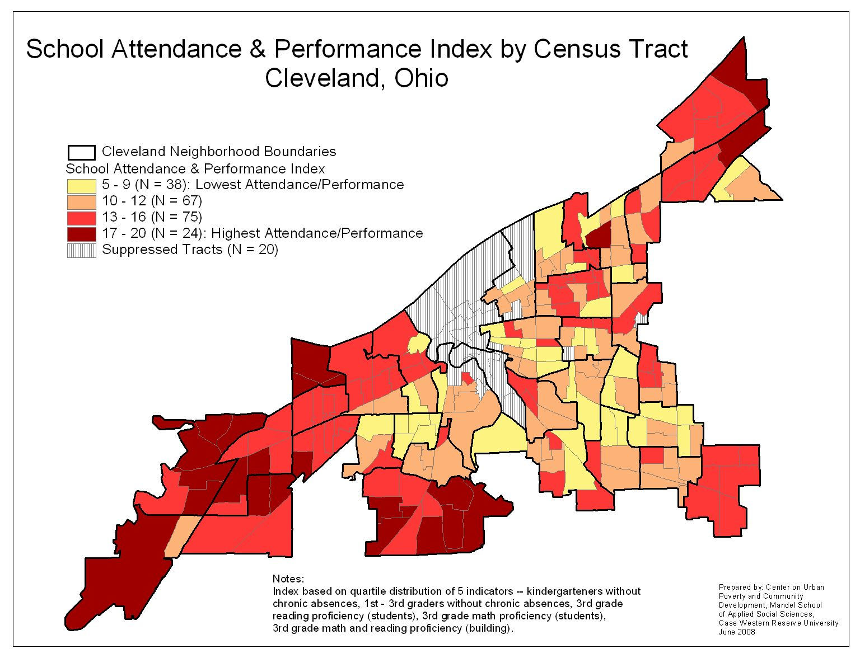
Figure 4 School Attendance and Performance Index by Tract (Cleveland only)
The pattern shows that tracts on the far west, near west, and far east have the highest scores on this index, while tracts on the east side and south side show a consistent pattern of lower performance.

Conclusion
This brief has sought to bring together key data related to the understanding and promotion of school readiness in Cuyahoga County. The work shows that the occurrence of child risk is heavily related to the incidence of poverty and, thus, intertwined with geography. This reality should challenge policy makers, public officials, and community leaders to think in a more integrated way about the ability of our community to produce children who are ready for school. The consideration of risk and the effectiveness of current programmatic responses only allow for more incremental approaches to improving the system of early childhood development. Though such responses may in fact lead to improvements, they may not capitalize on opportunities to formulate a more dramatic response to the overall condition of our children.

In addition, the formulation of a seamless system from birth to kindergarten is challenged by various structural and institutional factors. These factors include (a) programmatic targeting that leads to a transition issue for children between the prenatal to 3 period and the preschool period, as well as the preschool to kindergarten transition, (b) multiple funding streams for services that have categorical limitations on use, leading to a variety of requirements (sometimes conflicting) being placed on service organizations, (c) traditional issues related to agency turf and institutional history that may limit organizational willingness to engage in a system view, and federal legislation and mandates related to service provision and data access.

A clear implication of this analysis is that more data are needed to allow for a fuller examination of the factors crucial in producing school readiness. Though child-level data are available on many dimensions, some data are currently unavailable at this level. This includes blood lead testing data from the health departments, and data on enrollment in high quality pre-school settings such as Head Start, Early Head Start, and Ohio’s Early Learning Initiative. With the mandate of the use of the Kindergarten Readiness Assessment – Literacy (KRA-L) state-wide in public school districts beginning in 2006-2007, there is now the existence of another potential data source for deriving outcome indicators for the present analysis. At present availability of KRA-L data is limited to aggregate statistics and individual child data accessible via informed parental consent. With an emerging consensus among those working on school readiness that more and better data are essential for advancements to occur, the identification and access to data will need increasing focus.

References
Bruner, C. (2006). School Readiness Resource Guide and Toolkit: Using Neighborhood Data to Spur Action. Des Moines, IA: Child and Family Policy Center.

Coulton, C., & Fischer, R. (2008). School Readiness and Early Grade Success in Cuyahoga County, Ohio. Local Policy Research and Advocacy Support Project. Annie E. Casey Foundation. May.
Notes

TABLE A
Teen births: 2004 Birth data (numerator), 2004 population estimates for females aged 15-19, linear interpolations from the 1990 and 2000 Census (denominator). 307 of 1,846 teen births had addresses that could not be geocoded.

Births: LBW births and births to mothers with no high school diploma (2004). 1,692 of 16,915 births could not be geocoded (including 218 of 1745 LBW births, and 404 of 2830 births to mothers with no diploma). An additional 406 birth records were missing mother’s educational information.

Child maltreatment: 2006 DCFS data for children under age 1 (numerator), and 2004 Birth Data (denominator). 28 of 1,557 infants with report of maltreatment had addresses that could not be geocoded (11 of 361 with substantiated/indicated report not geocoded). 1,692 of 16,915 birth addresses could not be geocoded.

Children with elevated blood lead level: 2004 Cuyahoga County Board of Health data from http://www.ccbh.net/ccbh/opencms/CCBH/datastats. Data includes test results from neighborhoods where < 100 tests were performed, which may produce unreliable estimates.

TABLE B
Child care enrollment: 2007 Starting point data (numerator and denominator). Not geocoded (numerator): 218 of 4,154 enrollees ages 0-17 months, 329 of 7,585 enrollees ages 18-35 months, 864 of 26,767 enrollees ages 3-5 years (excluding kindergarten). Not geocoded (denominator): 258 of 6,203 slots for ages 0-17 months, 454 of 11,705 slots for ages 18-35 months, 1,118 of 37,169 slots for ages 3-5 years.

Newborns enrolled in Medicaid: 2007 CRIS-E Individual data (numerator), 2005 Birth data (denominator). 316 out of 6563 newborns enrolled in Medicaid within the first month of life had addresses that could not be geocoded. Includes infants who enrolled in Medicaid pre-natally up until age 2 months.

Infants identified as having a developmental delay: 2007 KIDS data (numerator), and 2004 Births. Includes children first identified as having a developmental delay in 2007, who were under age 1 at the time. 45 of 952 infants had addresses that could not be geocoded.

Newborn home visit: 2007 KIDS data (numerator), 2005 Birth data (denominator). Includes children receiving a newborn home visit in 2007, regardless of age. 381 of 7,423 children receiving a newborn home visit had addresses that could not be geocoded.

Ongoing home visit: 2007 KIDS data (numerator), and 2004 Births. 114 of 3,811 infants receiving ongoing home visiting before age 1 had addresses that could not be geocoded.

Eligible children receiving child care vouchers: 2007 Day Care Voucher data (numerator), and 2007 Medicaid recipients living at 185% of poverty level (denominator). 1,843 out of 22755 children aged 0-5 who received a day care voucher in 2007 had addresses that could not be geocoded.

TABLE C
Children with chronic absences: Cleveland Metropolitan School District Data are for the 2006-2007 school year. Students with 11.1% or more absent days are considered to be chronically absent. The numerator is the number of students with absent days of 11.1% or more, and the denominator is the number of students with absentee information. Not geocoded: kindergarten numerator: 30 out of 1,713; 1st – 3rd grade numerator: 93 out of 4,369; kindergarten denominator: 102 out of 5,057; 1st – 3rd grade denominator: 368 out of 16,279.

3rd grade proficiency test results: Cleveland Metropolitan School District Data are for the 2006-2007 school year. The numerator is the number of 3rd graders who passed the test, and the denominator is the number of 3rd graders who took the test. Not geocoded: reading numerator: 30 out of 2,027; math numerator: 23 out of 1,992; reading denominator: 64 out of 3,953; math denominator: 53 out of 3,676.

