School Readiness and
Early Grade Success in
Hamilton County, Tennessee

Community Research Council
July 2008

Dr. Eileen Robertson Rehberg
David Eichenthal
Shelby Kain
About this Report
In August 2007, the Community Research Council (CRC) was one of nine non-profit data analysis organizations selected to participate in a national, multi-site analysis of early grade success and school readiness. The project, funded by the Annie E. Casey Foundation, was overseen by the Urban Institute. The eight participating sites – Atlanta, Chattanooga, Cleveland, Denver, Indianapolis, Memphis, Miami, Milwaukee and Providence – are all part of the Urban Institute National Neighborhood Indicators Partnership.

The State of Tennessee, through a Community Enhancement Grant from the Secretary of State sponsored by State Senator Andrew Berke, also provided funding for this report.

As part of this process, CRC convened a panel of leading practitioners and scholars who address issues of school readiness on a daily basis to act as an advisory board for this project. Members of the Advisory Board include:

Phil Acord, Children's Home/Chambliss Shelter
Harold H. Baker, Orange Grove Center
Dr. Brenda Benford, Hamilton County Department of Education
Judi Byrd, Parents Are First Teachers, Hamilton County Social Services
Dr. David Cook, Siskin Children's Institute
Linda Daniel, Tennessee Department of Human Services
Kathy Daniels, Tennessee Commission on Children and Youth
Anne Gamble, Director, Project Ready for School
Bobbie Grantham, Child Care Resource and Referral
Jackie Hill, Chattanooga State College
Dr. Kirk Kelly, Hamilton County Department of Education
Shawn Kurrelmeier-Lee, Chief Reading Officer, Read 20, Hamilton County
Donna McConnico, Signal Centers, Inc
Beverly McKeldin, Chattanooga Department of Human Services
Linda McReynolds, Vice President of Organizational Development, United Way of Greater Chattanooga
Emily Perrine, Tennessee Department of Human Services
Judy Sisk, Child Care Resource Referral
Sarah Thompson, Head Start
Debra Vaughan, Public Education Foundation

As an initial step in this process, CRC – with the guidance of the Advisory Board – compiled a scan of existing data related to early grade success and school readiness. Advisory Board members also reviewed this final report: its findings, however, solely represent the views of the authors.

Summary of Findings
In Hamilton County, approximately 4,000 children are born and approximately the same numbers enter Kindergarten in the county’s public and private school systems every year.

During the five years between birth and a child’s first year in school, they go through a series of experiences and developmental stages that help to determine how they will perform in their first school years. And, while a number of efforts have proven successful in overcoming early year deficits, how a child performs in those early years often determines how they will perform throughout their academic life.

Most children entering Kindergarten have the basic skills to learn. Many already know how to read and write. They have been exposed to books. Their brains have been engaged by their parents or other caregivers. They have grown up in an environment that supports their learning and their success in school.

Unfortunately, that’s not true for all children. Some children have not yet learned to read and – in some cases – have rarely if ever been exposed to reading or books. Growing up in households where parents or other caregivers have not engaged them during their first years, these children are at risk of failure once they enter school.

National research – and local data – confirms that these children are most likely to have parents who are very poor and who lack high levels of educational attainment; are victims of abuse or neglect; have only one parent in the household; have limited English language proficiency or are born to teenage mothers. In addition, some of these children may also have physical, mental or learning disabilities or special needs that may also impede their ability to perform in school.

Based on these risk factors, approximately 1,000 children born every year in Hamilton County are at risk of not being ready for school and not succeeding during early grades. While not every child at risk will fail – and while children not in any of these categories may fail – these are the children most in need of assistance in being prepared for early grade success.

Children at risk prior to entering school are the most likely to fail to succeed in early grades. According to 2007 test data from the Tennessee Comprehensive Assessment Program (TCAP), 8.6% of Hamilton County third graders scored below proficient on the Reading/Language Arts exam; 12.7% were below proficient on the Math exam; and 23.7% were below proficient on the Social Studies exam.

- Children from economically disadvantaged households are four times more likely to score below proficient on the Reading/Language Arts TCAP and three times more likely to score below proficient on the Math and Social Studies TCAPs than those children not from economically disadvantaged households
- Students with disabilities are three times more likely to score below proficient on the Math TCAP, two and one half times more likely to score below proficient on the Reading/Language Arts and twice as likely to score below proficient on the Social Studies TCAP as those children without disabilities
- Students with limited English proficiency are three to four times more likely to score below proficient on the Reading/Language Arts and Math TCAPs than those students without an LEP issue

Significant public and philanthropic resources are already being devoted to address these disparities through a series of intervention programs for at risk children. More than $30 million annually is spent on these programs that serve at risk youth between the ages of 0 and 5 in Hamilton County. These include public programs to provide child care, Head Start, Pre-Kindergarten programs, as well as programs designed to provide at-home interventions for parents and children and to increase access to books and reading.

Still, there are hundreds of children who may need -- and be eligible -- for these services whose need goes unmet.

Moreover, despite an investment to meet a significant need in the community, there is no reliable means of measuring the effectiveness of different intervention programs in achieving school readiness. While thousands of children are assessed for developmental progress annually in Hamilton County, there is no standard or mandated single test or measure to identify the number of children entering Hamilton County public schools who are developmentally at risk. Individual programs or interventions have different measures of their success: in many cases, these measures are based on compliance – following specific models or regulatory requirements – rather than outcomes – the actual performance of children.

There is no current effort to link the types of interventions that a child receives before they enter school with how they perform in Kindergarten and other early grades.

Different programs have different costs and may produce different results for children with different risks. The lack of a comprehensive measure of program effectiveness makes it difficult to assess the outcomes of different programs and efficiently allocate resources to provide adequate services for the greatest number of children in need.

The Relationship between School Readiness and Early Grade Success in Hamilton County

Years of research suggest that many children risk failure during their school years as a result of environmental and developmental deficits that may take place before they even enter a school. According to the Economic Policy Institute, “[U]p to one-half of the gap in achievement scores in school can be attributed to gaps already evident at the time of school entry.” While schools can and should be held accountable for narrowing the gap once a child enters the school system, there remains a need for effective interventions between a child’s birth and their first day in school.

“School readiness” is a concept embraced by both federal and state funders and regulators of childhood intervention programs. At the federal level, the most recent reauthorization of Head Start was titled the “Improving Head Start for School Readiness Act.” In child care, Tennessee’s star rating system is designed to increase the quality of care and promote school readiness: the Tennessee Early Childhood Education Early Learning Developmental Standards (TN-ELDS) were developed to cover all domains of early learning to include early language, literacy and numeracy and distributed to child care providers participating in the star rating program. Those child care providers that participate in the star rating program are assessed annually and receive higher ratings for compliance and are eligible for higher funding levels per child from the State.

The federal government has recognized the importance of quantifying school readiness and linking readiness to a series of indicators related to a child’s learning environment. In 1997, the federal government established the Interagency Forum on Child and Family Statistics to increase the school readiness of young children “by making connections with local child care providers and preschools by creating policies that ensure smooth transitions to Kindergarten. Schools must be ready to address the diverse needs of the children and families in their community and be committed to the success of every child.” To do so, the Forum was mandated to develop priorities for collecting enhanced data on children and youth, improve the reporting and dissemination of information on the status of children to the policy community and the general public, and produce more complete data on children at the State and local levels.

Still, despite the recognition of the connection between “readiness” and early grade success, there is no common national or – in the case of Tennessee and most states – statewide means of assessing school readiness on a child by child basis. Definitions of school readiness focus on characteristics that are necessary to help children – and schools and communities – be ready for success.

Instead, all children meeting minimum requirements – such as age – are judged to be technically “ready for school.”

Identifying Hamilton County’s at Risk Children
Just as there is no common definition for children who are “not ready” for school, there is also no definition for those children most at risk of not being ready for school. But national research and local data suggest a series of criteria that can be used to identify and estimate the number of young children at risk in Hamilton County.

Research has suggested that factors such as household income, maternal educational attainment, presence in a single parent household, birth to a teenage mother and low birth weight present more challenges for a child to succeed in school. Many of these factors are correlated: for example, there is a direct relationship between single parent households, low maternal educational attainment and household income.

Data from the most recent TCAP tests of Hamilton County third graders emphasizes the relationship between student performance and demographic factors:
- Children from economically disadvantaged households are four times more likely to score below proficient on the Reading/Language Arts TCAP and three times more likely to score below proficient on the Math and Social Studies TCAPs than those children not from economically disadvantaged households
- Students with disabilities are three times more likely to score below proficient on the Math TCAP, two and half times more likely to score below proficient on the Reading/Language Arts and twice as likely to score below proficient on the Social Studies TCAP as those children without disabilities
- Students with limited English proficiency are three to four times more likely to score below proficient on the Reading/Language Arts and Math TCAPs than those students without an LEP issue
- Economically disadvantaged third graders were more than three times likely to score below proficient in the Science TCAPs. Higher percentages of children with disabilities were below proficient in the Science TCAPs when compared to those without disabilities (33.9% vs 18.7%).

Countywide, there are approximately 20,000 children under 5 years living in Hamilton County. In 2000, the Census identified an under five population of 18,228 and the 2006 American Community Survey and Census population estimates suggest a current under five population of 19,250. This data is also consistent with birth data for Hamilton County: between 2000 and 2005, there was an average of 3,950 births per year – or a five year birth cohort of 19,750 children.

At the same time, we can isolate the under five year old population at risk:

- According to 2006 ACS data, 20.5% of children under five lived in poverty – up from 18.9% in the 2000 Census. For a household of three, the poverty threshold in 2007 was $16,537. According to birth data from 2004 to 2006, nearly 30% of mothers reported annual household incomes less than $10,000 and 37% reported less than $15,000 in annual household income.
- Hamilton County birth data indicate that between 2001 and 2006, 25% of children born in the county had a mother with less than a high school education.
- According to 2006 ACS data, 29% of children under five live in households with just one parent.
- According to 2000 Census data, one in ten children under five were living in a home where English was not the primary spoken language: with the increase in the Latino population in the county, this percentage is now likely to be higher – in 2006, Latino mothers accounted for nearly 12% of all births in Hamilton County.
- According to 2000 Census data, 6.7% of children between the ages of 5 and 15 had one or more disabilities: applying the same proportion to the under five year old population, there are 1,340 children with disabilities

2007 TCAP Scores – Hamilton County Third Grade
 | Below Proficient:  Reading/  Language Arts | Below Proficient: Math | Below Proficient:  Social Studies | Below Proficient: Science
Total | 8.6% | 12.7% | 23.7% | 20.6%
Economically Disadvantaged | 13.0% | 18.6% | 34.8% | 30.6%
Not Economically Disadvantaged | 3.3% | 5.7% | 11.1% | 9.1%
With Disabilities | 18.6% | 31.2% | 40.8% | 33.9%
No Disabilities | 7.1% | 10.1% | 21.3% | 18.7%
LEP | 36.2% | 26.3% | NA | NA
No LEP | 7.9% | 12.4% | 23.8% | 20.6%

Based on these data, as many as one in four children – or 1,000 children born every year in Hamilton County with one or more risk factors – are at risk for low academic achievement.

Many of these indicators of risk are related, especially when examining concentrations of poverty by location within the county.

Because the American Community Survey does not provide poverty information at a neighborhood level, we examined an alternative source – Families First enrollment (the State TANF program).
- Countywide, there were 44.1 Families First recipients per 1000 persons: in four zip code areas in the City of Chattanooga, the Families First participation rate is more than four times the countywide rate.
- In four city zip code areas – Alton Park, East Chattanooga, East Lake and Downtown – rates are more than three and one-half times the county rate.

The same subregions within the county that had the highest concentrations of poverty also frequently had the highest concentrations of families with other indicators of risk:
- Highest rates of students eligible for special education programs and services are in three of the highest poverty census tracts.
- A subregion with the highest county poverty rate is also the area with the highest rates of reported child maltreatment.

Families First Enrollment Total Individuals By Zip Code
Post Office Location | Zip code | April 2008 Rates per 1000 families*
East Ridge | 37412 | 35.6
Red Bank | 37415 | 28.1
Highway 58 | 37416 | 45.5
Tiftonia | 37419 | 27.9
Soddy Daisy | 37379 | 19.4
Hixson | 37343 | 22.1
Alton Park | 37410 | 210.4
Signal Mountain | 37377 | 2.5
East Brainerd | 37421 | 25.8
Lupton City | 37351 | 54.6
East Lake | 37407 | 166.2
Brainerd | 37411 | 73.5
Erlanger UTC | 37403 | 35.4
Ooltewah | 37363 | 12.7
Sale Creek | 37373 | 18.7
East Chattanooga | 37406 | 181.2
Harrison | 37341 | 15.2
Downtown | 37402 | 159.8
Highland Park | 37404 | 93.1
North Chattanooga | 37405 | 29.3
Apison | 37302 | 8.0
Birchwood | 37308 | 7.2
McDonald | 37353 | 1.6
Lookout Mountain | 37350 | 0.0
Graysville | 37338 | 0.0
St. Elmo | 37409 | 34.8
Georgetown | 37336 | 5.0
South Broad | 37408 | 51.2
Total |  | 44.1
Source: State of Tennessee Department of Health and Human Services
*Note: Rate was calculated from the total number of individuals
Shaded cells are those zip code areas with Families First rates nearly or more than four times the county-wide rate.

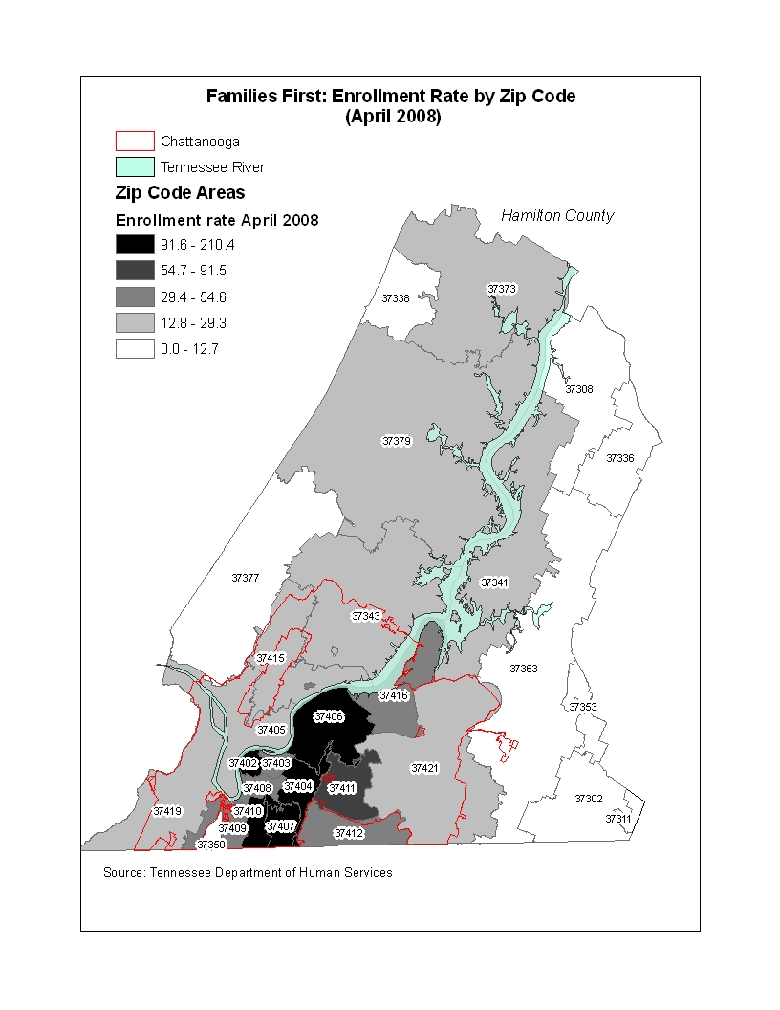

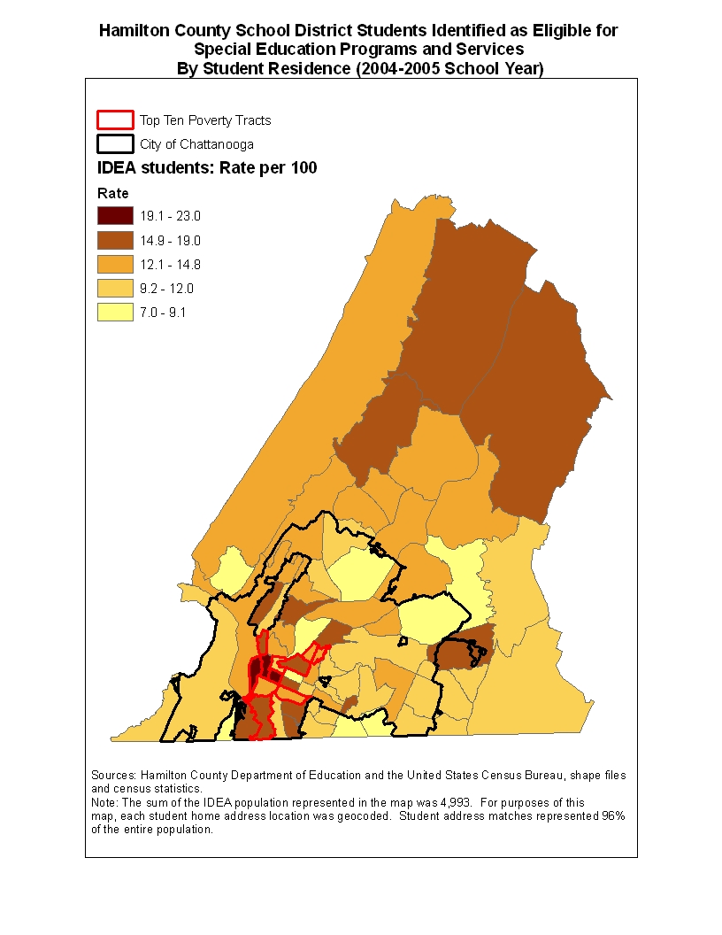

Child Maltreatment Rates By Zip Code Area Per 1000 Children
Neighborhood | Zip Code | Rate of child maltreatment per 1000 population
Chattanooga (Downtown) | 37302 | 3.8
Harrison | 37341 | 2.3
Hixson | 37343 | 1.8
Ooltewah | 37363 | 0.2
Soddy Daisy | 37379 | 0.7
Chattanooga (Downtown) | 37402 | 5.6
Chattanooga (Erlanger UTC) | 37403 | 7.9
Chattanooga (Highland Park) | 37404 | 6.6
Chattanooga (North Chattanooga) | 37405 | 1.9
Chattanooga (East Chattanooga) | 37406 | 6.5
Chattanooga (East Lake) | 37407 | 13.0
Chattanooga (South Broad) | 37408 | 11.9
Chattanooga (Alton Park) | 37410 | 4.1
Chattanooga (Brainerd) | 37411 | 4.8
Chattanooga (East Ridge) | 37412 | 4.5
Chattanooga(Red Bank) | 37415 | 1.2
Chattanooga (Highway 58) | 37416 | 1.2
Chattanooga (East Brainerd) | 37421 | 0.8
Sources: Census 2000 population under 18 years old and child maltreatment cases 2001-2005
Note: Only those zip code areas with reported child maltreatment cases are listed in this table

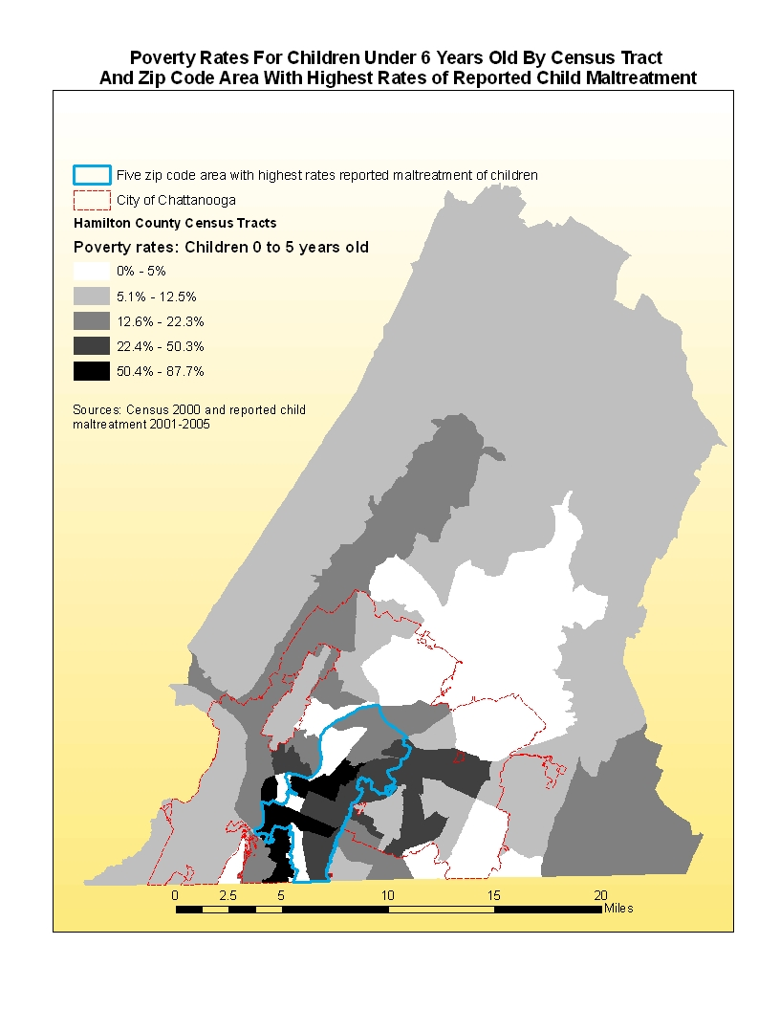
Birth Risks by Neighborhood

Birth data also revealed relationships between risk factors. For example, based on data from 2001 to 2006, teenage mothers had the highest risk for low weight babies in the county: nine out of ten teenage mothers under the age of 18 did not have a high school education at the time of birth. Between 2001 and 2006, eleven percent of children born in Hamilton County had mothers who were native to a country outside of the United States: nearly half of Latino mothers reported annual household incomes of less than $10,000.

Poverty has the most devastating effects on a child because poverty determines an overall quality of life that limits opportunities for early learning. The relationship between poverty and other risk factors are clear in Hamilton County subregion areas. Four areas -- Ridgedale/Oak Grove/Clifton Hills, Downtown, Bushtown/Highland Park, and Amnicola/East Chattanooga – are among neighborhoods with highest percentages of low birth weight babies, single mothers, mothers without a high school education and mothers who are teens. These are also areas subregion areas with more than 80% Latino and African American newborn babies and poverty rates that exceed 30% -- a rate that is two and one-half times the county rate

Two neighborhoods with highest percentages of Latino births were also neighborhoods with highest percentages of birth mothers without a high school education. Ridgedale/Oak Grove/ Clifton Hills with 38.6% of births to Latino mothers was an area where 61.7% of children were born to mothers without a high school education and in Bushtown/Highland Park 30.2% of newborn children were of Latino ethnicity and 55% of birth mothers were without a high school education.

In Glenwood/Eastdale, Amnicola/East Chattanooga, and Downtown, more than 80% of babies born were African American – three neighborhoods with the highest percentages of low birth weight babies.

County-wide, 1.5% of all births were low birth weight babies born to single parent teens lacking a high school education. In three neighborhoods -- Ridgedale/Oak Grove/ Clifton Hills, Amnicola/East Chattanooga and Downtown -- this percentage was more than two and one half times higher than the county-wide average.

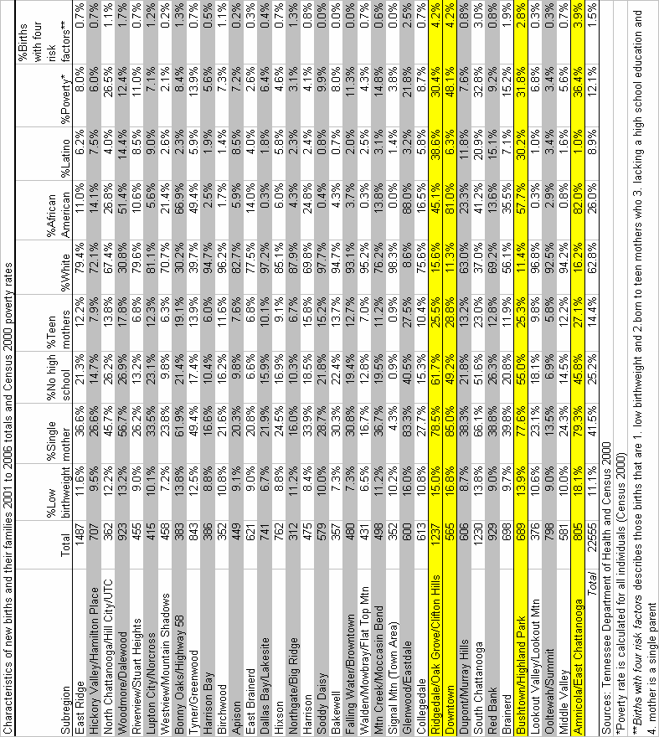

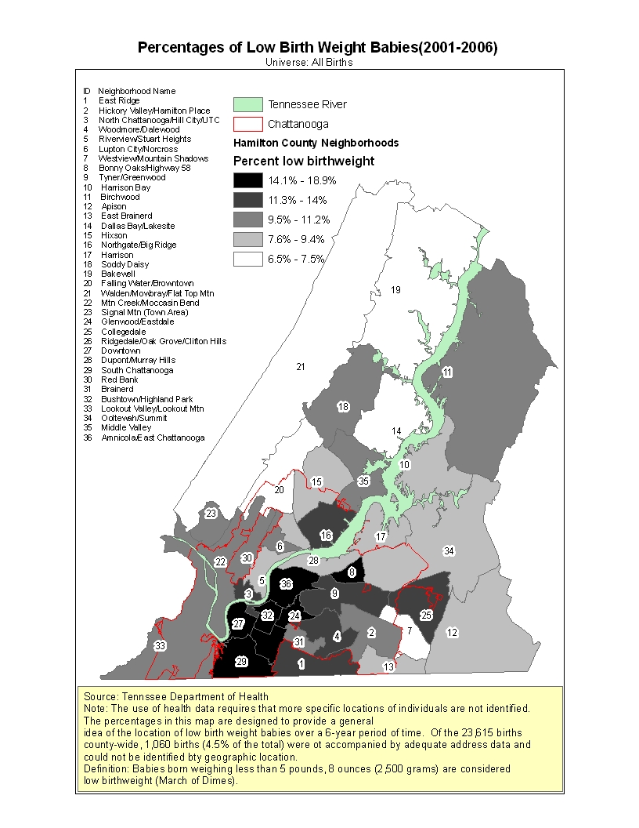

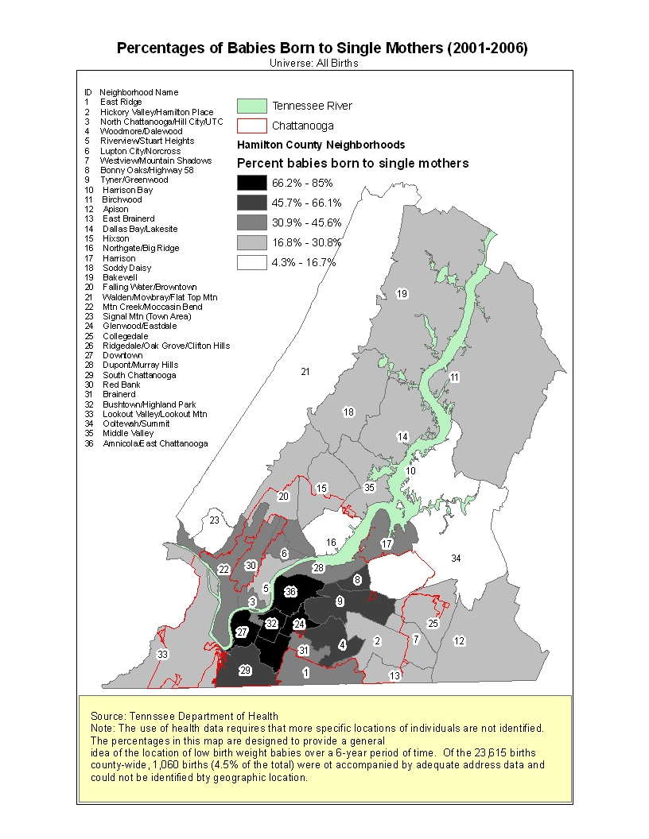
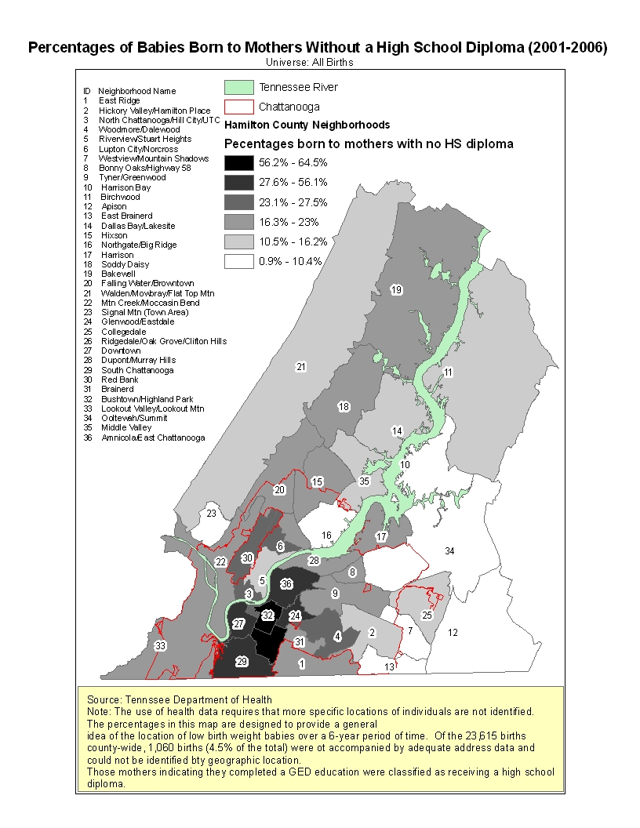

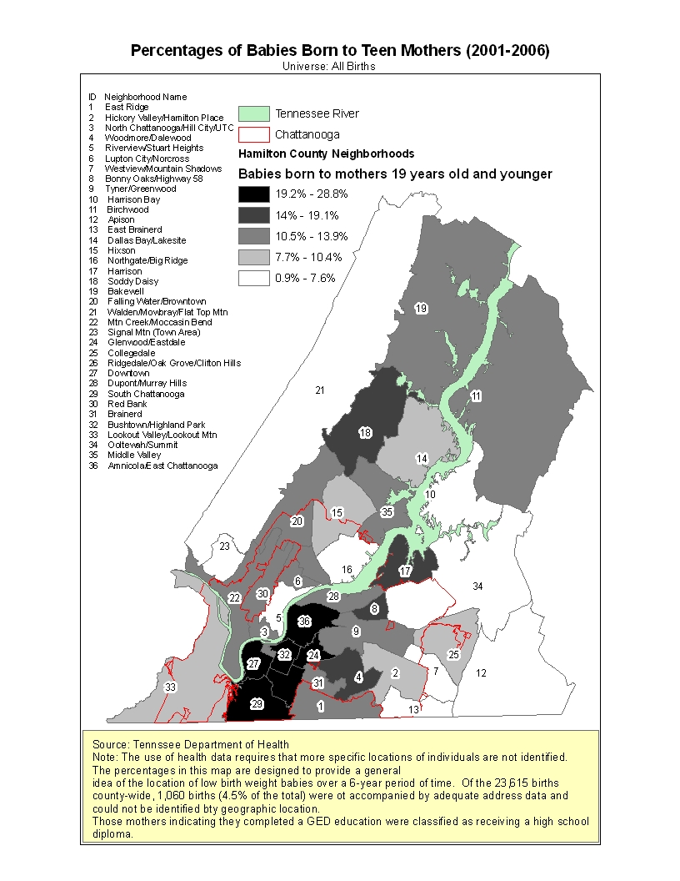

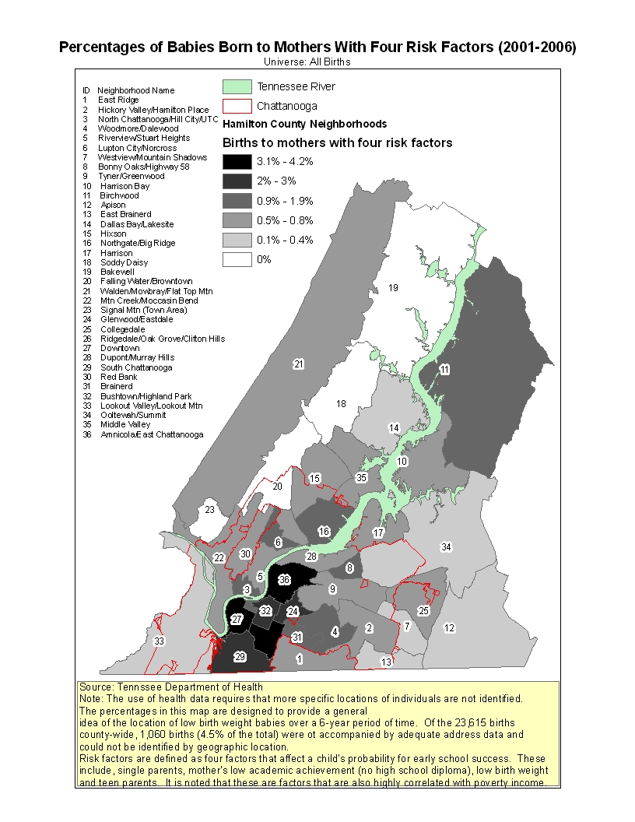

The Programmatic Response to Hamilton County’s At Risk Children
A variety of programs are in place to try to close the potential gap in readiness for these children. And, based on TCAP data, these programs – combined with the in school experience of these children -- are having an impact. For example, the vast majority of Hamilton County third graders who are from an economically disadvantaged household or have disabilities are scoring proficient or better on standardized tests. Nearly one quarter of children from economically disadvantaged households actually scored advanced on third grade Math and Reading/Language Arts TCAPs.

There is no single system of pre-school intervention. Pre-school programs receive both private and public funding. Some operate through the public school system, while most do not. Programs serve populations of different ages and different characteristics. Some – such as Head Start – involve educational components, as well as intense services and supports for children and families. Some only focus on the classroom – such as Pre-Kindergarten programs. Others focus only on activities outside of the classroom – such as the Parents are First Teachers.

Most programs are privately operated, by either for-profit or not-for-profit child care providers. For these programs, government involvement is limited to regulation, ratings for the purposes of the Star Quality program and funding for those students eligible for Families First child care vouchers.

The Families First program subsidizes the cost of child care for those who are income eligible and, at the same time, offers incentives to increase quality measured from zero-stars up to three-stars in those centers where care is provided. Staff training, the availability of age-appropriate educational materials, interaction with the child and the child’s family, as well as the quality of the classroom and staff to child ratios are among those factors that are assessed. A one-star rating results in a 5 percent increase in reimbursement rates for low-income children, a two-star rating leads to a 15 percent increase, and three-star programs receive a 20 percent increase. A facility goes through an annual assessment and six unannounced visits each year.

Child Care Facilities With 8 Hours Or More Of Service By Age And Star Rating
Age level | 1-Star | 2-Star | 3-Star | All Stars | Total locations | %Star-rated | %3-Star
Under 1 year | 2 | 23 | 72 | 97 | 146 | 66.4% | 49.3%
YR1 | 2 | 25 | 78 | 105 | 160 | 65.6% | 48.8%
YR2 | 2 | 27 | 88 | 117 | 181 | 64.6% | 48.6%
YR3 | 2 | 27 | 96 | 125 | 202 | 61.9% | 47.5%
YR4 | 2 | 27 | 96 | 125 | 227 | 55.1% | 42.3%
YR5 | 2 | 26 | 89 | 117 | 176 | 66.5% | 50.6%
Note: A total of 189 locations are represented in the table. This reflects overlap, where one location serves multiple age levels.
Universe: Facilities that include services for children under 5 years old

Four Hamilton County child care locations are accredited by the National Association for the Education of Young Children (NAEYC). NAEYC accreditation assesses many of the same qualities as the Tennessee program and also additional factors such as teachers that have a college degree, a curriculum teaches the knowledge, concepts, and skills appropriate for each age level, educational outcomes and learning standards and standards for professional development. Programs that meet NAEYC requirements frequently have increased costs.

NAEYC Accredited Programs In Hamilton County
Program name | Locations
Chattanooga Human Services Child Care Program | 501 West 12th Street
Siskin Children's Institute | 1101 Carter Street
UTC Children's Center Battle Academy | 1601 S Market Street
UTC Children's Center Brown & Battle Academy | 615 McCallie Ave
Source: NAEYC June 2008

As of August 2007, there were 141 licensed child care centers – each serving more than 12 children – with an enrollment of 7,884 children under the age of five in Hamilton County: 69.9% of children are in three star quality centers – the highest rating by the State. Some child care is provided through family and group home care programs that are licensed with the State. Family programs generally serve between five and seven children and group home programs generally serve between eight and twelve children. There are 64 licensed family and group home programs in Hamilton County with enrollment as of August 2007 of another 496 children under 5: 43.5% of children under five are in three star facilities.

Center Child Care
Star Rating | Number of  locations | Enrollment under  5 years old | Capacity  (All Ages)
0 | 17 | 505 | 1012
1 | 1 | 28 | 46
2 | 17 | 978 | 1248
3 | 74 | 5512 | 6968
New* | 11 | 825 | 873
Not Participating | 1 | 36 | 36
Not Rated** | 20 | Not Available | 1929
Total | 141 | 7884 | 12112
Child care locations are those that include service to children under 5 years old
*A facility must be in operation for at least one year before a star rating is assigned
**Not rated is a child care location that is exempted from participating due to a religious affiliation

Family and Group Home Child Care
Star Rating | Number of locations | Enrollment under 5 years old | Capacity (All Ages)
0 | 5 | 38 | 45
1 | 1 | 12 | 12
2 | 11 | 79 | 99
3 | 30 | 216 | 280
New* | 15 | 144 | 145
Not Participating | 1 | 7 | 7
Not Rated** | 1 | NA | 12
Total | 64 | 496 | 600
Child care locations are those that include service to children under 5 years old
*A facility must be in operation for at least one year before a star rating is assigned
**Not rated is a child care location that is exempted from participating due to a religious affiliation

Two zip code areas, Alton Park and Downtown, have the highest rates of birth risk factors and Families First recipients. The two areas are in the City of Chattanooga and one has the lowest percentage of 3-Star child care slots that are subsidized for low income families. Alton Park and South Broad are among those zip code areas with lowest total capacity for child care for children under six years old, each with slightly more than 100 available slots. By comparison, East Lake is a high risk neighborhood where nearly three-fourths of 927 child care slots for children under 6 are 3-Star.

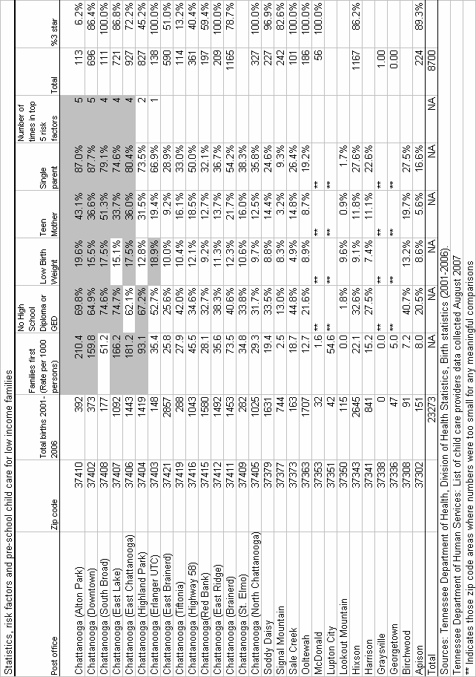
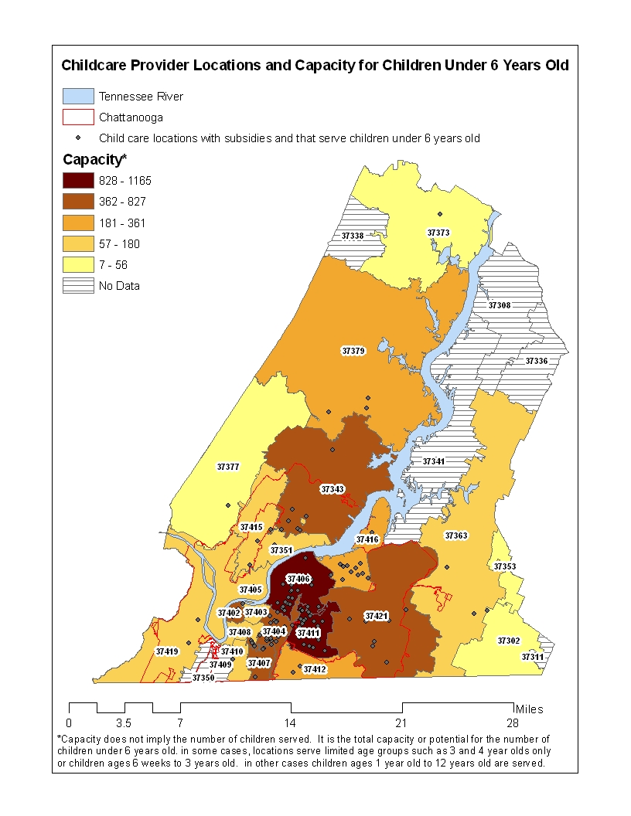

These child care programs are also the primary means of intervention for low income children in Hamilton County. A total of 2,655 low income children attend child care programs using vouchers for full time care issued through the State’s Families First program.

Three publicly operated programs are also designed to increase school readiness:

- Pre-Kindergarten (880 students, 44 classes with 20 students each): Hamilton County Department of Education (HCDE) administers the county’s Tennessee’s Voluntary Pre-Kindergarten Program. Children who meet free or reduced price lunch income guidelines, and are four years old by September 30th have priority for enrollment. HCDE also provides Title I Pre-Kindergarten programs. These programs generally serve Title I designated schools, and can serve any preschooler in the specific school zone, regardless of income. Preference is given to students who: (a) have been deemed at risk based on a screening assessment; (b) are zoned for a Title I school, especially to a school that have not made significant gains on standardized test scores; and (c) are eligible for free and reduced lunch programs.
- Head Start/Early Head Start (622 three and four years old and 146 children between birth and 30 months): Head Start and Early Head Start, operated by the Chattanooga Department of Human Services, are federal programs for preschool children from low-income families: the average household wage of a Head Start/Early Start household is $5,068 annually. Children who attend Head Start participate in a variety of age-appropriate educational activities, receive medical and dental care, have healthy meals and snacks, and enjoy playing indoors and outdoors in a safe setting. A minimum of ten percent (10%) of enrollment opportunities are offered to children with disabilities. Children in state custody or are homeless are given enrollment priority.
- Parents are First Teachers (approximately 200 families): Parents Are First Teachers, operated by the Hamilton County Department of Social Services, is a home visitation program, an evidence-based program for parent-child education, with developmental screening and a milestones assessment tool for children ages 0 to 5 years. A Parent Educator uses curriculum based resources in the home for activities during a monthly visit. In addition to the activities performed during the home visit, follow-up materials can be made available for parents to refer to as they interact with their child apart from the home visit. The program requires that a parent or guardian engage with the Parent Educator during an approximately one hour period dedicated to learning about their child and the types of support needed to create a learning environment in the home. Unlike Pre-Kindergarten and Head Start, there is no limitation on PAFT services based on a child’s risk: all families are eligible. There may also be overlap between families participating in PAFT and in Pre-Kindergarten and Head Start programs.

If up to one quarter of the approximately 20,000 children under five in Hamilton County are at risk, these publicly subsidized child care, Head Start and Pre-Kindergarten provide services to 87% of the at risk population, leaving approximately 637 at risk children without an early intervention.

In addition to the provision of direct child care or pre-school services, there are also a series of other programs affecting school readiness in Hamilton County.

The United Way’s Project Ready for School program provides curriculum support to child care centers in the community. Ages and Stages screenings are offered to children at events and child care centers to gauge how children’s language, cognitive and motor skills are developing: in the last 3 years, 1700 screenings have been provided to children in Hamilton County. PRFS also provides training and materials to 15 family child care providers to enhance implementation of curriculum to provide appropriate learning experiences for their children. The United Way also supports neighborhood reading centers that provide books, literacy activities, and parent education to families within each community. And the United Way supports the Imagination Library program that provides books to families of children under the age of five.

The County’s Read 20 program is a public private partnership designed to encourage reading to infants and young children for twenty minutes or more per day as a means of achieving childhood literacy. To do so, Read 20 works community, faith-based organizations, businesses, educators, and parents to support efforts in improving early childhood literacy being made across the community.

The local Childcare Resource and Referral Network (CCRRN), operated through the Signal Center, provides technical assistance, consultation, materials and resources to child care providers on developmentally appropriate practices, and health related issues and practices. The local Network is a member agency of the National Association of Child Care Resource and Referral Agency (NACCRA) and serves an 8-county region with resources for children with disabilities, onsite consultation to assist parents and child care providers in problem solving child care, health and inclusion issues.

There are also a series of local programs designed to improve the physical health of Hamilton County children. These programs have an indirect impact on school readiness as well.

Early Intervention Programs for School Readiness in Hamilton County Costs $30 Million Annually
Different intervention programs for school readiness have different costs.

Head Start/Early Head Start may be the most costly intervention on a per child basis. The City of Chattanooga’s FY 2008 budget for Head Start calls for spending $7,784,522 – or $10,136 per child.

Total annual spending for Families First child care vouchers is estimated at $17.5 million – or approximately $6,600 per child per year. In some cases, reimbursement rates were not equal to the total cost of child care. And actual per child spending by the State depends on both the age of the child and the quality of the child care center providing the service as determined under the star quality system.

Child Care Reimbursement Rates
 |  | Infant |  |  | Toddler |  |  | 3-5 Years
 | Week | Month | Annual | Week | Month | Annual | Week | Month | Annual
No Star | $132 | $528 | $6,864 | $115 | $460 | $5,980 | $99 | $396 | $5,148
1-Star | $139 | $556 | $7,228 | $121 | $484 | $6,292 | $104 | $416 | $5,408
2-Star | $152 | $608 | $7,904 | $132 | $528 | $6,864 | $114 | $456 | $5,928
3-Star | $158 | $632 | $8,216 | $138 | $552 | $7,176 | $119 | $476 | $6,188
Source: Tennessee Department of Human Services Reimbursement rates including Star Quality Bonus Payments effective January 1 2008 to June 30 2008

Statewide, the average cost of Pre-Kindergarten programs was $4,061 per child in FY 2005-2006. Applied to the Pre-Kindergarten population in Hamilton County, that suggests an annual investment of $3.4 million.

Finally, PAFT has an annual budget of $370,974 or a cost of $1,883 per child.

Despite the Importance of School Readiness Efforts, There is No Consensus on How to Assess School Readiness or Measure the Effectiveness of Different Programs
Research strongly supports the importance of Head Start, Pre-Kindergarten, quality child care and home visit programs as a means of better preparing at risk students for school. Many of the different programs designed to improve school readiness of at risk children regularly assess a number of different factors to measure their success.

Assessments of Pre-School Children in Hamilton County
Program | Assessment | Target | Children
HCDE PreK (4 years old) | First Step, Bracken, OWL, IGDI, and ongoing teacher observation and notes | Low-income | 680
Head Start/HCDE PreK (4 years old) | Creative Curriculum Assessment /Teacher observation | Low-income | 160
Total PreK |  |  | 840
Head Start(3-4 year olds) | Creative Curriculum Assessment/Teacher observation | Low-income | 622
Early Head Start (6wks to 3mos) | Creative Curriculum Assessment | Low-income | 146
PAFT Home Visit (prenatal up to 5 years old) | Parents As Teachers/ Developmental Milestones/Ages and Stages Questionnaire | Universal | 197
Child Care Centers (0 to up to 5 years old) | Ages and Stages Questionnaire* | Universal | 1200

While thousands of children are assessed for developmental progress annually in Hamilton County, there is no standard or mandated single test or measure to identify the number of children entering Hamilton County schools who are developmentally at risk or otherwise “not ready” for school. In fact, providers could not agree on a single measure or assessment that would define readiness, despite the fact that their programs are – in many cases – specifically designed to improve readiness.

Other children in subsidized child care programs do not undergo any type of assessment. Assessments are not required by the State even for those programs that receive Families First vouchers.

There is also little, if any, linkage between early interventions. At the local level, providers are unable to demonstrate that children served by their program performed better or worse than a control group once they entered public school.

While all children entering HCDE Kindergarten classes are screened, most agree that this is not currently a valid assessment of children ready for school. Although measures include the domains of school readiness indicators, results are reported to have no utility for this purpose.

A recent statewide study sponsored by the Tennessee State Comptroller did seek to link participation in Pre-Kindergarten programs with later performance in public schools: it found that children participating in Pre-Kindergarten programs on average had significantly higher scores in math computation, science, social studies, and word analysis.

The study of the effects of Pre-Kindergarten programs on low-income children, however, excluded any information about programs serving these children from ages 0 to 3 – prior to their entry into a Pre-Kindergarten program. Gain in academic achievement was solely attributed to a Pre-Kindergarten program, when in fact, program participation prior to Pre-Kindergarten may have contributed to differences among groups in academic achievement.

The lack of shared information has a practical impact as well. While more than 2,000 preschool children in the county are assessed for age-appropriate development with follow-up strategies for remediation, this information is not used by the child’s public school teacher or documented in HCDE student databases. For example, if a child had been ejected from one program due to emotional or behavioral problems, any assessment or even indication of the problem would remain unknown to any other program or Kindergarten the child may attend.

Conclusions
Children in their early years and those in child care and other early childhood programs are positioned to reap the benefits of programs that provide the basic elements fundamental to their early grade success. Tennessee’s Star Quality program has the broadest reach across the county to those children at risk for low achievement. Although not as rigorous as NAEYC requirements, the Star Quality program serves many low-income children in places that open their doors for state inspectors and follow a regimen of quality improvement.

Those children most in need of early childhood programs are concentrated in inner city areas of Chattanooga. These are areas with the highest percentages of other risk factors such as mothers without a high school education, children who were low birth weight babies, those with teen mothers and born in a single parent family. In a six year period of time (from 2001 to 2006), more than 3,000 children were born in five neighborhoods indicating the highest number of risk factors. During the same period, more than 5,000 children in the county were born to a mother who lacked a high school education – three quarters of those births were in the city of Chattanooga.

Affordability, quality and a third factor – accessibility – are all essential for effective and efficient delivery of early childhood programs. Accessibility requires that those children in need of program interventions can receive services. State policy and financial incentives have created a child care program that universally supports those children at greatest risk in neighborhoods throughout the county. But other services, such as those that are more intensive and require more resources can serve far fewer children.

Ideally, providers and funders would work together to:

- Identify those children who are at risk from birth and provide these children with a continuum of services
- Ensure that parents, child care providers, parent educators and teachers of every child work together to provide children with the resources and programs needed to overcome risks to academic achievement
- Identify opportunities for coordination and integration of services to improve service provision and avoid duplication
- Connect the early childhood program providers community with the school system so that the knowledge and information on each child is passed along and used
- Develop a basic, easy to use instrument – based on best practices elsewhere and consultation with Kindergarten teachers, Pre-Kindergarten teachers and child care providers – that provides assessment information on school readiness for every child entering Hamilton County schools.
- Using the common assessment tool, develop a database that captures this child by child information and can be used to develop school performance based outcome measures for early childhood interventions

By taking these steps, providers and funders can ensure that thousands of children in Hamilton County are better able to succeed in school and that the tens of millions of dollars invested in early childhood interventions in Hamilton County are used in the most effective and efficient way possible.

Lee, V. and Burkham, D. (2002). Inequality at the Starting Gate: Social Background Differences in Achievement as Children Begin School. Washington, DC: Economic Policy Institute. www.epinet.org. Also in Shonkoff, J. and Phillips, D., eds. (2002). From Neurons to Neighborhoods: The Science of Early Childhood Development. Washington, DC: National Academies Press.
Rothstein, R. (2004). Class and schools—Using social, economic and educational reform to close the Black-White achievement gap. Teacher’s College: Columbia University.
Child Care and Development Fund Plan for Tennessee FFY 2006-2007
Tennessee’s environmental rating system assesses programs for 1. protection of health and safety, 2. building relationships with children, parents, extended family, and community, and 3.opportunities for stimulation and learning from experience. Outcome measurement or measurement of a child’s performance is not part of the state’s Star Quality Program. (Source: Smart and Happy Kids, All about program assessments http://tnstarquality.org/html/assessment.htm accessed July 3, 2008.
Getting Ready: Findings from the National School Readiness Indicators Initiative A 17 State Partnership. (February 2005) The School Readiness Indicators Initiative was supported by the David and Lucile Packard Foundation, the Ewing Marion Kauffman Foundation and the Ford Foundation. Seventeen states participated in the initiative to provide a starting point for other states as they develop state and local school readiness indicator systems. The report can be accessed at the following URL: http://www.gettingready.org/matriarch/
Students in Grades 3-8 take the Tennessee Comprehensive Assessment Program (TCAP) Achievement Test each spring. The Achievement Test is a timed, multiple choice assessment that measures skills in Reading, Language Arts, Mathematics, Science and Social Studies. Student results are reported to parents, teachers and administrators.
Unregulated homes can receive state subsidy through parent’s choice of care. Subsidy will go to the place that the parent identifies as the caregiver, but if the provider does not participate in the Star Quality program, they forego the financial benefits that accrue by star rating.
According to the National Association of Child Care Resource & Referral Agencies (NACCRRA) Tennessee’s child care quality for child care centers ranks 7th among 50 states, the District of Columbia and the Department of Defense Issue Backgrounder: Child Care Standards & Oversight http://www.vhcoaudit.com/events/NACCRRA/Media_Backgrounder.doc
The four programs in Hamilton County that are NAEYC accredited also participate in Tennessee’s Star Quality program.
http://tennessee.gov/education/prek/doc/OEL_FAQs.pdf
All data except for subsidized child care in this section of the report is approximate, based on the available 2007-2008 statistics. The number of children in subsidized child care is based on the number of children subsidized in the month of April 2008.
Assessing the Effectiveness of Tennessee’s Pre-Kindergarten Program: First Interim Report, December 12, 2007. Strategic Research Group: Columbus Ohio.
Head Start representatives on the School Readiness Advisory Board reported that a portfolio accompanies each Head Start child as they exit the program into Kindergarten. The representatives indicated that at least in some cases, they thought that Kindergarten teachers may use the portfolio assessments, but they were not aware of how the portfolios were used.

