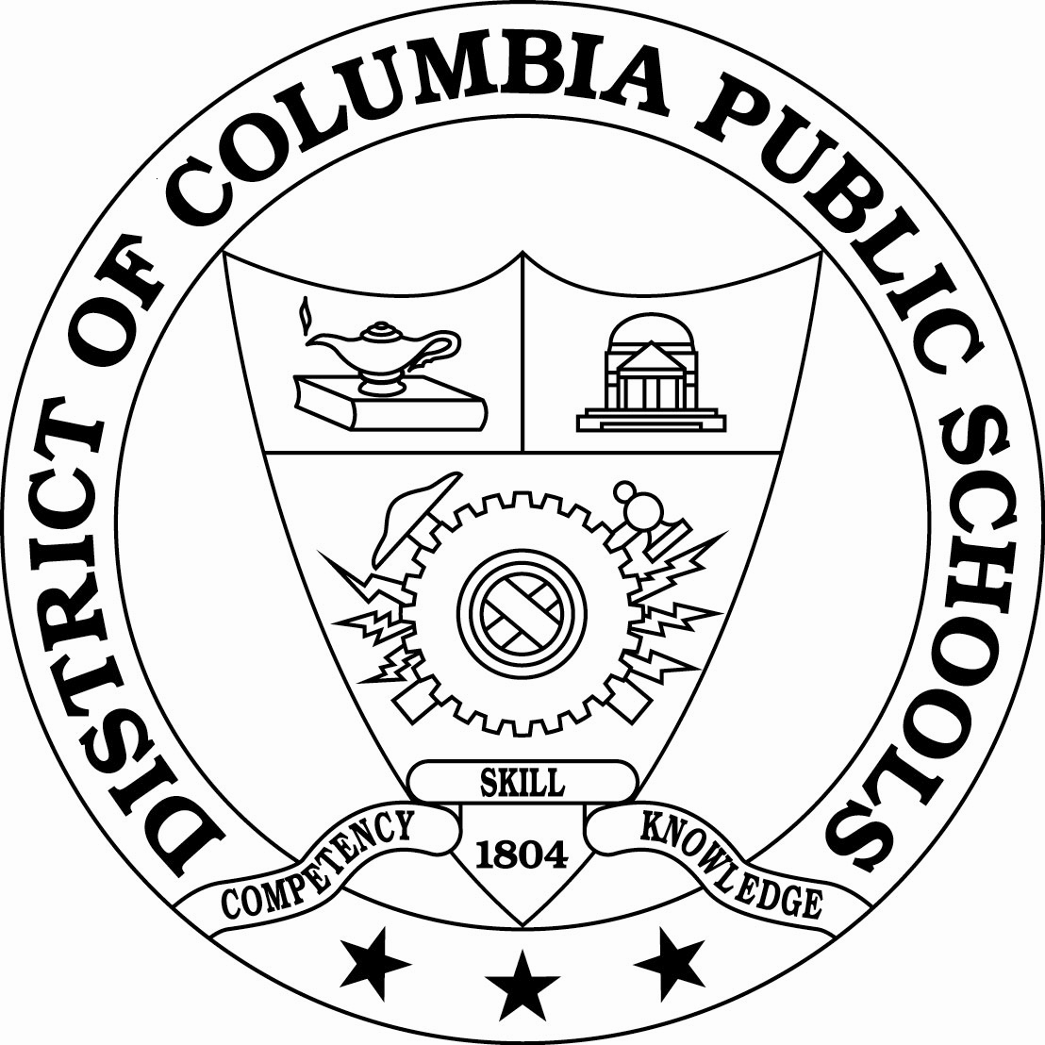

Office of Data and Accountability

District of Columbia Public Schools
825 North Capitol Street, NE
Washington, DC 20002
MEMORANDUM OF AGREEMENT BETWEEN THE DISTRICT OF COLUMBIA PUBLIC SCHOOLS AND THE URBAN INSTITUTE

I. Introduction

This Memorandum of Agreement (MOA) is entered into between the District of Columbia Public Schools (DCPS) and The Urban Institute, an independent, nonpartisan think tank that analyzes policies, evaluates programs, and informs community development to improve social, civic, and economic well-being, as of the last date set forth on the signature page hereto.

The purpose of this agreement is to document the terms under which DCPS will provide access to information, including personally-identifiable student information, for approved research projects and to designate authorized representatives of the parties consistent with applicable federal and state laws concerning access to and confidentiality of student record information. This MOA must be accompanied by a research proposal approved by DCPS.

During the term of this MOA both parties will take necessary steps to facilitate the implementation of the provisions outlined in the MOA.

II. Overview of Project Purpose, Scope and Duration
The Urban Institute is requesting using DCPS student-level data for the 2009 Housing in the Nation’s Capital (HNC) report (funded by the Fannie Mae Corporation) and two affiliated policy briefs funded by the Open Society Institute (the “Project”).

The HNC report is an annual report and the purpose of it is to update basic housing market information (prices, volume, building permits, etc) in the District and the region as well as focus on a special topic each year. The 2009 edition’s special focus will be on subprime lending and foreclosures in the District and region. We intend to match the 2003-04 through 2008-09 DCPS student level data to foreclosure data to analyze the students, schools, and neighborhoods affected by foreclosures. We also hope to determine where families move post foreclosures using linked SY2007-08 and SY2008-09 DCPS student-level data. The HNC report is expected to be released in the fall of 2009.

The Urban Institute will also conduct the same analysis of the 2003-04 through 2008-09 DCPS student-level data for two in-depth policy briefs targeting DCPS students and foreclosures funded by the Open Society Institute. Due to the limited space in the HNC report, the Open Society Institute policy briefs will allow more in-depth analysis, reporting, and suggested policy solutions for the District. The first policy brief will focus exclusively on the District, and the second policy brief will be a cross-site brief including analysis from Washington, D.C; Baltimore, MD; and New York, New York. The policy briefs are expected to be released in 2010. A complete description of the Project is attached hereto as “Attachment A.”

III. Statement of Purpose

This MOA sets forth the requirements for the sharing of certain data by DCPS with Researcher. The data will be used by Researcher for the sole purpose described in this MOA. The Project will assist DCPS in highlighting the concentrations of DCPS students and schools affected by foreclosure and assisting DCPS officials to target services and instruction to those students and schools in need. Research supports that residential moves can negatively affect children’s educational outcomes, particularly when foreclosure leads to ongoing housing instability for families. Families formally living in foreclosed homes (either owned themselves or rented) may be forced into precarious housing situations such as transitional housing or homelessness. The ultimate purpose of the project is to provide analysis so that DCPS administrators (i.e., principals, school counselors, and homeless/housing counselors) can work with teachers in schools affected by the foreclosure crisis to provide additional assistance to their students easing the stress of housing instability. This can include specialized instruction (for academics and behavioral) and counseling (for behavior, adjustment, and housing possibilities for the family). In addition, the Urban Institute’s analysis can provide DCPS with the tools to create a standardized response to the effect of the housing crisis on its students and families.

IV. Data Disclosure and Funding

To complete the Project, the Researcher will have access to DCPS student level data from SY2003-04 through SY2008-09 for a limited duration, for use in the Project identified in this MOA and any amendments to it. The Urban Institute already has these data for previous research projects (see attached MOA and amendment I of the MOA); therefore, DCPS is not required to provide any additional data for this new analysis.

DCPS will not be responsible for funding any component of the project.

V. Terms and Conditions

To affect the transfer of data and information that is subject to federal and local confidentiality laws, and to ensure that the required confidentiality of personally identifiable information shall always be maintained, Researcher agrees:

- To comply in all respects with the provisions outlined in the DCPS Process and Requirements to Conduct Research or Obtain Confidential Data attached hereto as “Attachment B” (“DCPS Data Policy”).
- To comply in all respects with the provisions of the Family Educational Right to Privacy Act (FERPA) (20 U.S.C. § 1232g; 34 CFR Part 99). Researcher will notify DCPS in the event of a breach of any measures to keep confidential the data received pursuant to this MOA. Researcher will also make all reasonable efforts to cure any such breach and to prevent further breaches, and to inform DCPS of such efforts. Nothing in this agreement shall be construed to allow Researcher to maintain, use, disclose, or share data received pursuant to this MOA in a manner prohibited by any federal or District of Columbia laws or regulations.
- To obtain all necessary approvals from authorized officials of Researcher prior to beginning the Project. Researcher will also obtain informed consent from Project participants as described in the DCPS Data Policy.
- That for purposes of this Project and for ensuring Researcher’s compliance with the terms of this MOA and all applicable local and federal laws, Researcher shall designate an official to act as temporary custodian of the data received by Researcher pursuant to this MOA and the contact person for all matters related to this MOA, which person shall initially be the Researcher representative identified in Section IX (“Temporary Custodian”). Researcher will promptly notify DCPS of the name and contact information for any newly designated Temporary Custodian. The Temporary Custodian shall be responsible for transmitting all data requests and maintaining a log or other record of all data requested and received pursuant to the MOA, including confirmation of completion of the Project, destruction of DCPS data and certification of that destruction. DCPS or its agents may upon request review the records required to be kept by Researcher under this MOA.
- To use data shared under the MOA for no purpose other than the research project described in this agreement, and as authorized under 34 CFR §§ 99.31(a)(6). Nothing in the MOA shall be construed to authorize Researcher to have access to DCPS data beyond that included in the scope of the MOA, or to permit access to such data by entities other than the Parties. Researcher further agrees not to share data received under the MOA with any other entity, except as permitted by this MOA and applicable law. Researcher understands that the MOA does not convey ownership of DCPS data to Researcher.
- To put procedures in place to safeguard the confidentiality and integrity of personal data, to place limitations on its use and to maintain compliance with applicable privacy laws. Researcher shall require all employees, contractors, and agents of any kind to comply with the MOA, the DCPS Data Policy, the DCPS Confidentiality Agreement and all applicable provisions of FERPA and other laws with respect to the data and information shared under the MOA. Researcher agrees to require and maintain a confidentiality agreement from each employee, contractor, or agency with access to data pursuant to the MOA in the form of “Attachment C”. Nothing in this section authorizes Researcher to share data and information provided under the MOA with any other individual or entity for any purpose.
- That personally identifiable information collected in the course of conducting the Project is confidential. Researcher will not disclose data produced to it under the MOA in any manner that could identify any individual or school, except as authorized by FERPA, to any entity other than DCPS, or authorized employees, contractors, and agents of Researcher working on the Project. Researcher and persons participating in the Project on behalf of the Parties shall neither disclose nor otherwise release data and reports relating to an individual or school, nor disclose information relating to a group or category of individuals without ensuring the confidentiality of individuals in that group. Publications and reports of these data and information related to them, including preliminary project descriptions and draft reports, shall involve only aggregate data and no personally identifiable information or other information that could lead to the identification of any individual or school.
- To not provide any data obtained under this MOA to any entity or person ineligible to receive data protected by FERPA, or prohibited from receiving data from any entity by virtue of a finding under 34 CFR § 99.31(a)(6)(iv).
- Upon termination of the MOA or two years after the publication of reports related to the Project, whichever occurs first, to return all data files and hard copy records transferred pursuant to the MOA to DCPS and purge any copies of such data from its computer systems. Researcher agrees to require all employees, contractors, or agents of any kind working on the Project to comply with this provision. No entity is authorized to continue research using the data obtained under the MOA upon the termination of this agreement and the Project described herein. Researcher will destroy all data obtained under the MOA and amendments to it when no longer needed for the Project. Nothing in this MOA authorizes Researcher to maintain data beyond the time period needed to complete the Project.
- That Researcher has the right, consistent with scientific standards, to publish, present, or use the study results from the Project, but only if the publication, presentation or use does not permit personal identification of DCPS students or their parents by individuals other than representatives of Researcher. In order to protect the confidentiality of previously identified confidential information disclosed to Researcher, Researcher agrees to provide to DCPS any proposed publications or presentations which are to make public any findings, data, or results of the Project for DCPS's review, comment and approval at least fourteen (14) days prior to submission of a manuscript or abstract for publication or the date of the presentation.
- To provide DCPS with one electronic and at least one paper copy of the final versions of all reports and other documents associated with the Project. DCPS reserves the right to use the information in the research report and research findings for educational programming or services, planning, solicitation of grants, staff development, and any other purposes to improve instruction or services to DCPS students.
- To provide DCPS with one electronic copy and at least one paper copy of the data files, codebooks and the computer code/instrument used to create data analysis files and perform analyses for the Project. DCPS agrees to keep these files for at least seven years.

VI. Authorization and Related Parties.

Researcher’s signatory to this agreement represents that it is authorized to bind Researcher to all terms of the MOA, and to bind all related or associated institutions, individuals, employees or contractors who may have access to data received pursuant to this MOA or who may own, lease, or control equipment or facilities of any kind where the data is stored, maintained or used in any way.

VII. Term and Termination

This MOA takes effect upon signature by the authorized representative of each Party and shall remain in effect for five (5) years thereafter or through completion of the Project, whichever occurs first. Early termination of the MOA shall occur upon written notice of termination by either party. The MOA is renewable for additional periods upon mutual written agreement by the authorized representatives of each party. DCPS reserves the right to request additional changes to approved research proposals.

VIII. Indemnification

Researcher agrees to hold harmless and indemnify DCPS and the District of Columbia and their officers, agents, employees and independent contractors for and against all losses and liabilities, including any resulting expenses and costs, without limitation, arising out of Researcher’s use of any data provided by DCPS under this MOA

IX. Notices

The following individuals are the contact points for each party under this MOA:

[RESEARCHER]

Office of Data and Accountability contact person:

[DISTRICT AGENCY]

These individuals are responsible for the management and coordination of the requirements for each respective party under this agreement. Copies of correspondence related to the modification, amendment, extension or termination of this agreement, or any other legal matter pertaining to this agreement, shall be furnished to these individuals with additional copies to:

[DISTRICT AGENCY]

X. Miscellaneous

- Researcher may not assign any right, obligation or other interest under the MOA to any third party.

- This MOA constitutes and contains the entire agreement between the Parties with respect to the subject matter hereof and supersedes any prior and contemporaneous oral or written agreements between the Parties.

- Any dispute arising under this agreement shall be resolved in accordance with the laws of the The District of Columbia.

- This agreement may be executed in two or more counterparts, all of which shall have the same force and effect.

- The terms of this MOA may be modified only upon a prior written amendment agreement executed by the Parties.

- The Parties have caused this agreement to be executed by their duly authorized representatives. By signing this agreement DCPS and Researcher signify that each party understands and will comply with the conditions stated above.

District of Columbia Public Schools

_____________________ _____________________________
[name] Date
Chancellor
[LEA]

Researcher/organization

______________________________ ______________________________
[name] Date
[organization]

