Youth UpRising East Oakland Park Survey
Summary Report
December 20, 2010

Prepared by:
Urban Strategies Council

Authors:
Steve Spiker
Leah Skahen
Steve King

Contents
Introduction 3
Summary Findings 4
Methodology 4
Scores and Ratings 5
Individual Park Results 7
Arroyo Viejo 7
Carney Park 8
Coliseum Gardens Park 9
Columbian Gardens Park 10
Concordia Park 11
Elmhurst Plaza Park 12
Holly Mini Park 13
Ira Jinkins/Brookfield Park 14
Rainbow Park 15
Sobrante Park 16
Stonehurst Park 17
Tassafaronga Park 18
Verdese Carter Park 19
88th Avenue Mini Park 20
Appendix 21
Full Survey Results 21
Maps

Introduction

During the summer of 2010, research staff from Urban Strategies Council worked with students from the Mayor’s Summer Jobs Program at Youth UpRising to implement a survey of all the public parks in East Oakland. The purpose of the survey was to assess the physical conditions of various elements within each of the parks. In consultation with the Oakland Parks Coalition (OPC), Urban Strategies Council adapted OPC’s detailed 56 question park survey instrument for use in the East Oakland park assessment. Upon completion of the East Oakland survey by the students at Youth UpRising, the results were submitted to OPC as a contribution to their 2010 evaluation of Oakland parks.
The survey was conducted at a total of 14 parks, all within the boundary of the California Endowment’s East Oakland Building Healthy Communities initiative planning area. The parks include:

Arroyo Viejo Park
Carney Park
Coliseum Gardens
Concordia Park
Rainbow Park
88th Avenue Mini Park
Columbian Gardens Park
Elmhurst Plaza Park
Holly Mini Park
Ira Jinkins/Brookfield Park
Sobrante Park
Stonehurst Park
Tassafaronga Park
Verdese Carter Park

The survey consisted of 56 questions over nine major categories. The nine categories correspond to various physical park elements, including:

Litter
Picnic Areas
Restrooms
Hardscape, Furniture, and Signage
Drainage and Irrigation
Greenery (Ground Cover, Trees, Flowers)
Recreation Centers (Exterior Only)
Outdoor Sports Areas
Outdoor Children's Play Areas

Given the variety of types of parks included in the survey, all of the nine major categories of park features were not necessarily present at—or relevant to—each park. For instance, not all parks have formal recreation centers or sports fields. Accordingly, not all 56 of the survey questions garnered responses at each park. In addition to the maximum of 56 questions, each of the nine major categories for each park was assigned a rating. Finally, each of the 14 parks was assigned an overall park rating. The surveyors also had the ability to note any special comments or concerns in a narrative section of the survey.

Summary Findings

Methodology

Overall Park Scoring
Surveyors assigned each park an overall rating: Good, Needs Improvement, or Poor.
Composite Scoring
Two different composite scores—“Coarse” and “Fine”—were calculated for each park. The “Coarse” scoring is based on the ratings for each of the nine major categories at each park, while the “Fine” scoring is based on the sum of points from the entire 56 question survey battery.
Coarse Composite Score
For each “Good” rating in a category, the park was assigned one point; for each “Needs Improvement” it received two points; and for each “Poor” rating it received three points. For “N/A” no points were designated. The composite score is a sum of points in all ten categories. The average score is the composite score divided by the total number of categories assessed (i.e. does not include “N/A” categories in the denominator).

Fine Composite Score
The survey was designed so that “yes” and “mostly” answers always correspond with good conditions, and “partly” and “no” answers indicate poor conditions. For each “yes” answer, the park received 1 point; for each “mostly” answer 2 points were awarded; for each “partly” the park received 3 points; and for each “no” answer 4 points were designated. For “N/A” no points were designated. The composite score is a sum of points for all 56 questions.

Scores

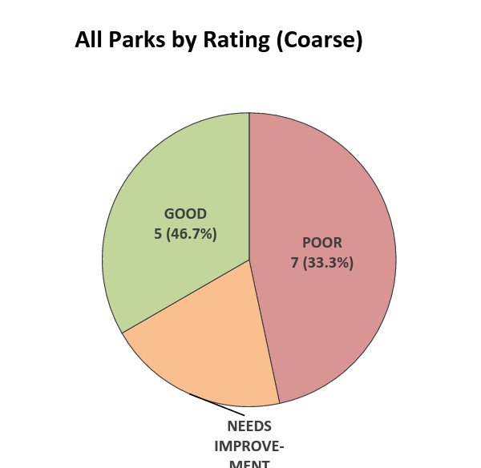

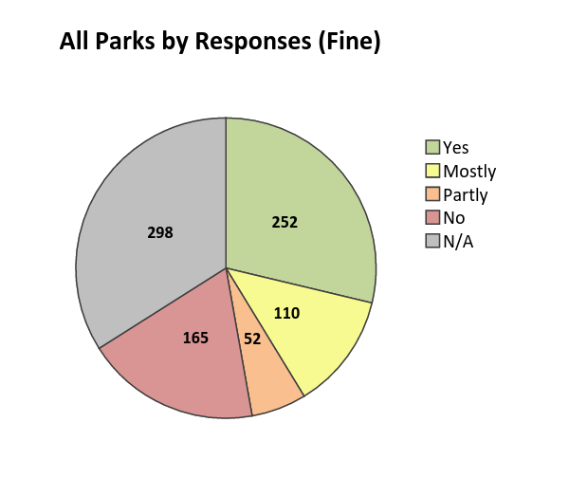
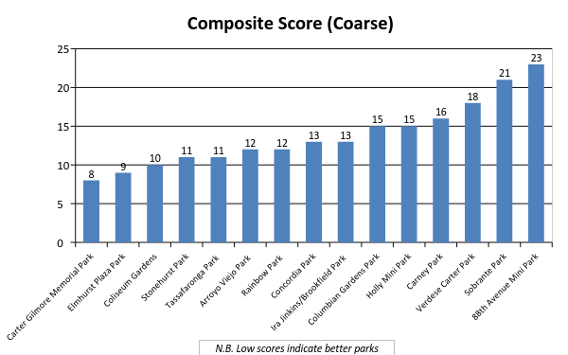
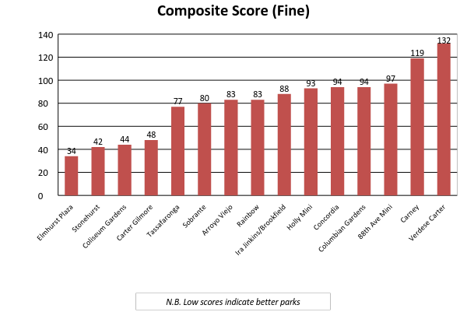

Ratings

Summaries of ratings for individual categories
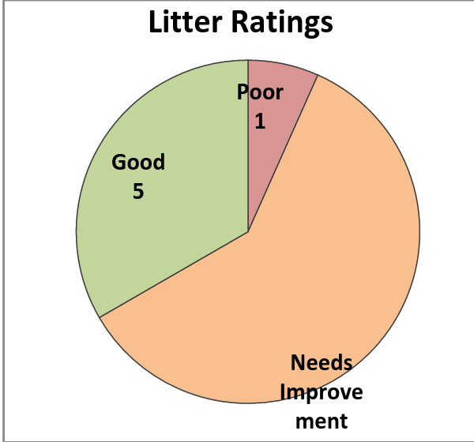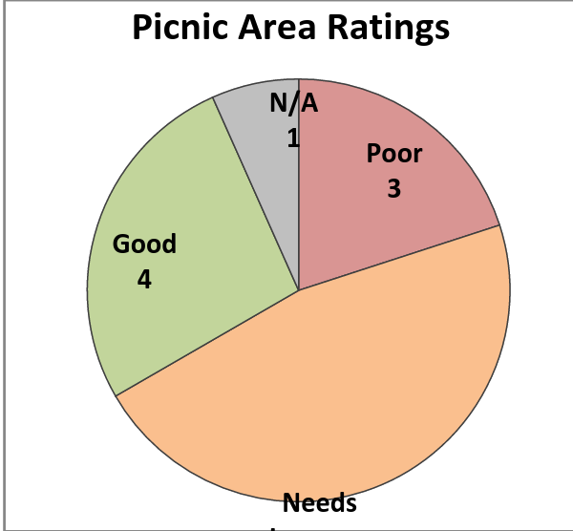
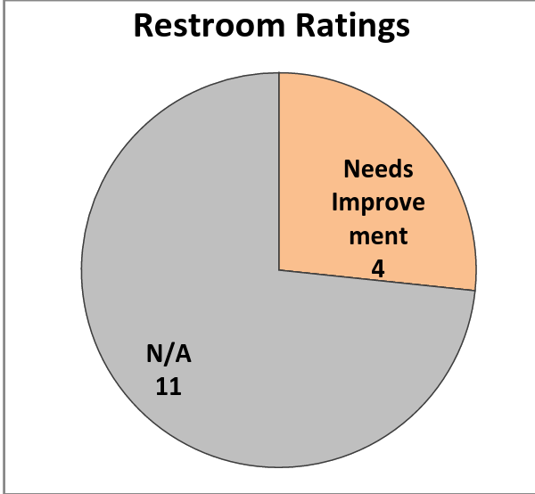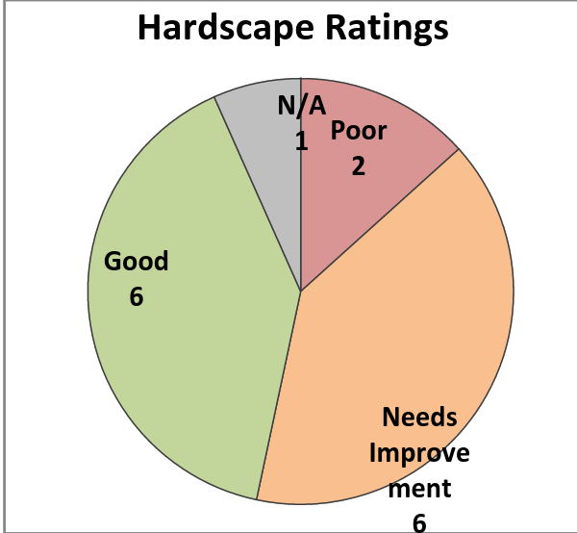
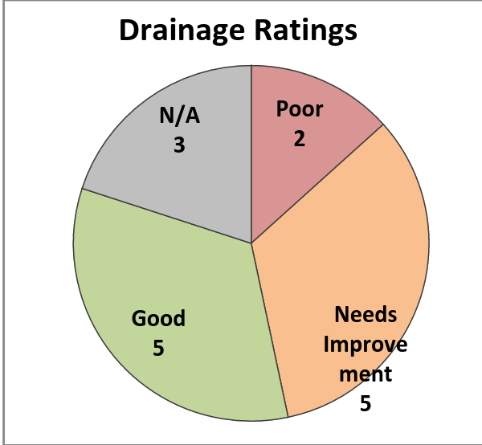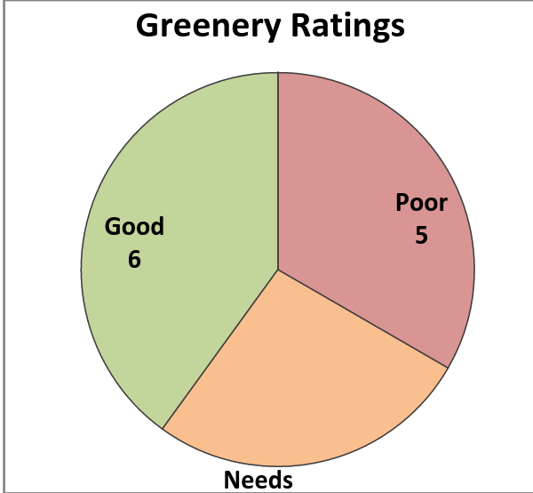
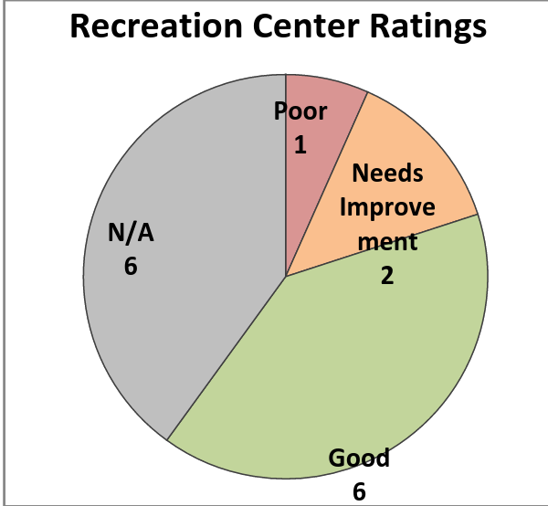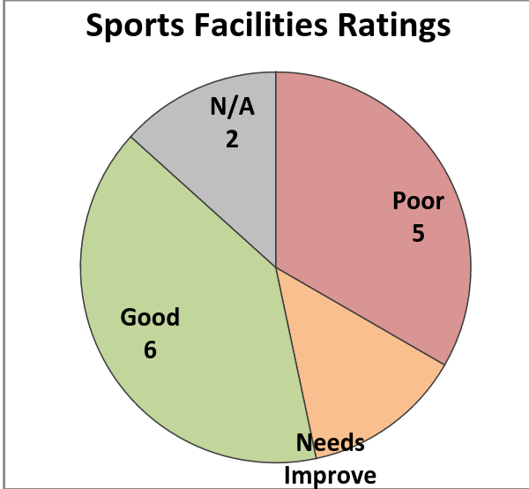
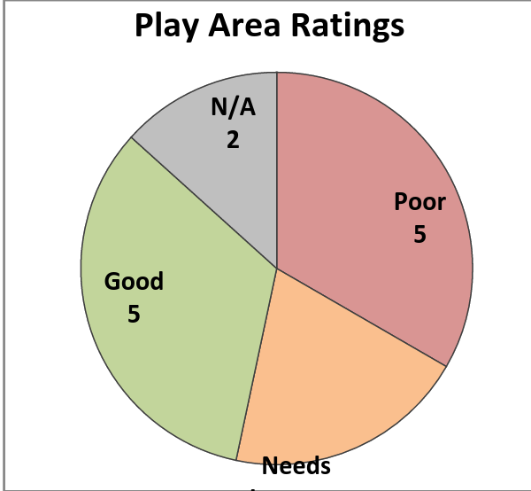

Individual Park Results

Arroyo Viejo
7701 Krause Avenue
ACREAGE: 18.75
SCORE: 12
RANK: T6

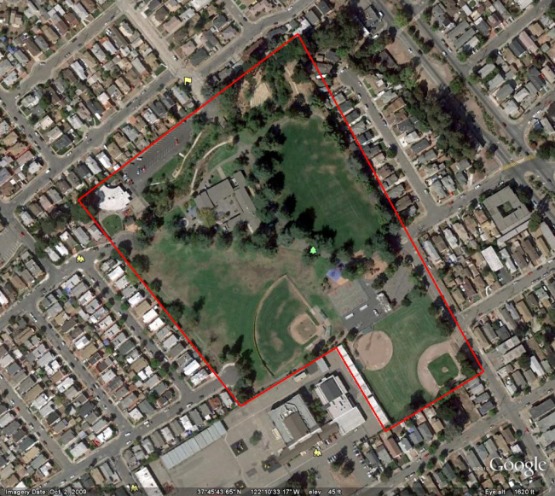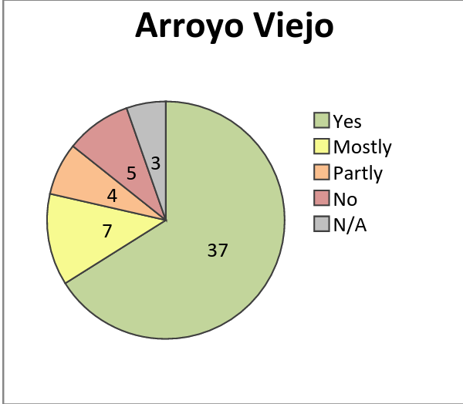
 | OVERALL RATING
- Litter in Park | Good
- Park Picnic Areas | Needs Improvement
- Park Restrooms | Needs Improvement
- Hardscape, furniture, signage | Good
- Drainage and Irrigation Systems in Park | Needs Improvement
- Greenery (Ground Cover, Trees, Flowers, etc) | Good
- Recreation Centers (Exterior Only) | Good
- Outdoor Sports Areas | Good
- Outdoor Children's Play Areas | Good
- Park Overall Rating | Good
Composite score (coarse) | 12
Composite score (fine) | 83
Rank (coarse) | T6
Rank (fine) | T7

Carney Park

10501 Acalanes Drive
ACREAGE: 0.44
SCORE: 16
RANK: 12

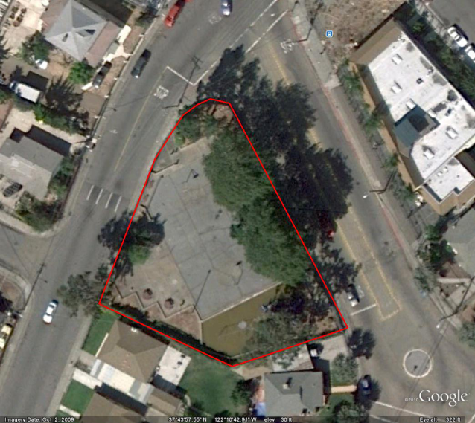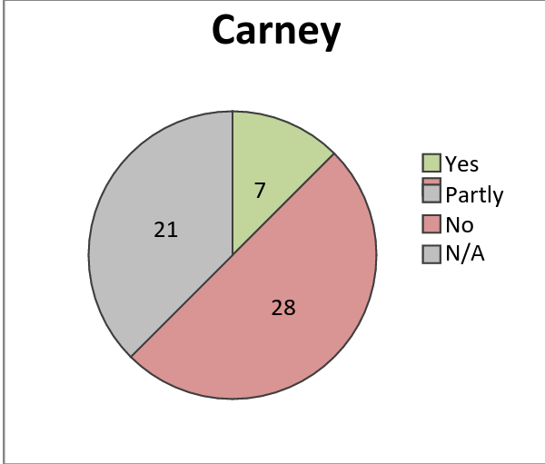
 | OVERALL RATING
- Litter in Park | Needs Improvement
- Park Picnic Areas | Poor
- Park Restrooms | N/A
- Hardscape, furniture, signage | Needs improvement
- Drainage and Irrigation Systems in Park | N/A
- Greenery (Ground Cover, Trees, Flowers, etc) | Poor
- Recreation Centers (Exterior Only) | N/A
- Outdoor Sports Areas | Poor
- Outdoor Children's Play Areas | Poor
- Park Overall Rating | Poor
Composite score (coarse) | 16
Composite score (fine) | 119
Average | 2.67
Rank (coarse) | 12
Rank (fine) | 14

Coliseum Gardens Park

966 66th Avenue
ACREAGE: 4.85
SCORE: 10
RANK: 3
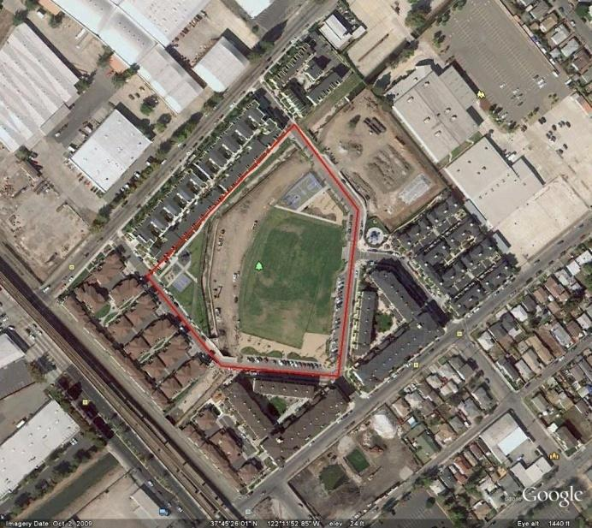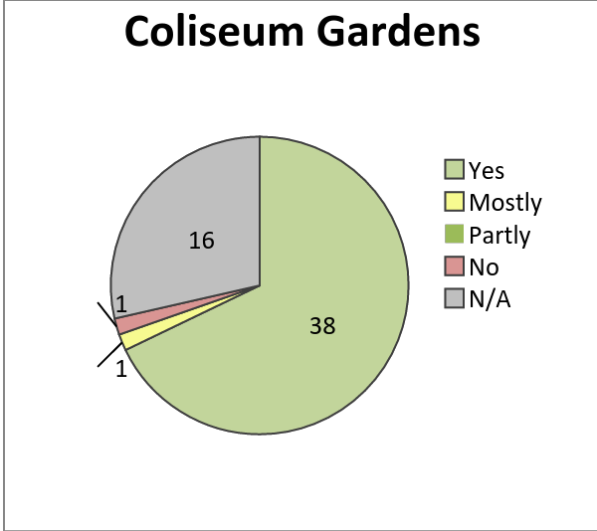
 | OVERALL RATING
- Litter in Park | Good
- Park Picnic Areas | Good
- Park Restrooms | N/A
- Hardscape, furniture, signage | Needs improvement
- Drainage and Irrigation Systems in Park | Good
- Greenery (Ground Cover, Trees, Flowers, etc) | Needs improvement
- Recreation Centers (Exterior Only) | Good
- Outdoor Sports Areas | Good
- Outdoor Children's Play Areas | Good
- Park Overall Rating | Good
Composite score (coarse) | 10
Composite score (fine) | 44
Average | 1.25
Coarse rank | 3
Fine rank | 3

Columbian Gardens Park
9920 Empire Road
ACREAGE: 2.33
SCORE: 15
RANK: T10
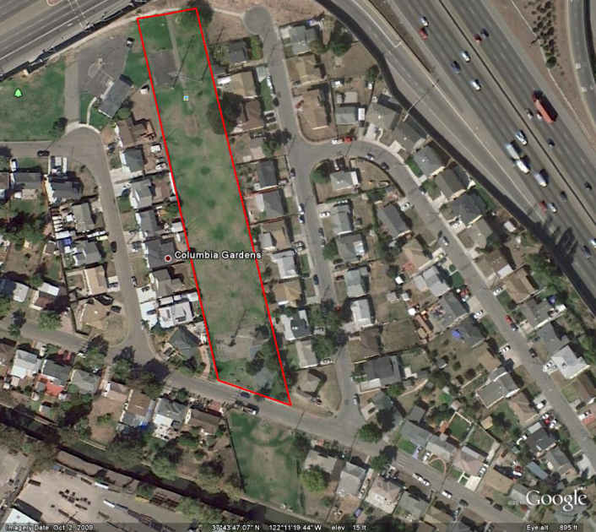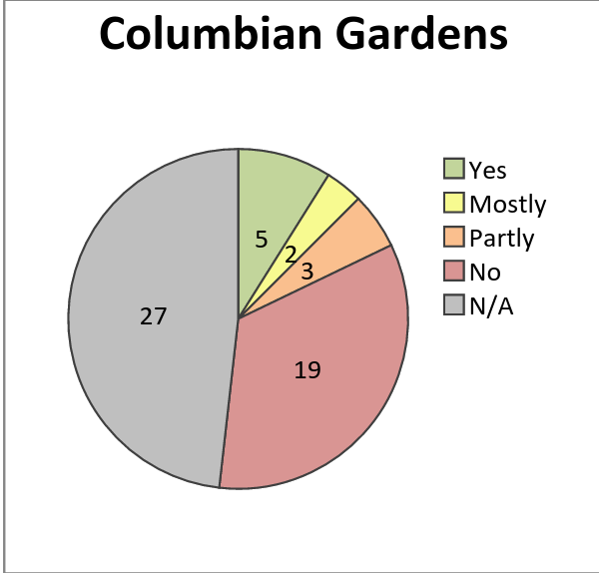
 | OVERALL RATING
- Litter in Park | Needs Improvement
- Park Picnic Areas | Needs Improvement
- Park Restrooms | N/A
- Hardscape, furniture, signage | Needs Improvement
- Drainage and Irrigation Systems in Park | N/A
- Greenery (Ground Cover, Trees, Flowers, etc) | Poor
- Recreation Centers (Exterior Only) | N/A
- Outdoor Sports Areas | Poor
- Outdoor Children's Play Areas | Poor
- Park Overall Rating | Poor
Composite score (coarse) | 15
Composite score (fine) | 94
Average | 2.5
Coarse rank | T10
Fine rank | 12

Concordia Park

2901 64th Avenue
ACREAGE: 3.51
SCORE: 13
RANK: T8
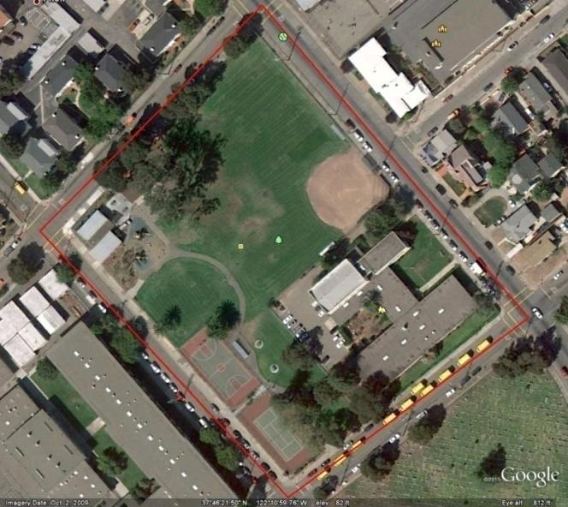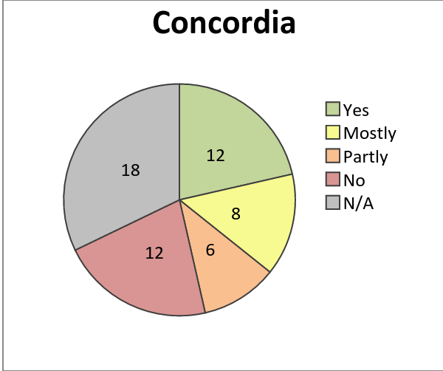
 | OVERALL RATING
- Litter in Park | Needs Improvement
- Park Picnic Areas | Good
- Park Restrooms | N/A
- Hardscape, furniture, signage | Good
- Drainage and Irrigation Systems in Park | Needs Improvement
- Greenery (Ground Cover, Trees, Flowers, etc) | Good
- Recreation Centers (Exterior Only) | Good
- Outdoor Sports Areas | Good
- Outdoor Children's Play Areas | Needs Improvement
- Park Overall Rating | Needs Improvement
Composite score (coarse) | 13
Composite score (fine) | 94
Average | 1.44
Coarse rank | T8
Fine rank | T11

Elmhurst Plaza Park
9700 C Street
ACREAGE: 2.01
SCORE: 9
RANK: 2
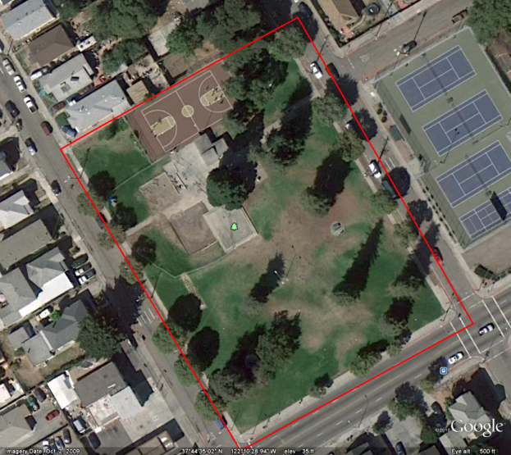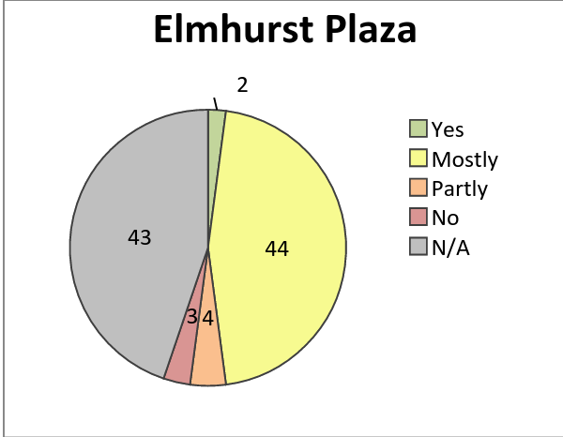

 | OVERALL RATING
- Litter in Park | Needs Improvement
- Park Picnic Areas | N/A
- Park Restrooms | N/A
- Hardscape, furniture, signage | N/A
- Drainage and Irrigation Systems in Park | Needs Improvement
- Greenery (Ground Cover, Trees, Flowers, etc) | Needs Improvement
- Recreation Centers (Exterior Only) | N/A
- Outdoor Sports Areas | Poor
- Outdoor Children's Play Areas | N/A
- Park Overall Rating | Poor
Composite score (coarse) | 9
Composite score (fine) | 34
Average | 2.25
Coarse rank | 2
Fine rank | 1

Holly Mini Park
9830 Holly Street
ACREAGE: 0.35
SCORE: 15
RANK: T10
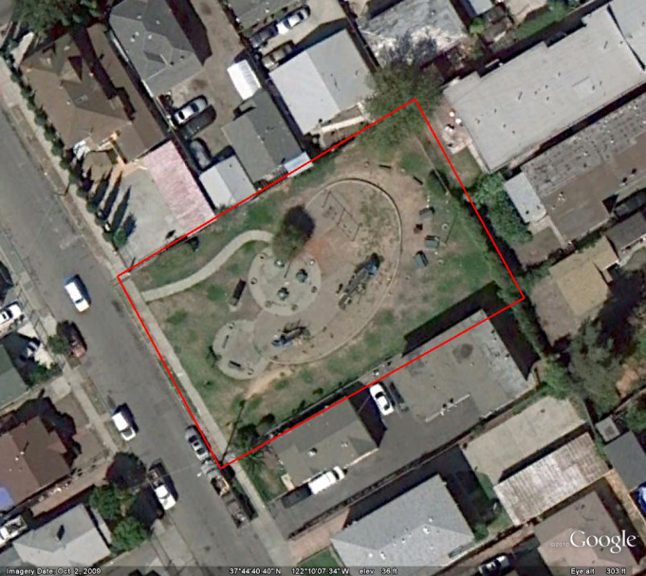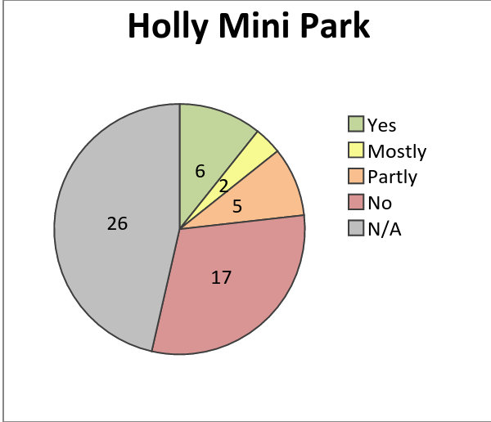
 | OVERALL RATING
- Litter in Park | Needs Improvement
- Park Picnic Areas | Needs Improvement
- Park Restrooms | N/A
- Hardscape, furniture, signage | Needs Improvement
- Drainage and Irrigation Systems in Park | Poor
- Greenery (Ground Cover, Trees, Flowers, etc) | Poor
- Recreation Centers (Exterior Only) | N/A
- Outdoor Sports Areas | N/A
- Outdoor Children's Play Areas | Poor
- Park Overall Rating | Poor
Composite score (coarse) | 15
Composite score (fine) | 93
Average | 2.5
Coarse rank | T10
Fine rank | 10

Ira Jinkins/Brookfield Park
9175 Edes Avenue
ACREAGE: 14.0
SCORE: 13
RANK: T8
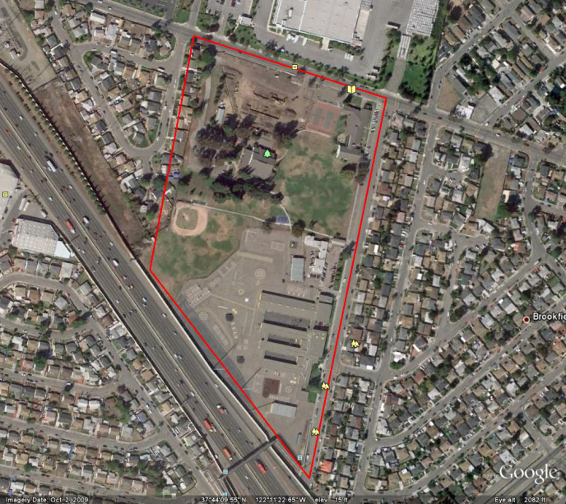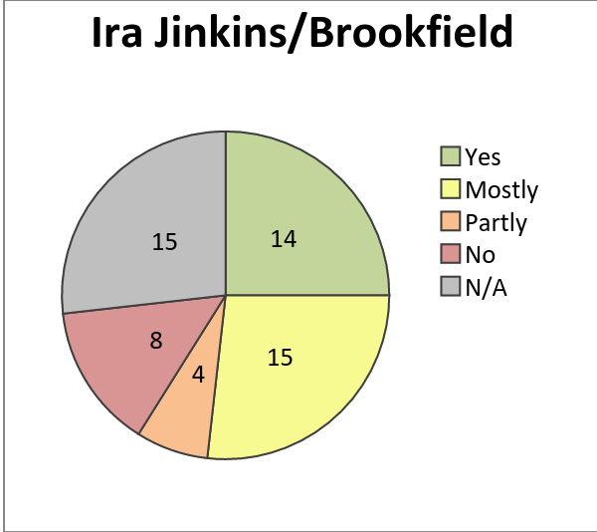
 | OVERALL RATING
- Litter in Park | Needs Improvement
- Park Picnic Areas | Needs Improvement
- Park Restrooms | N/A
- Hardscape, furniture, signage | Good
- Drainage and Irrigation Systems in Park | Good
- Greenery (Ground Cover, Trees, Flowers, etc) | Good
- Recreation Centers (Exterior Only) | Good
- Outdoor Sports Areas | Good
- Outdoor Children's Play Areas | Needs Improvement
- Park Overall Rating | Needs Improvement
Composite score (coarse) | 13
Composite score (fine) | 88
Average | 1.44
Coarse rank | T8
Fine rank | 9

Rainbow Park

5800 International Boulevard

ACREAGE: 2.44
SCORE: 12
RANK: T6
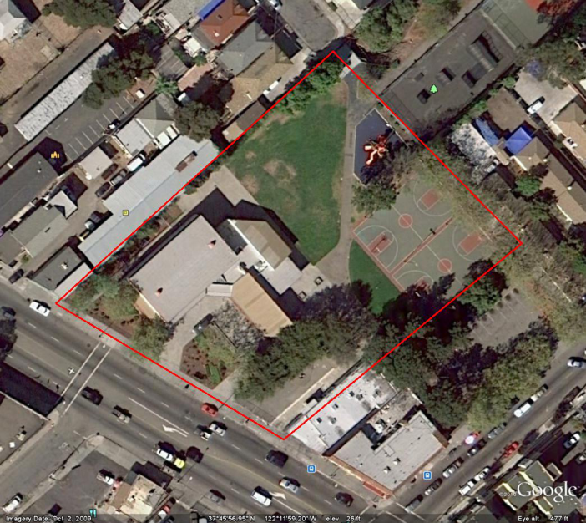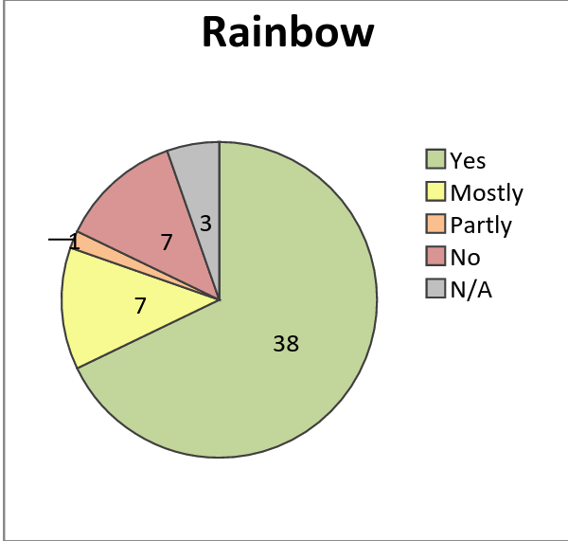

 | OVERALL RATING
- Litter in Park | Good
- Park Picnic Areas | Needs Improvement
- Park Restrooms | Needs Improvement
- Hardscape, furniture, signage | Good
- Drainage and Irrigation Systems in Park | Good
- Greenery (Ground Cover, Trees, Flowers, etc) | Good
- Recreation Centers (Exterior Only) | Good
- Outdoor Sports Areas | Needs Improvement
- Outdoor Children's Play Areas | Good
- Park Overall Rating | Good
Composite score (coarse) | 12
Composite score (fine) | 83
Average | 1.33
Coarse rank | T6
Fine rank | 8

Sobrante Park
470 El Paseo Drive
ACREAGE: 4.69
SCORE: 21
RANK: 14
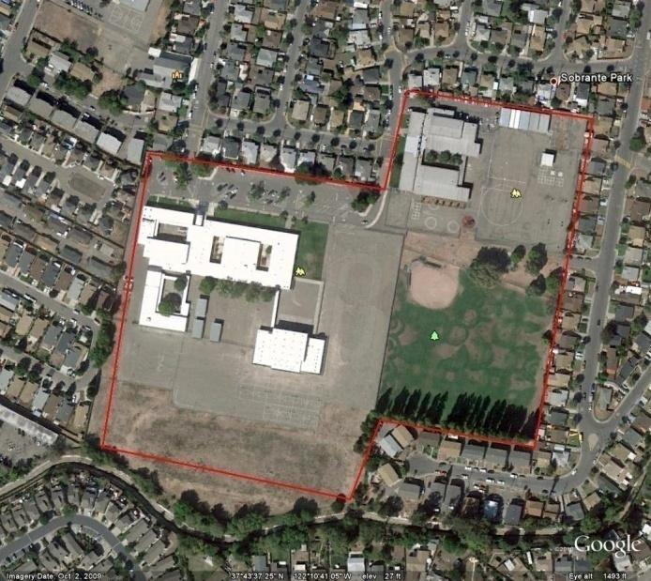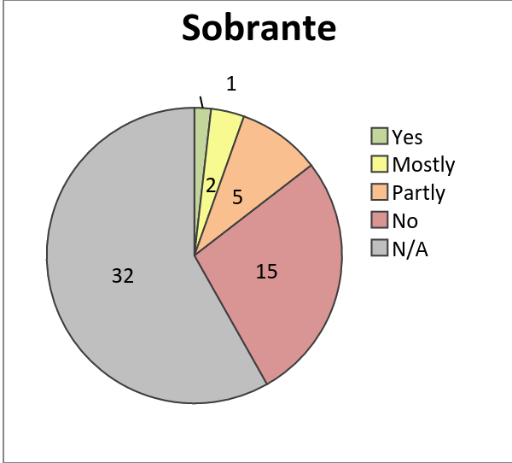
 | OVERALL RATING
- Litter in Park | Needs Improvement
- Park Picnic Areas | Needs Improvement
- Park Restrooms | Needs Improvement
- Hardscape, furniture, signage | Needs Improvement
- Drainage and Irrigation Systems in Park | Needs Improvement
- Greenery (Ground Cover, Trees, Flowers, etc) | Needs Improvement
- Recreation Centers (Exterior Only) | Poor
- Outdoor Sports Areas | Poor
- Outdoor Children's Play Areas | Poor
- Park Overall Rating | Poor
Composite score (coarse) | 21
Composite score (fine) | 80
Average | 2.33
Coarse rank | 14
Fine rank | 6

Stonehurst Park
10315 E Street
ACREAGE: 2.67
SCORE: 11
RANK: T4
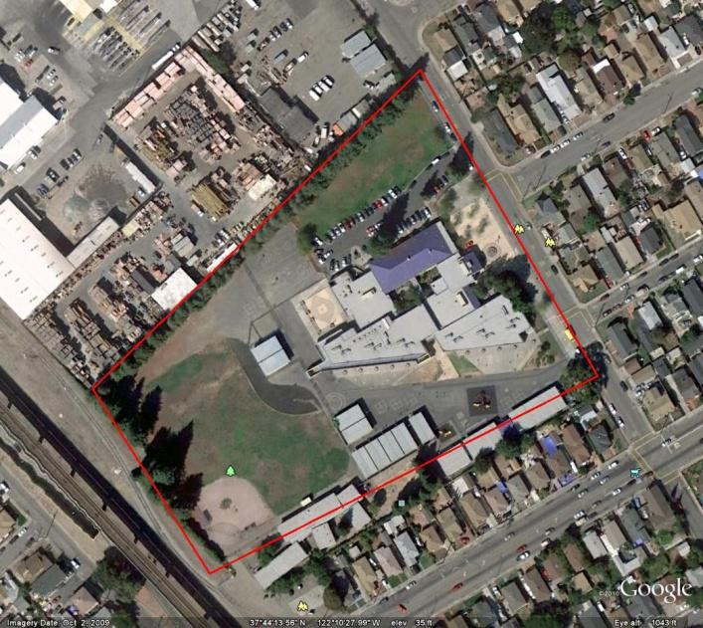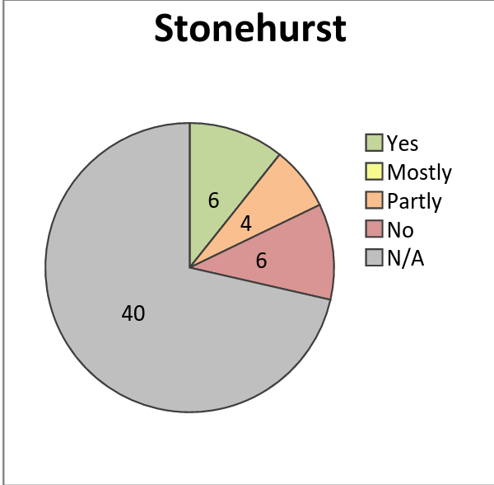
 | OVERALL RATING
- Litter in Park | Needs Improvement
- Park Picnic Areas | Poor
- Park Restrooms | N/A
- Hardscape, furniture, signage | Poor
- Drainage and Irrigation Systems in Park | N/A
- Greenery (Ground Cover, Trees, Flowers, etc) | Poor
- Recreation Centers (Exterior Only) | N/A
- Outdoor Sports Areas | N/A
- Outdoor Children's Play Areas | N/A
- Park Overall Rating | Poor
Composite score (coarse) | 11
Composite score (fine) | 42
Average | 2.75
Coarse rank | T4
Fine rank | 2

Tassafaronga Park
85th Avenue & E Street
ACREAGE: 2.50
SCORE: 11
RANK: T4
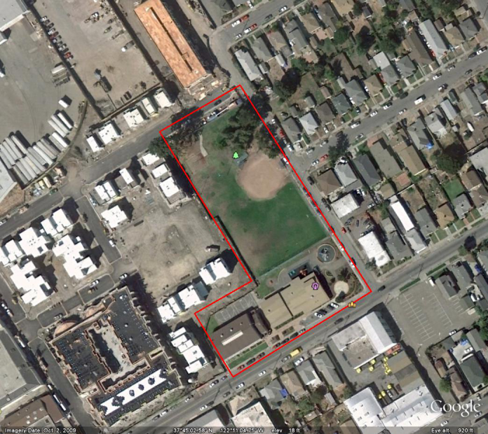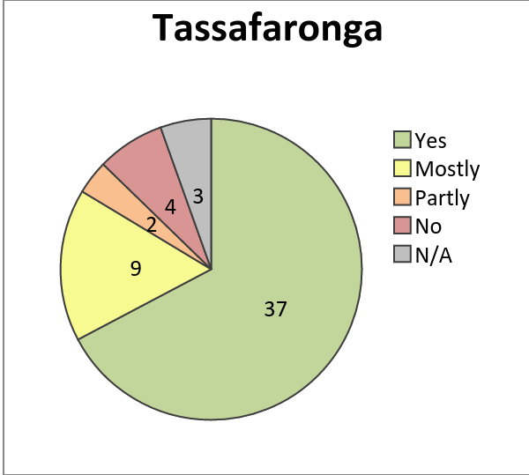
 | OVERALL RATING
- Litter in Park | Good
- Park Picnic Areas | Good
- Park Restrooms | Needs Improvement
- Hardscape, furniture, signage | Good
- Drainage and Irrigation Systems in Park | Good
- Greenery (Ground Cover, Trees, Flowers, etc) | Good
- Recreation Centers (Exterior Only) | Needs improvement
- Outdoor Sports Areas | Good
- Outdoor Children's Play Areas | Good
- Park Overall Rating | Good
Composite score (coarse) | 11
Composite score (fine) | 77
Average | 1.22
Coarse rank | T4
Fine rank | 5

Verdese Carter Park
9600 Sunnyside Street
ACREAGE: 3.36
SCORE: 18
RANK: 13
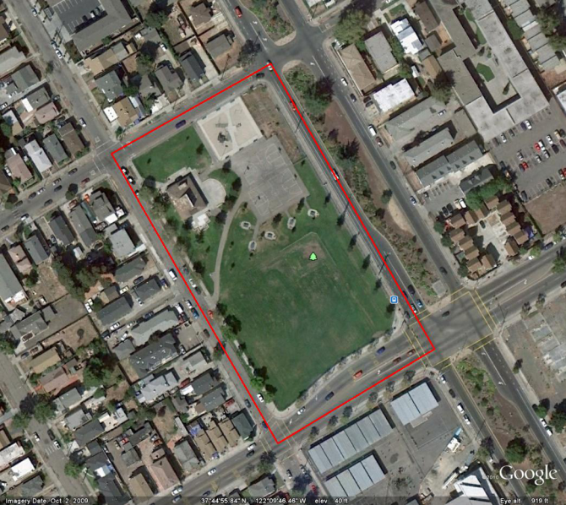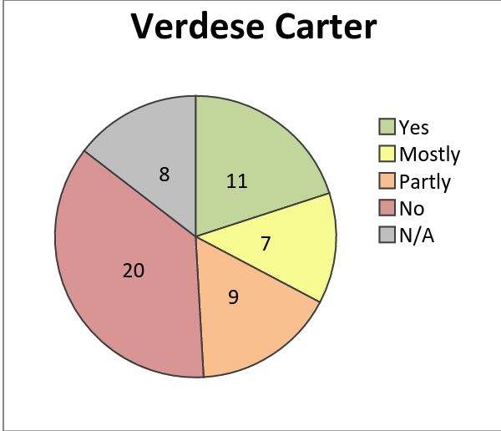
 | OVERALL RATING
- Litter in Park | Needs Improvement
- Park Picnic Areas | Needs Improvement
- Park Restrooms | N/A
- Hardscape, furniture, signage | Needs Improvement
- Drainage and Irrigation Systems in Park | Needs Improvement
- Greenery (Ground Cover, Trees, Flowers, etc) | Needs Improvement
- Recreation Centers (Exterior Only) | Needs Improvement
- Outdoor Sports Areas | Needs Improvement
- Outdoor Children's Play Areas | Needs Improvement
- Park Overall Rating | Needs Improvement
Composite score (coarse) | 18
Composite score (fine) | 132
Average | 2
Coarse rank | 13
Fine rank | 15

88th Avenue Mini Park
1722 88th Avenue
ACREAGE: 0.31
SCORE: 23
RANK: 15
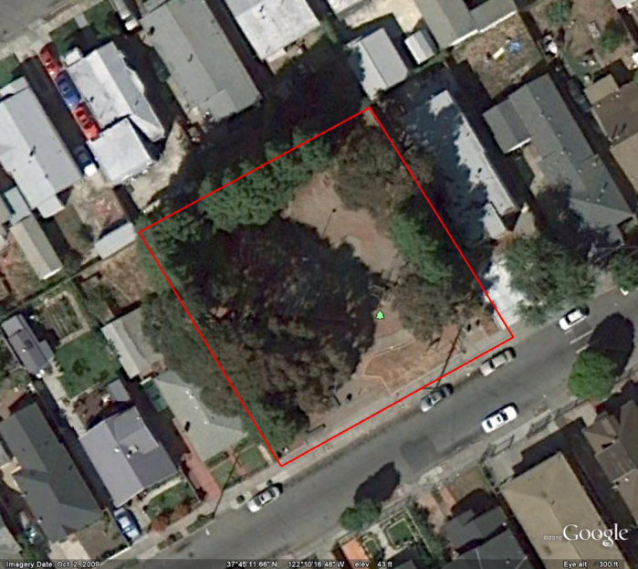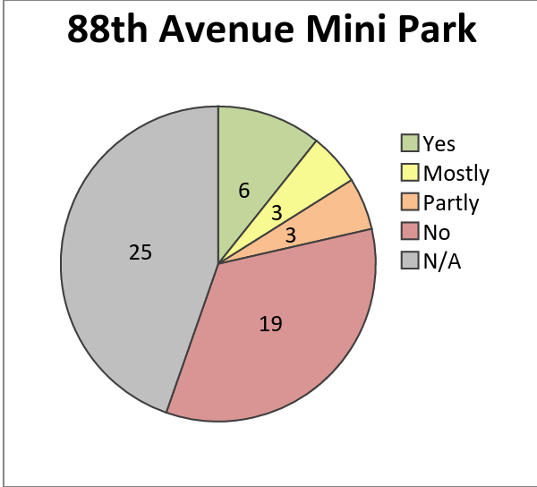
 | OVERALL RATING
- Litter in Park | Poor
- Park Picnic Areas | Poor
- Park Restrooms | N/A
- Hardscape, furniture, signage | Poor
- Drainage and Irrigation Systems in Park | Poor
- Greenery (Ground Cover, Trees, Flowers, etc) | Poor
- Recreation Centers (Exterior Only) | N/A
- Outdoor Sports Areas | Poor
- Outdoor Children's Play Areas | Poor
- Park Overall Rating | Poor
Composite score (coarse) | 23
Composite score (fine) | 97
Average | 2.88
Coarse rank | 15
Fine rank | 13

Appendix

Full Survey Results
 | East Oakland Park Survey - August 2010
 | Park Name | Arroyo Viejo Park |  | Carney Park |  | Coliseum Gardens |  | Concordia Park |  | Rainbow Park |  | 88th Avenue Mini Park |  | Columbian Gardens Park | Elmhurst Plaza Park | Holly Mini Park | Ira Jinkins/Brookfield Park
 | Survey Category
 | 1. Litter in Park
 | Are the grounds generally free of litter? | Mostly |  | No |  | Yes |  | Mostly |  | No |  | No |  | Partly | Mostly | Partly | Yes
 | Are trash receptacles available? | Yes |  | Yes |  | Yes |  | Partly |  | Yes |  | Mostly |  | Yes | N/A | Partly | Yes
 | Are trash receptacles emptied? | Mostly |  | No |  | Mostly |  | No |  | Yes |  | Yes |  | Yes | N/A | Yes | No
 | LITTER: Please give this category an OVERALL RATING. | Good |  | NI |  | Good |  | NI |  | Good |  | Poor |  | NI | NI | NI | NI
 | Comments regarding litter: |  |  | The park was actually closed but if it were open & the city took care of it it has potential |  |  |  |  |  |  |  |  |  |  | Needs trash cans, doesn't have any
 | 2. Park Picnic Areas
 | Are picnic areas litter-free? | Yes |  | No |  | Yes |  | Mostly |  | Mostly |  | No |  | Mostly | N/A | Yes | Yes
 | Are trash receptacles available? | Yes |  | No |  | Yes |  | Partly |  | Yes |  | Partly |  | Yes | N/A | Yes | Yes
 | Are drinking fountains for picnickers working? | Yes |  | No |  | Yes |  | N/A |  | No |  | No |  | No | N/A | No | No
 | Are barbecues in Good condition? | Partly |  | No |  | N/A |  | N/A |  | Yes |  | No |  | No | N/A | No | Partly
 | Are picnic benches & tables in Good condition? | Yes |  | Yes |  | Yes |  | Mostly |  | Mostly |  | Mostly |  | Partly | N/A | Partly | Mostly
 | Are picnic benches & tables graffiti-free? | Yes |  | No |  | Yes |  | Partly |  | Mostly |  | No |  | Yes | N/A | No | Mostly
 | PICNIC AREAS: Please give this category an OVERALL RATING. | NI |  | Poor |  | Good |  | Good |  | NI |  | Poor |  | NI | N/A | NI | NI
 | Park Name | Arroyo Viejo Park |  | Carney Park |  | Coliseum Gardens |  | Concordia Park |  | Rainbow Park |  | 88th Avenue Mini Park |  | Columbian Gardens Park | Elmhurst Plaza Park | Holly Mini Park | Ira Jinkins/Brookfield Park
 | Comments regarding picnic areas: |  |  |  |  |  |  |  |  |  |  |  |  | The park was deserted | No equipment for a barbeque | The tables are really small and close together
 | 3. Park Restrooms
 | Is the restroom open for use? | Yes |  | N/A |  | N/A |  | No |  | Yes |  | No |  | N/A | N/A | No | No
 | Are toilets clean & working? | No |  | N/A |  | N/A |  | N/A |  | Partly |  | N/A |  | N/A | N/A | N/A | No
 | Are sinks clean & working? | Mostly |  | N/A |  | N/A |  | N/A |  | Mostly |  | N/A |  | N/A | N/A | N/A | No
 | Are doors on stalls? | No |  | N/A |  | N/A |  | N/A |  | Yes |  | N/A |  | N/A | N/A | N/A | No
 | Do stall door locks work? | No |  | N/A |  | N/A |  | N/A |  | Yes |  | N/A |  | N/A | N/A | N/A | No
 | Are supplies (soap, paper towels, toilet paper) available? | Mostly |  | N/A |  | N/A |  | N/A |  | Yes |  | N/A |  | N/A | N/A | N/A | No
 | Are restrooms free of odor? | No |  | N/A |  | N/A |  | N/A |  | Yes |  | N/A |  | N/A | N/A | N/A | No
 | Are restrooms free of graffiti? | Yes |  | N/A |  | N/A |  | N/A |  | Yes |  | N/A |  | N/A | N/A | N/A | No
 | Are trash receptacles available? | Yes |  | N/A |  | N/A |  | N/A |  | Yes |  | N/A |  | N/A | N/A | N/A | No
 | RESTROOMS: Please give this category an OVERALL RATING | NI |  | N/A |  |  |  |  |  | NI |  | Poor |  | N/A | N/A | N/A | Poor
 | Comments regarding restrooms: |  |  |  |  |  |  |  |  |  |  |  |  |  | No restrooms | No restrooms | Restrooms are only available when park rec center is open
 | 4. Hardscape, furniture, signage
 | Is there a sign with the park name at an entrance? | Yes |  | No |  | No |  | No |  | Yes |  | Yes |  | Yes | N/A | Yes | Yes
 | Is there a sign with park rules at an entrance? | Yes |  | Yes |  | Yes |  | No |  | Yes |  | No |  | No | N/A | No | Yes
 | Are signs graffiti-free? | Mostly |  | Yes |  | Yes |  | No |  | No |  | Yes |  | No | N/A | No | Mostly
 | Are fences in Good condition? | Yes |  | Yes |  | Yes |  | Yes |  | Yes |  | N/A |  | N/A | N/A | N/A | Yes
 | Are gates working properly & open during posted hours? | Yes |  | Yes |  | N/A |  | N/A |  | Yes |  | N/A |  | N/A | N/A | N/A | Yes
 | Park Name | Arroyo Viejo Park |  | Carney Park |  | Coliseum Gardens |  | Concordia Park |  | Rainbow Park |  | 88th Avenue Mini Park |  | Columbian Gardens Park | Elmhurst Plaza Park | Holly Mini Park | Ira Jinkins/Brookfield Park
 | Are benches in Good condition? | Yes |  | No |  | N/A |  | Yes |  | Yes |  | Partly |  | Partly | N/A | Mostly | Mostly
 | Are walkways in Good condition? | Mostly |  | No |  | Yes |  | Yes |  | Yes |  | Mostly |  | No | N/A | Mostly | Mostly
 | HARDSCAPE: Please give this category an OVERALL RATING | Good |  | NI |  | NI |  | Good |  | Good |  | Poor |  | NI | N/A | NI | Good
 | Comments regarding hardscape: |  |  |  |  |  |  | Needs open & closing gates |  |  |  |  |  |  | Doesn't have any hardscape, furniture, or signage.
 | 5. Drainage and Irrigation Systems in Park
 | Is there drip irrigation or a sprinkler system? | Yes |  | N/A |  | Yes |  | No |  | No |  | N/A |  | N/A | Partly | No | Yes
 | Do grounds & plantings appear to be adequately watered? | Yes |  | N/A |  | Yes |  | Mostly |  | Yes |  | Yes |  | N/A | Partly | No | Yes
 | Are the low areas free of collected water? | Mostly |  | N/A |  | Yes |  | Yes |  | No |  | Yes |  | N/A | Partly | Yes | Partly
 | DRAINAGE & IRRIGATION: Please give this category an OVERALL RATING. | NI |  | N/A |  |  |  | NI |  | Good |  | Poor |  | N/A | NI | Poor | Good
 | Comments Regarding Drainage & Irrigation |  |  | The park was gated and closed so the water was off |  |  |  |  |  |  |  |  |  | No signs of water | The grass and the ground were wet just a little
 | 6. Greenery (Ground Cover, Trees, Flowers, etc)
 | Is the grass mowed? | Yes |  | No |  | Yes |  | Yes |  | Yes |  | No |  | No | Yes | No | No
 | Is the grass edged? | Yes |  | No |  | Yes |  | Partly |  | Yes |  | No |  | No | Yes | No | No
 | Is the grass or ground cover free of dog/bird poop? | Partly |  | Yes |  | Yes |  | Mostly |  | No |  | No |  | Mostly | Mostly | Yes | No
 | Is the grass or ground cover free of bare spots? | Partly |  | No |  | Yes |  | Mostly |  | Yes |  | No |  | No | Mostly | No | No
 | Are trees in Good condition? | Yes |  | No |  | N/A |  | Yes |  | Yes |  | Yes |  | N/A | N/A | No | Yes
 | Are flower beds watered? | Yes |  | No |  | N/A |  | N/A |  | Yes |  | No |  | N/A | N/A | No | N/A
 | Are flower beds weeded? | Yes |  | No |  | N/A |  | N/A |  | Yes |  | No |  | N/A | N/A | No | N/A
 | Are shrubs weeded & pruned? | Yes |  | No |  | N/A |  | N/A |  | Yes |  | No |  | No | N/A | No | N/A
 | Park Name | Arroyo Viejo Park |  | Carney Park |  | Coliseum Gardens |  | Concordia Park |  | Rainbow Park |  | 88th Avenue Mini Park |  | Columbian Gardens Park | Elmhurst Plaza Park | Holly Mini Park | Ira Jinkins/Brookfield Park
 | GREENERY: Please give this category an OVERALL RATING. | Good |  | Poor |  | NI |  | Good |  | Good |  | Poor |  | Poor | NI | Poor | Good
 | Comments regarding GREENERY: | Grass in very good condition |  |  |  |  |  |  |  |  |  |  |  |  | The grass was okay there was just no trees and flower beds
 | 7. Recreation Centers (Exterior Only)
 | Is the building name visible? | Yes |  | N/A |  | Yes |  | Yes |  | Yes |  | N/A |  | N/A | N/A | N/A | Yes
 | Are rules, hours & programs posted outside? | No |  | N/A |  | Yes |  | No |  | Yes |  | N/A |  | N/A | N/A | N/A | Yes
 | Are building exterior walls/windows free of graffiti? | Yes |  | N/A |  | Yes |  | Yes |  | Yes |  | N/A |  | N/A | N/A | N/A | Mostly
 | Is exterior paint in Good condition? | Yes |  | N/A |  | Yes |  | Yes |  | Yes |  | N/A |  | N/A | N/A | N/A | Mostly
 | Are windows clean & in Good condition? | Yes |  | N/A |  | Yes |  | Mostly |  | Mostly |  | N/A |  | N/A | N/A | N/A | Mostly
 | RECREATION CENTER EXTERIOR: Please give this category an OVERALL RATING. | Good |  | N/A |  | Good |  | Good |  | Good |  | N/A |  | N/A | N/A | N/A | Good
 | Comments regarding RECREATION CENTER: |  |  |  |  |  |  |  |  |  |  |  |  |  | No rec center
 | 8. Outdoor Sports Areas
 | Is the turf (in sports fields only) in Good condition? | N/a |  | N/A |  | Yes |  | N/A |  | N/A |  | No |  | N/A | Mostly | N/A | N/A
 | Is court surfacing in Good condition? | Yes |  | No |  | Yes |  | Yes |  | Yes |  | N/A |  | No | No | N/A | Yes
 | Is court drainage system free of blockage? | Yes |  | No |  | Yes |  | Mostly |  | Yes |  | N/A |  | No | No | N/A | Mostly
 | Are drinking fountains at fields & courts working? | N/A |  | No |  | Yes |  | N/A |  | Yes |  | N/A |  | No | N/A | N/A | Mostly
 | Is there netting where it is needed? | Yes |  | No |  | Yes |  | Partly |  | No |  | N/A |  | No | No | N/A | Partly
 | Are courts properly marked with lines? | Yes |  | No |  | Yes |  | Yes |  | Yes |  | N/A |  | No | N/A | N/A | Mostly
 | Are baseball field bases & mounds in Good condition? | Yes |  | N/A |  | Yes |  | Yes |  | N/A |  | N/A |  | No | Partly | N/A | N/A
 | Are bleachers graffiti-free? | Yes |  | N/A |  | Yes |  | N/A |  | Mostly |  | N/A |  | N/A | N/A | N/A | N/A
 | Are bleachers in Good condition? | Yes |  | N/A |  | Yes |  | N/A |  | Yes |  | N/A |  | N/A | N/A | N/A | N/A
 | OUTDOOR SPORTS AREAS: Please give this category an overall rating. | Good |  | NI |  | Good |  | Good |  | NI |  | Poor |  | Poor | Poor | N/A | Good
 | Park Name | Arroyo Viejo Park |  | Carney Park |  | Coliseum Gardens |  | Concordia Park |  | Rainbow Park |  | 88th Avenue Mini Park |  | Columbian Gardens Park | Elmhurst Plaza Park | Holly Mini Park | Ira Jinkins/Brookfield Park
 | Comments Regarding Outdoor Sports Areas: |  |  |  |  |  |  |  |  |  |  |  |  |  | Needs a lot of work |  | Recreation center keeps removable mounts and bleachers
 | 9. Outdoor Children's Play Areas
 | Is area free of litter, sharp objects, weeds? | Yes |  | No |  | Yes |  | Partly |  | Mostly |  | No |  | No | N/A | Partly | Mostly
 | Is play equipment in Good condition? | Yes |  | No |  | Yes |  | No |  | Yes |  | No |  | No | N/A | No | Mostly
 | Is play equipment free of graffiti? | Partly |  | No |  | Yes |  | No |  | Yes |  | No |  | N/A | N/A | No | Partly
 | Is the sand clean? | N/A |  | No |  | Yes |  | No |  | N/A |  | N/A |  | N/A | N/A | N/A | No
 | Is the play surface in Good condition? | Yes |  | No |  | Yes |  | No |  | Yes |  | No |  | No | N/A | No | Mostly
 | Is seating for parents in Good condition? | Yes |  | No |  | Yes |  | No |  | Yes |  | Partly |  | No | N/A | Partly | Mostly
 | OUTDOOR CHILDREN'S PLAY AREAS: Please give this category an OVERALL RATING. | Good |  | Poor |  | Good |  | NI |  | Good |  | Poor |  | Poor | N/A | Poor | NI
 | Comments regarding children's play areas |  |  |  |  |  |  | The sand is very dirty |  |  |  |  |  |  | Has no play area
 | 10. Park Overall Rating
 | Considering all you've observed in this park, indicate your OVERALL RATING in terms of the condition of the park's amenities.
 | PARK OVERALL RATING | Good |  | Poor |  | Good |  | NI |  | Good |  | Poor |  | Poor | Poor | Poor | NI
 | Comments Regarding This Park |  |  | The park was closed initially because of murder |  |  |  | There's lots of trash around the park |  |  |  |  |  | Poorly taken care of | This isn't really a park, it's a school so it needs a lot of work and improvements | Really dirty, should be redone
East Oakland Park Survey - August 2010
Park Name |  |  | Sobrante Park |  | Stonehurst Park |  | Tassafaronga Park |  | Verdese Carter Park |  | Carter Gilmore Memorial Park
Survey Category
1. Litter in Park
Are the grounds generally free of litter? |  |  | No |  | Yes |  | Yes |  | No |  | Yes
Are trash receptacles available? |  |  | No |  | No |  | Yes |  | Yes |  | Yes
Are trash receptacles emptied? |  |  | No |  | No |  | Mostly |  | Yes |  | Yes
LITTER: Please give this category an OVERALL RATING. |  |  | NI |  | NI |  | Good |  | NI |  | Good
Comments regarding litter:
2. Park Picnic Areas
Are picnic areas litter-free? |  |  | N/A |  | N/A |  | Yes |  | No |  | Yes
Are trash receptacles available? |  |  | N/A |  | N/A |  | No |  | Yes |  | Partly
Are drinking fountains for picnickers working? |  |  | N/A |  | N/A |  | N/A |  | Mostly |  | Yes
Are barbecues in Good condition? |  |  | N/A |  | N/A |  | N/A |  | Partly |  | N/A
Are picnic benches & tables in Good condition? |  |  | N/A |  | N/A |  | Yes |  | Partly |  | Mostly
Are picnic benches & tables graffiti-free? |  |  | N/A |  | N/A |  | Yes |  | No |  | Mostly
PICNIC AREAS: Please give this category an OVERALL RATING. |  |  | NI |  | Poor |  | Good |  | NI
Comments regarding picnic areas: |  |  |  |  | They need to put park benches so that they can be available for people to sit down somewhere
Park Name |  |  | Sobrante Park |  | Stonehurst Park |  | Tassafaronga Park |  | Verdese Carter Park |  | Carter Gilmore Memorial Park
3. Park Restrooms
Is the restroom open for use? |  |  | N/A |  | N/A |  | Yes |  | No |  | N/A
Are toilets clean & working? |  |  | N/A |  | N/A |  | Yes |  | N/A |  | N/A
Are sinks clean & working? |  |  | N/A |  | N/A |  | Yes |  | N/A |  | N/A
Are doors on stalls? |  |  | N/A |  | N/A |  | Yes |  | N/A |  | N/A
Do stall door locks work? |  |  | N/A |  | N/A |  | Yes |  | N/A |  | N/A
Are supplies (soap, paper towels, toilet paper) available? |  |  | N/A |  | N/A |  | Partly |  | N/A |  | N/A
Are restrooms free of odor? |  |  | N/A |  | N/A |  | Mostly |  | N/A |  | N/A
Are restrooms free of graffiti? |  |  | N/A |  | N/A |  | Mostly |  | N/A |  | N/A
Are trash receptacles available? |  |  | N/A |  | N/A |  | Yes |  | N/A |  | N/A
RESTROOMS: Please give this category an OVERALL RATING |  |  | NI |  | Poor |  | NI |  | NI
Comments regarding restrooms: |  |  |  |  | They have no restrooms at all in the area except inside the school
4. Hardscape, furniture, signage
Is there a sign with the park name at an entrance? |  |  | No |  | Yes |  | Yes |  | Yes |  | Yes
Is there a sign with park rules at an entrance? |  |  | No |  | N/A |  | No |  | No |  | Yes
Are signs graffiti-free? |  |  | No |  | Partly |  | No |  | Partly |  | Partly
Are fences in Good condition? |  |  | Mostly |  | Yes |  | Yes |  | Yes |  | Yes
Are gates working properly & open during posted hours? |  |  | Mostly |  | No |  | Yes |  | Yes |  | Yes
Are benches in Good condition? |  |  | N/A |  | N/A |  | Yes |  | MPSTLY |  | Yes
Are walkways in Good condition? |  |  | No |  | Partly |  | Yes |  | Partly |  | Yes
HARDSCAPE: Please give this category an OVERALL RATING |  |  | NI |  | Poor |  | Good |  | NI |  | Good
Comments regarding hardscape:
Park Name |  |  | Sobrante Park |  | Stonehurst Park |  | Tassafaronga Park |  | Verdese Carter Park |  | Carter Gilmore Memorial Park
5. Drainage and Irrigation Systems in Park
Is there drip irrigation or a sprinkler system? |  |  | Partly |  | N/A |  | Yes |  | No |  | Yes
Do grounds & plantings appear to be adequately watered? |  |  | No |  | N/A |  | Yes |  | No |  | Yes
Are the low areas free of collected water? |  |  | Partly |  | N/A |  | Yes |  | Yes |  | Yes
DRAINAGE & IRRIGATION: Please give this category an OVERALL RATING. |  |  | NI |  | N/A |  | Good |  | NI
Comments Regarding Drainage & Irrigation
6. Greenery (Ground Cover, Trees, Flowers, etc)
Is the grass mowed? |  |  |  |  | No |  | Yes |  | No |  | Yes
Is the grass edged? |  |  | Partly |  | No |  | Mostly |  | No |  | Yes
Is the grass or ground cover free of dog/bird poop? |  |  | No |  | Partly |  | Yes |  | Partly |  | Yes
Is the grass or ground cover free of bare spots? |  |  | No |  | Partly |  | Mostly |  | No |  | Yes
Are trees in Good condition? |  |  | Yes |  | Yes |  |  |  | Mostly |  | Yes
Are flower beds watered? |  |  | N/A |  | Yes |  | Yes |  | No |  | Yes
Are flower beds weeded? |  |  | N/A |  | No |  | Yes |  | Yes |  | Yes
Are shrubs weeded & pruned? |  |  | No |  | Yes |  | Yes |  | Yes |  | Yes
GREENERY: Please give this category an OVERALL RATING. |  |  | NI |  | Poor |  | Good |  | NI
Comments regarding GREENERY: |  |  |  |  |  |  |  |  |  |  | No trash, grass is mowed properly
7. Recreation Centers (Exterior Only)
Is the building name visible? |  |  | N/A |  | N/A |  | Yes |  | Partly |  | Yes
Are rules, hours & programs posted outside? |  |  | N/A |  | N/A |  | Yes |  | No |  | Yes
Are building exterior walls/windows free of graffiti? |  |  | N/A |  | N/A |  | Mostly |  | No |  | N/A
Is exterior paint in Good condition? |  |  | N/A |  | N/A |  | Partly |  | No |  | N/A
Are windows clean & in Good condition? |  |  | N/A |  | N/A |  | Mostly |  | No |  | N/A
Park Name |  |  | Sobrante Park |  | Stonehurst Park |  | Tassafaronga Park |  | Verdese Carter Park |  | Carter Gilmore Memorial Park
RECREATION CENTER EXTERIOR: Please give this category an OVERALL RATING. |  |  | Poor |  | N/A |  | NI |  | NI
Comments regarding RECREATION CENTER: |  |  |  |  |  |  |  |  |  |  | Doors were locked
8. Outdoor Sports Areas
Is the turf (in sports fields only) in Good condition? |  |  | N/A |  | N/A |  | No |  | No |  | Yes
Is court surfacing in Good condition? |  |  | N/A |  | N/A |  | Yes |  | Mostly |  | Mostly
Is court drainage system free of blockage? |  |  | Partly |  | N/A |  | Yes |  | Yes |  | Yes
Are drinking fountains at fields & courts working? |  |  | N/A |  | N/A |  | Yes |  | Yes |  | Yes
Is there netting where it is needed? |  |  | Partly |  | N/A |  | Yes |  | No |  | Yes
Are courts properly marked with lines? |  |  | N/A |  | N/A |  | Yes |  | No |  | N/A
Are baseball field bases & mounds in Good condition? |  |  | N/A |  | N/A |  | Yes |  | Partly |  | N/A
Are bleachers graffiti-free? |  |  | N/A |  | N/A |  | Mostly |  | No |  | N/A
Are bleachers in Good condition? |  |  | N/A |  | N/A |  | Yes |  | Mostly |  | N/A
OUTDOOR SPORTS AREAS: Please give this category an overall rating. |  |  | Poor |  | N/A |  | Good |  | NI |  | Good
Comments Regarding Outdoor Sports Areas: |  |  |  |  |  |  |  |  | Drinking fountain is inappropriate |  | Basketball area is in maintainable condition
9. Outdoor Children's Play Areas
Is area free of litter, sharp objects, weeds? |  |  | No |  | N/A |  | Yes |  | Partly |  | Yes
Is play equipment in Good condition? |  |  | No |  | N/A |  | Yes |  | Mostly |  | Yes
Is play equipment free of graffiti? |  |  | No |  | N/A |  | Mostly |  | Partly |  | No
Is the sand clean? |  |  | N/A |  | N/A |  | N/A |  | No |  | N/A
Is the play surface in Good condition? |  |  | No |  | N/A |  | Yes |  | Mostly |  | Yes
Is seating for parents in Good condition? |  |  | N/A |  | N/A |  | Yes |  | Mostly |  | Yes
OUTDOOR CHILDREN'S PLAY AREAS: Please give this category an OVERALL RATING. |  |  | Poor |  | N/A |  | Good |  | NI |  | Good
Comments regarding children's play areas |  |  |  |  |  |  |  |  | Instead of sand, have a turf surface
Park Name |  |  | Sobrante Park |  | Stonehurst Park |  | Tassafaronga Park |  | Verdese Carter Park |  | Carter Gilmore Memorial Park
10. Park Overall Rating
Considering all you've observed in this park, indicate your OVERALL RATING in terms of the condition of the park's amenities.
PARK OVERALL RATING |  |  | Poor |  | Poor |  | Good |  | NI |  | Good
Comments Regarding This Park |  |  | The park is in horrible condition! |  | The park is in poor condition, none of the normal things that should be at a park are there |  |  |  | Park needs to upgraded with paint and better equipment, grass, flowers and weeds need to be cut, watered |  | The park is in excellent condition, hopefully it will remain that way

