Apply Now: ETL Developer @ Data Driven Detroit!
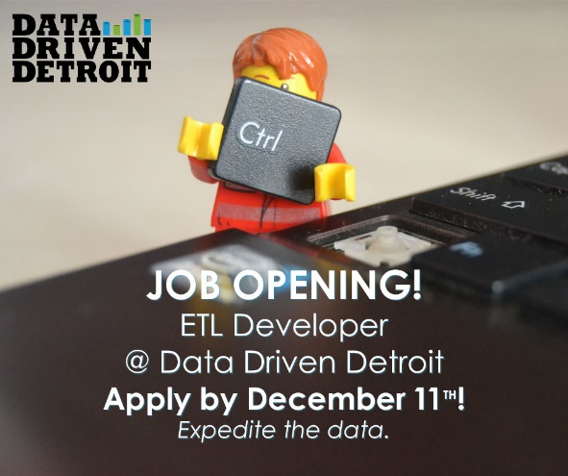
Apply Now: ETL Developer @ Data Driven Detroit!
What: Data Driven Detroit is seeking an experienced and energetic ETL Developer to join our diverse team to assist in super-charging our internal data infrastructure processes.
This is a full-time position, working 40 hours per week. D3 provides an attractive benefits package, including paid vacation and personal time; access to group health, dental, and vision insurance; a 401(k) profit- sharing plan; and eligibility for paid sabbatical leave. This position is based in Detroit, Michigan.
Why: At D3, we exist as a data utility for the Southeast Michigan region. New open data systems and an ever-expanding range of information mean that we have an opportunity to turn our existing data systems and processes into something truly unique for the region. If selected, you’ll join a fast- paced, dynamic working environment where suggestions are welcomed and critical thinking is strongly encouraged.
Where: Founded in 2009, Data Driven Detroit (D3) is a low-profit social enterprise pursuing our mission of providing accessible, high-quality analysis to drive informed decision-making in our communities. As a people-focused company, we rely on the unique skills of our dedicated staff to provide information and analysis that reinforces the capacity of nonprofits, local governments, community groups, and other actors throughout Detroit, Southeast Michigan, and beyond.
Who: The ideal candidate must be passionate about data, standardization, and problem solving; they must be efficient when it comes to manipulating data, able to work independently, and eager to learn new concepts and technical skills.
Required Experience and Skills:
- Bachelor’s degree in Computer Science, Information Science, or relevant field; or equivalent coursework/work experience
- Demonstrated proficiency with standard SQL
This individual will be primarily responsible for expediting the acquisition of data from multiple sources and maintaining our data repository for internal and external consumption. In addition, the ETL Developer will work with the Data Manager and other team members to recommend, develop, implement, and maintain tools and resources to improve day-to-day operations.
The role that you’ll play will be crucial in supporting the organization’s internal data infrastructure and helping D3 adapt to the ever-changing data landscape
- Ability to articulate fundamental programming concepts
- An operational knowledge of at least one scripting and/or general purpose programming language (i.e. Python, PHP, Perl, Ruby) and desire to learn new languages as needed
- Familiarity with or desire to learn basic statistical concepts
- Excellent technical writing skills
- Acute attention to detail
Preferred Skills:
- Application and/or web development experience
- MySQL/Microsoft SQL Server database management experience, specializing with regards to data architecture, database tuning, and query optimization
- Proficiency with statistical software and/or concepts
- Interest in range of topics affecting social conditions, especially in an urban setting
- Familiarity with local governmental and political structures
- Understanding of the relationships between social conditions and quality of life outcomes
How: Please submit a resume, cover letter, and response to the challenge below to work@datadrivendetroit.org. We look forward to reviewing your materials!
Please provide a sample of source code you’ve written (full disclosure, you’re welcome to provide more than one). All code samples should be submitted as a zip file. Each sample should be in plain-text format and sufficiently annotated. Feel free to use whatever language with which you are most comfortable.
Apply by December 11, 2016 @ 11:59pm

