CATALYZING DATA-DRIVEN LOCAL MOBILIZATION FOR THE 2020 CENSUS

A Proposal of the National Neighborhood Indicators Partnership

January 2018

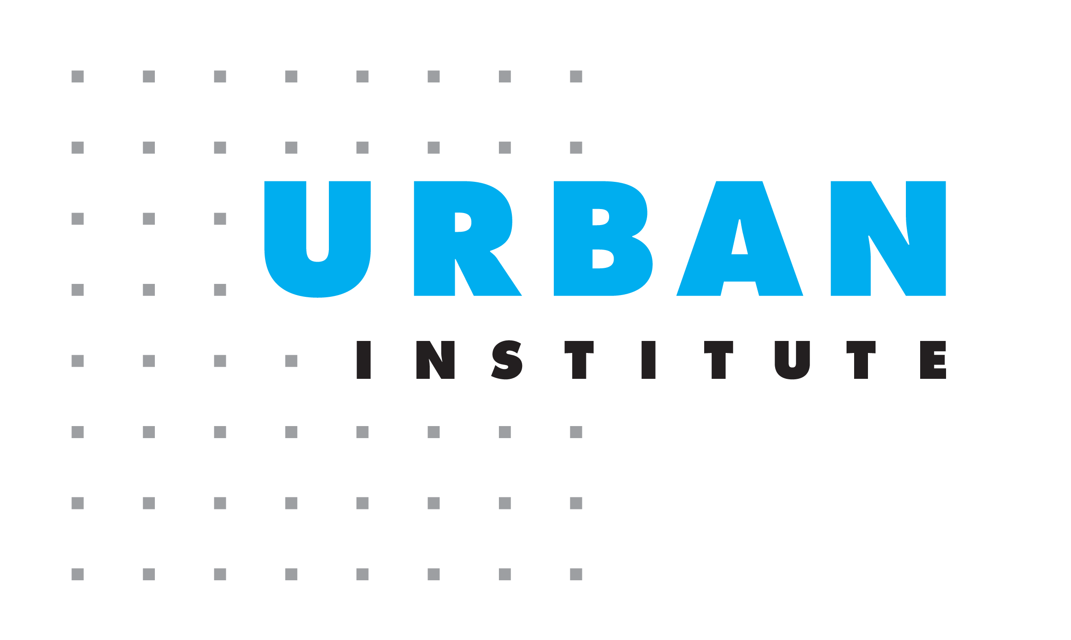
About the Urban Institute
The nonprofit Urban Institute is dedicated to elevating the debate on social and economic policy. For nearly five decades, Urban scholars have conducted research and offered evidence-based solutions that improve lives and strengthen communities across a rapidly urbanizing world. Their objective research helps expand opportunities for all, reduce hardship among the most vulnerable, and strengthen the effectiveness of the public sector.
Copyright © 2018. Urban Institute. Permission is granted for reproduction of this file, with attribution to the Urban Institute.

Summary
The National Neighborhood Indicators Partnership (NNIP) is seeking funding for a cross-site project that will accelerate mobilization across the country for the 2020 Census and expand local data-driven planning for outreach to neighborhoods with high proportions of children and families of color. Coordinated by the Urban Institute, NNIP Partners are trusted local organizations in 33 cities that share a mission to help community stakeholders use neighborhood-level data for better decisionmaking, with a focus on assisting organizations and residents in low-income communities. The scope of work will be two-fold: 1) to directly support select NNIP Partners in promoting the 2020 Census and providing data and analytic support to local coalitions and 2) to educate communities across the country on how to leverage local and national data to effectively activate community stakeholders for a Complete Count. Both strands of work will employ the ready-made communications and peer-learning infrastructure of the NNIP network.

Challenges to a Complete Count for the 2020 Census
The Decennial Census provides the basis for apportioning representation in Congress, serves as the foundation for other federal sources of neighborhood-level data, and guides the distribution of nearly $600 billion (Reamer 2017). With these important functions on the line, an accurate and complete decennial census is essential. Historically, the traditional methods of surveying for the Decennial Census have resulted in an undercount of young children and people of color, particularly in urban counties with populations over 500,000 (O’Hare 2015). In 2020, for the first time, the Census Bureau will rely on most households responding through the Internet, potentially reducing the response rate for groups less likely to have digital skills or computers in their homes.
In addition, the political environment for the 2020 Census will be more challenging than ever. Local organizations report that growing concerns about immigration enforcement are causing immigrant households to be reluctant to have contact with government agencies. Public and private-sector data breaches raise additional concerns about the security and possible misuses of the data. Despite these increased challenges, Congress has reduced the budget in the current and upcoming fiscal years to the Census Bureau, leading to delayed or reduced interest group outreach, communications campaigns, and other programs to activate local communities. These reductions and delays will have the most impact on efforts to reach households that are hard to count – particularly those with young children and people of color.
To avoid having millions of people missed by the Census, local communities must bring together stakeholders across sectors to plan effective strategies to ensure a complete count. They will need to raise awareness and assemble action coalitions much earlier than in past decades. They also must incorporate the use of data and analytics into their plans from the start to ensure they can put their limited resources to use towards neighborhoods and groups that will have the greatest impact. The national resources like the CUNY Hard-to-Count map provide an excellent foundation, but our 20 twenty years of experience in dozens of cities show that many community groups do not have the capacity, experience, or time to take advantage of the national tools or the rich local data resources. They also may not be aware of the informational and communications resources produced by the Census and national advocacy groups. With technical assistance and accessible analysis from trusted local organizations, coalitions could overcome these limitations and become equipped with the right information and skills they need to put data to use in their outreach strategy.

Proposal to Empower Communities with Data for a Complete Count
To overcome these challenges, NNIP is seeking funding for a cross-site project that will accelerate mobilization across the country for the 2020 Census and expand local data-driven planning for outreach to neighborhoods with high proportions of children and families of color. Coordinated by the Urban Institute, NNIP Partners are trusted local organizations in 33 cities that share a mission to help community stakeholders use neighborhood-level data for better decisionmaking, with a focus on assisting organizations and residents in low-income communities. The scope of work will proceed on two parallel tracks. Locally, NNIP Partners in select places will educate nonprofits, philanthropy, and government agencies on the importance of proactive community coordination on the 2020 Census and provide data and analytic support to outreach efforts. Nationally, Urban staff will educate local communities across the country on how to leverage local and national data to effectively activate stakeholders for a Complete Count. Both strands of work will employ the ready-made communications and peer-learning infrastructure of the NNIP network. Funding this work will advance two of the goals articulated in the Democracy Funders Collaborative Census Subgroup’s Get out the Count 2020 Plan:
- to enable trusted voices, especially local community-based organizations, to encourage and assist minority, immigrant and other hard-to-count households to complete the census (Goal 3), and
- to leverage technologies and analytics to identify and assist households in completing the census (Goal 5).
The local members of NNIP are ideally suited to help their communities gain the full benefits from the national data and communications tools, as well as to contribute tailored analyses based on local data. Partners already provide data and analytic support to action coalitions in many issue areas such as housing, education, and environment. They regularly facilitate connections among advocacy organizations, service nonprofits, community groups, foundations, and government agencies to address critical local issues. They are skilled in transforming and communicating data to a variety of stakeholders and focus on building the long-term capacity of their communities to use data. Their local up-to-date neighborhood indicators will provide insights to enhance the analysis of national data on hard-to-count populations, and many have technology tools and interactive platforms to present accessible data and analysis to lay audiences. Our NNIP Partners are eager to apply their skills to support data-driven planning for more effective 2020 Census outreach. Currently, NNIP has representation covering eight of the 10 counties with the highest net undercount of young children in 2010. The undercount of young children in these counties alone was 263,000, one-quarter of the estimated young children missed in 2010 (O’Hare 2015).
Having a set of organizations undertake this kind of local 2020 Census support as a cohort will produce better outcomes in the local places and extend the impact of the project to communities across the country. As coordinator of NNIP, the Urban Institute has led more than a dozen cross-site projects like this to advance local and national goals. Participating Partners already have close relationships with each other and will share innovations and challenges in real time. Urban’s research staff will write accessible products to highlight examples and draw out lessons from the sites. As part of NNIP’s strong peer learning network, we hold regular webinars and Partner meetings where we can motivate the other NNIP Partner organizations to promote the 2020 Census in their metropolitan areas. Altogether, NNIP’s metropolitan areas cover 41 percent of the U.S. population. We will also use Urban’s sophisticated communications platforms to reach out to other national networks.
Proposed Activities, 2018-2020
As described above, the project will consist of two parts: direct engagement in select NNIP Partner sites to catalyze and assist organizing efforts and national communications to spread the insights to other communities. Appendix A lists a potential set of timing and activities for a 28-month engagement, assuming a March 1 start date. Throughout the project, Urban’s NNIP staff will stay engaged with the US Census Bureau Communications staff, the Census Subgroup and the national advocacy organizations that are developing 2020 Census outreach resources.
Directly Supporting Informed Local Strategies for a Successful Complete Count
Urban’s first major task will be to seek three to eight NNIP Partner organizations to use national and local data resources to facilitate community conversations and advance strategic planning efforts for the 2020 Census. Appendix B includes brief descriptions of four NNIP Partner organizations in counties with high undercounts in the 2010 Census to illustrate the missions and community connections of Partner organizations. The process for selecting sites will be developed with the funders. From the network’s experience in cross-site projects, issuing a brief request for proposals (RFP) is essential for confirming the local sites have the interest, connections, and capacity to perform the work. Depending on funding sources and levels, the invitation to apply may be issued to all Partner organizations or a subset of Partners (such as those in counties with a minimum population size or with a historic large undercount of young children).
The exact scope of work will be tailored by each site, depending on the type of organization applying, pre-existing activities in the local area, and the ultimate level of funding. In all cases, they will coordinate throughout the project with their state hubs organizing 2020 Census activities. As early as possible, funded NNIP Partners will hold meetings with stakeholders to educate them about the importance of 2020 Census to the local community and learn about related current and planned activities. They will also review and share findings from the national Hard-to-Count map and publicize national communications resources. At the end of the year, they will produce a planning document, which includes a scan of any current 2020 local organizing efforts and an outline of their plan for 2019, including supplemental analysis of local data that will aid in outreach planning.
In the first half of 2019, they will undertake that analysis and help their communities use local and national data 1) to continue to educate key stakeholders about the importance of the 2020 Census and 2) identify high-priority neighborhoods and relevant organizations trusted by residents in those areas. In some places, partners may take a more active role in the convening of stakeholders and direct outreach to key organizations in the focus neighborhoods. Specific tasks in the first half of 2019 may also include:
- Analyzing local data to identify neighborhoods experiencing population or housing change relevant to Census outreach that may not be represented in the national data.
- Conducting an inventory of nonprofits, government agencies, or anchor institutions key to outreach in the focus neighborhoods or to people of different racial or ethnic background.
- Developing tailored fact sheets to identify and describe characteristics of focus neighborhoods (using national and local data sources). These will inform outreach planning and local messaging.
- Organizing design-thinking workshops, such as the one conducted at the NNIP meeting in Baltimore.
For the remainder of 2019 and early 2020, sites will share their analysis with key stakeholders, participating in planning meetings, and provide ad hoc data and analytic support for their local coalitions. Some Partners have also expressed interest in supporting efforts to recruit enumerators from neighborhoods of color with the idea that people who know the neighborhoods will be more effective in the non-response follow-up efforts. Throughout the entire period, Urban’s NNIP staff will facilitate exchange on approaches among the participating sites.
Inspiring Informed Planning for a Complete Count Across the Country
Over the two years of the project, Urban staff will produce materials on a rolling basis to promote the use of local and national data in planning more strategic 2020 outreach. The specific format and timing will be refined with the funders, the participating local sites, and Urban’s communications staff. In the first months, NNIP staff will connect with existing contacts at the Census Bureau and other knowledgeable individuals in the national organizations involved in Census activities so we can complement and publicize any other planned resources related to data, research, and communications.
Throughout the project, we will leverage NNIP’s regular communications channels to reach the full partnership and other NNIP-related audiences. This includes an active internal listserve, quarterly webinars and newsletters, semi-annual in-person meetings, and an average of 8 to 10 presentations to national audiences. The October 2018 Partners’ meeting in particular presents an excellent opportunity to raise awareness in the network, as it will be held in Los Angeles, a county that experienced one of the highest undercounts of young children in 2010.
We will consult with the Census Subgroup members and the national hub organizations to help identify key audiences for dissemination of the products from this project and to amplify the national resources funded by the Subgroup. NNIP and Urban have relationships with many national networks related to data, analytics, and neighborhood development that will complement the audiences of the advocacy hub organizations already supporting the Census Subgroup. This includes national networks with local affiliates such as Robert Wood Johnson’s All-in Health network, the Community Indicators Consortium, the Federal Reserve Bank’s community development offices, KIDS COUNT, LISC, and the Urban Library Association. We also have connections with local government agencies through the What Works Cities network, Data Smart Cities, and the Civic Analytics network of local chief data officers. (These are described in more detail in Appendix C). Early in the project, we will also interview contacts in these and other data and community development networks to understand the baseline level of awareness and planned activities related to the 2020 Census.
In the interest of getting the message out early, we will publish a brief in mid-2018 outlining the many ways that local data-savvy organizations (NNIP Partners and others) should support 2020 Census outreach planning, including promotion of the national Hard-to-Count map. This will raise awareness of the importance of data and analysis in the formative stages of local coalitions, including but not limited to those officially affiliated with the Census Partnership program or Complete Count Committees. The materials will make clear that communities can access data expertise through a variety of organizations, such as NNIP Partners, KIDS COUNT organizations, indicators projects, and university centers, and city and county planning offices. Any of these institutions can and should be contributing data and analysis to local campaigns to reduce the undercount of young children and people of color.
In the first half of 2019, we propose to publish periodic updates about how local sites are approaching incorporating data into their strategies. We also will create template educational materials on applying data and data resources for Complete Count committees or other action coalitions coordinating 2020 Census outreach. We have examples from our NNIP Partners in Boston and St. Louis of trainings like this that they conducted in 2010. In the second half of 2019, Urban will gather products and information from the participating sites through interviews with Partners and other local organizations. To present examples from a broader set of places, we will also conduct a network-wide survey asking all NNIP Partners about their current and planned involvement in 2020 Census outreach. Urban will publish these findings in Fall 2019, which will provide a range of ideas about how using local and national data can enhance planning for 2020 Census outreach. Finally, we propose to publish recap of lessons from the project and recommendations for the 2030 Census in June 2020.
We will use NNIP’s and Urban Institute’s website, social media, and blogs to share the products resulting from this project. We will also seek to place blogs and articles with external organizations. Urban will also host webinars to share these resources and real-life examples from the Partners and their local collaborators. With little publicity, recent webinars targeted towards practitioners and advocates about organizing events around 500 Cities data and about identifying data sources for promoting equal opportunity and fair housing have attracted 400 to 500 registrants. We will report back outcomes on all communications efforts to the Executive Committee and project funders.

Project Staffing and Management
The project will be led by Kathryn L.S. Pettit, principal research associate in the Metropolitan Housing and Communities Policy Center at the Urban Institute and director of NNIP. Her research focuses on measuring and understanding neighborhood change. Pettit is a recognized expert on several small-area local and national data sources and on the use of neighborhood data in research, policymaking, and program development. She also serves on the Census Scientific Advisory Committee and the board of the Association of Public Data Users. She will be assisted by Leah Hendey, an Urban senior research associate and the deputy director of NNIP and other NNIP project staff. This work, however, will be grounded in local experience benefit from the insights of NNIP’s elected Executive Committee: John Cruz (St. Louis), Seema Iyer (Baltimore), Laura McKieran (San Antonio), Bernita Smith (Atlanta), April Urban (Cleveland), and Noah Urban (Detroit).

References
O’Hare, William. 2015. The Undercount of Young Children in the US. Decennial Census. Springer Briefs in Population Studies.
Reamer, Andrew. 2017. Counting for Dollars 2020: The Role of the Decennial Census in the Geographic Distribution of Federal Funds: Initial Analysis: 16 Large Census-guided Financial Assistance Programs. Accessed August 28, 2017. https://gwipp.gwu.edu/sites/gwipp.gwu.edu/files/downloads/Counting%20for%20Dollars%202020%2008-22-17_0.pdf

Appendix A: Potential Project Activities and Schedule
Potential National Project Activities and Schedule (28-month period)
Date | Network Activity
March – May 2018 | Conduct field interviews with national hub organizations, hold initial conversations to educate key networks, and select local sites.
May 2018 | Promote Partners’ roles in 2020 Census at Atlanta meeting of the NNIP network, including pre-session on local data intermediaries and public libraries.
June 2018 | Publish brief on potential ways for local and national data and analysis to improve local Census outreach efforts.  Publish blog to announce sites and promote the use of data in local planning, highlighting the available national data tools.
July - December 2018 | Disseminate brief to various national networks, including placing 2-3 tailored blogs on external sites.  Promote Partners’ roles in 2020 Census at the October Los Angeles meeting of the NNIP network.
January 2019 | Blogs, brief, or feature summarizing local experiences to date and 2019 analytic plans.
February 2019 – June 2019 | Publish periodic informal stories/features about how local sites are approaching incorporating data into their strategies.  Publish educational materials on applying data and data resources for both government-led and community Complete Count committees and other coalitions.
October 2019 | Publish brief on lessons from local sites in using data and analysis.
October 2019 - March 2020 | Disseminate brief and project resources to key audiences through blogs, presentations, and webinars.
June 2020 | Publish summary of lessons from the project and recommendations for the 2030 Census.

Potential Local Project Activities and Schedule: Local Activities (24-month period)
Date | Local Partner Activity
May 2018 – December 2018 | Promote the importance of the 2020 Census.  Assess and share data from national tools.  Scan and document local organizing activities.
December 2018 | Produce document on current 2020 Census efforts and outline 2019 analysis and activities.
January – April 2019 | Continue to promote the importance of the 2020 Census.  Conduct initial analysis of local data.
May – September 2019 | Get feedback from stakeholders on local analysis.  Publish and disseminate final analysis.  Assist local coalitions to plan outreach strategies.
October 2019 – April 2020 | Provide ad hoc support and supplemental analysis as needed for final outreach strategies.

Appendix B: Descriptions of Select NNIP Partners
The following paragraphs describe select NNIP Partners in counties with historically high undercounts.
- Dallas: The Institute for Urban Research at the University of Texas at Dallas provides research and evaluation, education and outreach, and guidance and consulting to inform, motivate, and inspire community-focused organizations that improve the quality of life in the communities they serve. They have a close relationship with the local United Way and its grantees and provide community organizations training on program design. They also have a strong relationship with the City of Dallas, particularly the Office of the Mayor, the City Manager’s Office, and Economic Development.
- Houston: Rice University’s Kinder Institute for Urban Research advances understanding of the challenges facing Houston through research, policy analysis, and outreach and works with community partners to implement solutions. Kinder has built trusted connections with community-based groups and city agencies. Since Hurricane Harvey, the Institute has been instrumental in sharing information about the needs of low-income residents in recovery efforts. The effects of the hurricane on housing mean that the traditional national data on Houston neighborhoods is less accurate, so examination of local data to identify areas with concentrations of hard-to-count groups will be essential.
- Los Angeles: Housed at the University of Southern California, the Sol Price Center for Social Innovation develops ideas and illuminates strategies to improve the quality of life for people in low-income, urban communities. The Center’s Neighborhood Data for Social Change platform compiles and organizes census-tract level data from a variety of sources to analyze and disseminate findings to civic actors. The platform enables stakeholders to tell stories about shifts and challenges to local neighborhoods by: tracking change; accessing technical assistance to better understand and use data to enhance their mission; using data to more strategically plan community development strategies; and assessing the impact of new policies, programs, or external shocks much more immediately.
- Miami: The Children’s Trust partners with the community to plan, advocate for, and fund strategic investments that improve the lives of all children and families in Miami-Dade County. They do in-depth engagement in several neighborhoods of color, have long-term connections across sectors, and were a Census Partner organization in 2010. With their network of community collaborators and grantee service organizations, they are very well-positioned to provide guidance for reaching out to families with young children.

Appendix C: Potential National Audiences for 2020 Census Outreach

All-In Network: Data for Community Health: a nationwide learning collaborative funded by the Robert Wood Johnson Foundation that helps communities build capacity to address the social determinants of health through multi-sector data sharing collaborations. Collectively, All In includes over 50 community collaborations across the country. NNIP and All-In staff attend each other’s conferences and help to disseminate each other’s products.
Civic Analytics Network (CAN): a network of leading urban Chief Data Officers managed by the Harvard’s Ash Center for Democratic Governance and Innovation, which also manages the Data-Smart Cities website. The network collaborates on shared projects that advance the use of data visualization and predictive analytics in solving important urban problems related to economic opportunity, poverty reduction, and addressing the root causes of social problems of equity and opportunity. NNIP and Ash Center staff attend each other’s conferences and help to disseminate each other’s products.
Code for America Brigade Network: a national alliance of community organizers, developers, and designers that are putting technology to work in service of our local communities. They have volunteer groups in dozens of cities across the country. NNIP is currently participating in a cross-site project titled Civic Tech and Data Collaborative with Code for America and Living Cities.
Community Indicators Consortium: a group that advances and supports the development, availability and effective use of community indicators for making measurable and sustainable improvements in quality of community life. They track 275 indicator projects, mostly in communities in the United States. An NNIP Partner currently serves on the CIC board, and several other members are CIC members.
Federal Reserve Bank Community Development Offices: the community development programs of the twelve Federal Reserve Banks and their offices in dozens of other cities activate financial, human, and social capital to foster the conditions that facilitate economic growth. Through action-oriented research, conferences, and expanding networks on these topics and others, they are a valuable resource as you work to foster economic growth and opportunity in low- and moderate-income communities. NNIP has collaborated with regional community development staff on major conferences, edited What Counts, a book on community data for decisionmaking

KIDS Count: a project of the Annie E. Casey Foundation to track the well-being of children in the United States to enrich local, state and national discussions concerning ways to secure better futures for all children — and to raise the visibility of children's issues through a nonpartisan, evidence-based lens. Fifty KIDS COUNT state organizations provide state and local data, as well publications providing insights into trends affecting child and family well-being.
Local Initiatives Support Corporations (LISC): a national network that forges resilient and inclusive communities of opportunity across America. Government, foundations and for-profit companies have the capital; residents and local institutions understand the need; and LISC bridges the gap by offering the relationships and expertise to help community organizations attract the kinds of resources that allow them do their best work. LISC has 31 local offices and a rural program that reaches nearly 1,400 counties in 44 states. NNIP has presented to the LISC network and communicates with the knowledge officer at the national New York office.
MetroLab Network: a network of more than 35 regional city-university partnerships that focus on research, development, and deployment projects that offer technological and analytically-based solutions to challenges facing urban areas including: inequality in income, health, mobility, security and opportunity; aging infrastructure; and environmental sustainability and resiliency. MetroLab staff regularly attend NNIP Partner meetings, and Partners have participated in the MetroLab conferences.
Urban Library Council: a membership association of more than 150 leading public library systems, whose initiatives strategically advance the value that 21st century libraries provide communities in critical areas such as education/lifelong learning, workforce and economic development, public safety, health and wellness, safety and environmental sustainability. NNIP is participating in a Institute of Museum and Library Studies grant led by our Pittsburgh Partner and the Carnegie Library System to connect local data intermediaries and their public and academic libraries.
What Works Initiative: a national initiative launched by Bloomberg Philanthropies in April 2015 to help 100 mid-sized American cities enhance their use of data and evidence to improve services, inform local decision-making and engage residents. Johns Hopkins’ Center for Government Excellence and the Sunlight Foundation are two of the What Works implementation organizations with which NNIP regularly shares information.

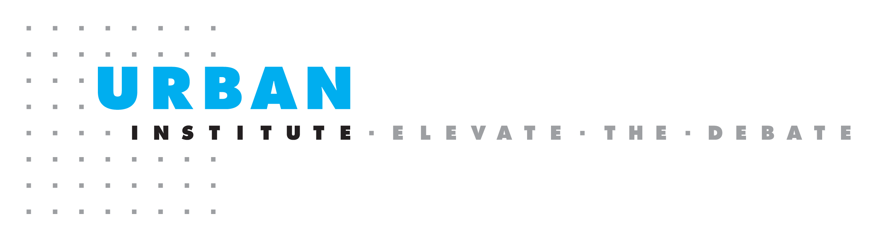
2100 M Street NW
Washington, DC 20037
www.urban.org

