United Way of San Antonio and Bexar County

In Partnership with

U.S. Census Bureau, Denver Region

Invite You to Attend

“Using Census Data for Community and Neighborhood Analysis“

Location??
San Antonio, TX

8:30 am to 12:30 p.m.
On
Tuesday, September 18, 2012

The “Community Analysis” workshop will train participants on using data from the 2010 Census and American Community Survey, the most relied-on source for detailed, up-to-date socio-economic statistics covering every community in Texas.

Who should come? The lab is designed for member agency staff that use data for budget analysis, needs assessment and planning.

In a live computer lab setting, students will use the American Factfinder (data search tool); conduct searches using the Census 2010 for population numbers/basic characteristics, and American Community Survey for social/economic characteristics such as educational attainment, income, occupation, poverty status, nativity and selected homeowner costs. Special emphasis will be placed on researching small area data to understand the demographics of the area of service.

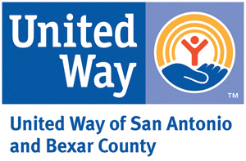
Seating is limited and computers will be provided. Registration is required and space will be guaranteed to the first ?? participants who register. Please register by emailing meburns@unitedwaysatx.org. Any questions, please call Mary Ellen @ 210-352-7028.

